Skip to content
////// Science for a better life
English (EN)
- Locations
- Contact Us

- This is Bayer
- Health
- Agriculture
- Products
- Innovation
- Sustainability
- Media
- Investors
- Career

Breadcrumb
- Home
- Health
- Pharmaceuticals
- Innovation & Technologies
- Pipeline
- FAQ
Clinical Trials

FAQ

- Health at Bayer
- Pharmaceuticals
  - Treatments & Therapies
  - Innovation & Technologies
    - Trends
    - Pipeline
      - Clinical Trials
      - Ethics in Clinical Trials
      - FAQ
      - Access to investigational medicines
    - Technology
    - Partnering
  - Cell and Gene Therapy
  - Sustainability
  - Transparency
  - News & Stories
  - Clinical Trials Explorer
  - Transparency Policy
- Personal Health
- Report a Side Effect
- Medical Counterfeits
You wanna know more about clinical trials? You can find the answers to eleven frequently asked questions in our FAQ below.
1. What are clinical trials, and why are they important?
Clinical trials are research studies conducted with people who volunteer to take part in testing how well new medical approaches work. Each study answers scientific questions and tries to find better ways to prevent, screen for, diagnose, or treat a disease.
2. Who sponsors clinical trials?
Clinical trials are sponsored or funded by a variety of organizations or individuals such as physicians, medical institutions, foundations, voluntary groups, and pharmaceutical companies, in addition to federal agencies.
Trials can take place in a variety of locations, such as hospitals, universities, doctors' offices, or community clinics.
3. How are participants protected?
4. What are eligibility criteria, and why are they important?
5. What is informed consent?
6. Where do clinical trials take place?
7. How are clinical trials conducted?
8. What happens when a clinical trial is over?
9. What are some of the benefits of taking part in a clinical trial?
10. What are some of the possible risks associated with taking part in a clinical trial?
11. What are some questions people might ask their health care provider before entering a clinical trial?
Share:
- Facebook
- Twitter
- Email
- LinkedIn
Discover More

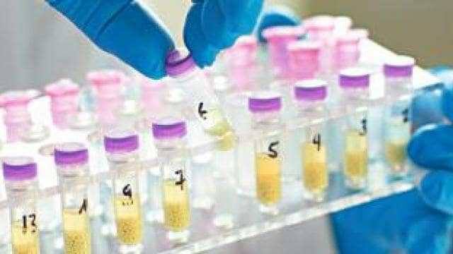
INNOVATION

Development Pipeline
Bayer concentrates its R&D activities on innovative treatment alternatives for diseases with a high unmet medical need to improve patients’ quality of life and prolong lives.
READ MORE


INNOVATION

Clinical Trials
Clinical trials study potential new treatments in healthy volunteers or people with a specific illness or condition.
READ MORE

Last Updated: Saturday, December 17, 2022
- Our Business
  - Pharmaceuticals
  - Consumer Health
  - Crop Science
  - Our Products
  - Bayer Worldwide
- Magazines & Reports
  - News & Stories
- Stay Tuned
  - Job Postings
  - Latest News
  - Newsletter
  - Bayer Share Price
Get in Touch
Do you have any queries or comments?
GLOBAL FORM
REPORT A SIDE EFFECT
Follow Us
Copyright © Bayer AG
- Conditions of Use

- Privacy Statement

- Cookie Settings

- Imprint
Sitemap
Top

