

Kapture –Bobcat AI- Agent-Configuration-Steps

Table of Contents
Create Actions 3
Create Agent 9
Creating Topics for the Kapture –Bobcat AI- Agent 14
Adding Action/s under the Topics 19

Create Actions

Login to Service Connect using following URL:

https://aiplatform.kapturekm.com/service-connect-agent/login

Following Screen will Come:

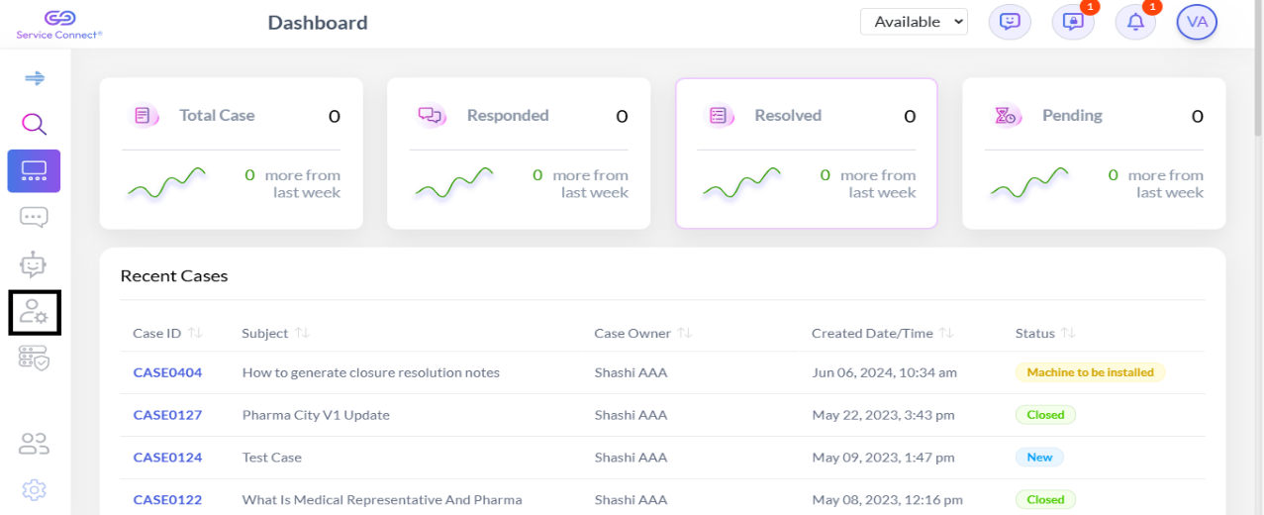

Click on the Icon as shown in above Screenshot, following screen will come. Click on Create Action:

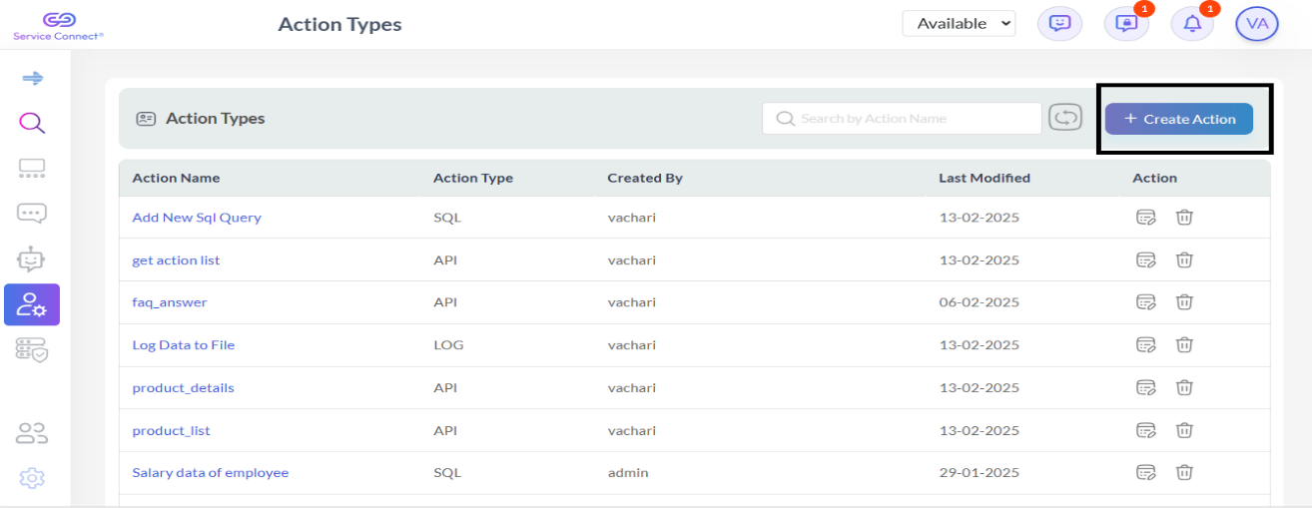

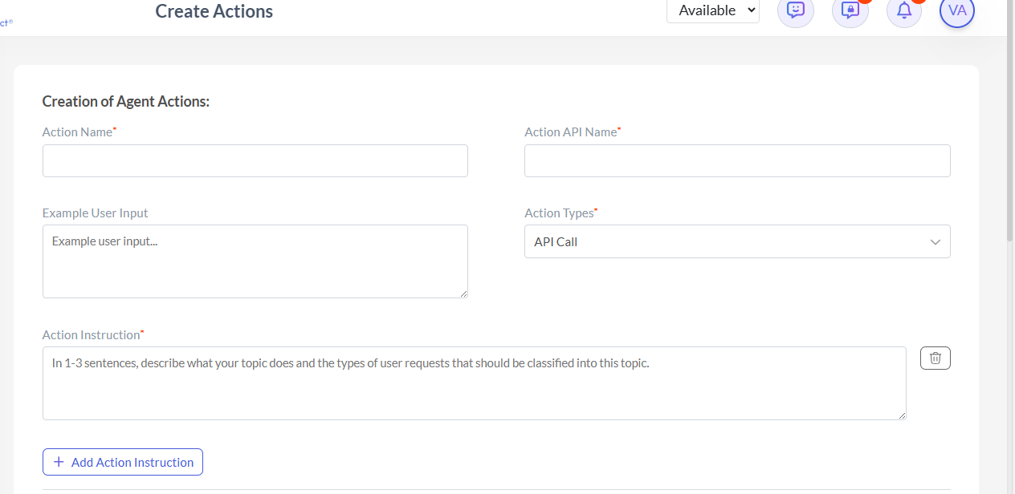
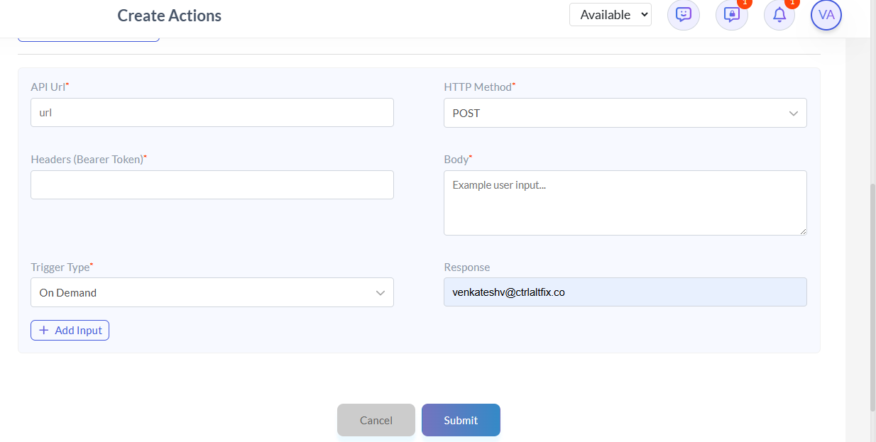

Create following Five actions by using above screen:

- equipment_type

Action Name: equipment_type
Action API Name: equipment_type
Example User Input: --
Action Types* : API Call

Action Instruction*- Fetch and list all available equipment types.
API Url*- https://aiplatform.kapturekm.com/kapture-bobcat-crawling/api/get-type-of-products/Equipment
HTTP Method*- GET
Headers (Bearer Token)*- NONE
Trigger Type*- On Demand
Response -- venkateshv@ctrlaltfix.co ( respective email id will come automatically).
Click on Submit Button. Action will be created with the name equipment_type.

- product_type

Action Name: product_type
Action API Name: product_type
Example User Input: --
Action Types* : API Call
Action Instruction*- Fetch and list all available product types.
API Url*- https://aiplatform.kapturekm.com/kapture-bobcat-crawling/api/get-type-of-products/
Method*- GET
Headers (Bearer Token)*- NONE
Trigger Type*- On Demand
Response -- venkateshv@ctrlaltfix.co ( respective email id will come automatically).
Then Click on following Button:


Following screen will come:

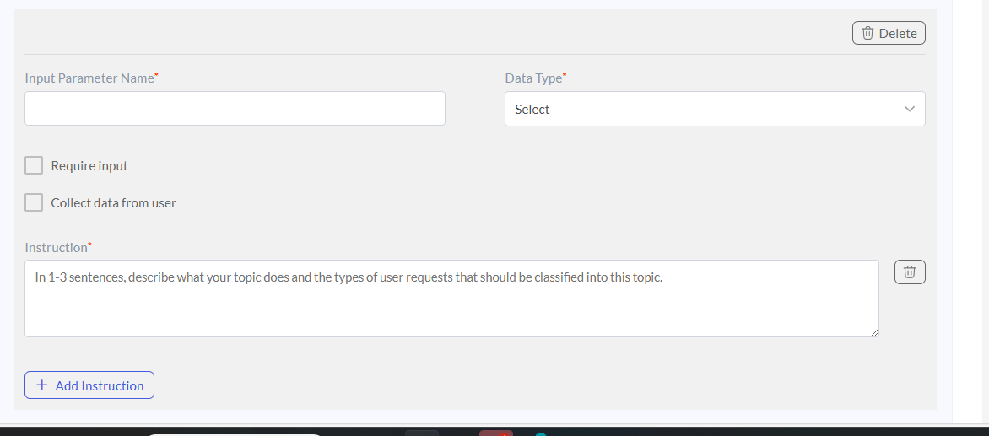
In the above screen, fill the following parameters:

Input Parameter Name*- equipment_type
Data Type*- String
Require Input- Check it
Collect data from user: Check it.
Instruction*- please provide equipement type details
Click on Submit Button. Action will be created with the name product_type.
- product_list

Action Name: product_list
Action API Name: product_list
Example User Input: --
Action Types* : API Call
Action Instruction*- Fetch product list for a specified product type.
API Url*- https://aiplatform.kapturekm.com/kapture-bobcat-crawling/api/products/
Method*- GET
Headers (Bearer Token)*- NONE
Trigger Type*- On Demand
Response -- venkateshv@ctrlaltfix.co ( respective email id will come automatically).
Then Click on following Button:
Following screen will come:

In the above screen, fill the following parameters:

Input Parameter Name*- product_type
Data Type*- String
Require Input- Check it
Collect data from user: Check it.
Instruction*- please provide all details about product list by their type
Click on Submit Button. Action will be created with the name product_list.

- product_details

Action Name: product_details
Action API Name: product_details
Example User Input: --
Action Types* : API Call
Action Instruction*- Fetch product details for a specified product name.
API Url*- https://aiplatform.kapturekm.com/kapture-bobcat-crawling/api/products/details/
Method*- GET
Headers (Bearer Token)*- NONE
Trigger Type*- On Demand
Response -- venkateshv@ctrlaltfix.co ( respective email id will come automatically).
Then Click on following Button:
Following screen will come:

In the above screen, fill the following parameters:

Input Parameter Name*- product_name
Data Type*- String
Require Input- Check it
Collect data from user: Check it.
Instruction*- please provide all details about product type.
Click on Submit Button. Action will be created with the name product_details.

- faq_answer

Action Name: faq_answer
Action API Name: FAQ_ANSWER
Example User Input: --
Action Types* : API Call
Action Instruction*- Retrieves answers for frequently asked questions related to Bobcat products, services, and support.
API Url*- https://aiplatform.kapturekm.com/kapture-bobcat-crawling/api/faq
Method*- GET
Headers (Bearer Token)*- NONE
Trigger Type*- On Demand
Response -- venkateshv@ctrlaltfix.co ( respective email id will come automatically).
Click on Submit Button. Action will be created with the name faq_answer.

Create Agent

Login to Service Connect using following URL:

https://aiplatform.kapturekm.com/service-connect-agent/login

Following Screen will Come:

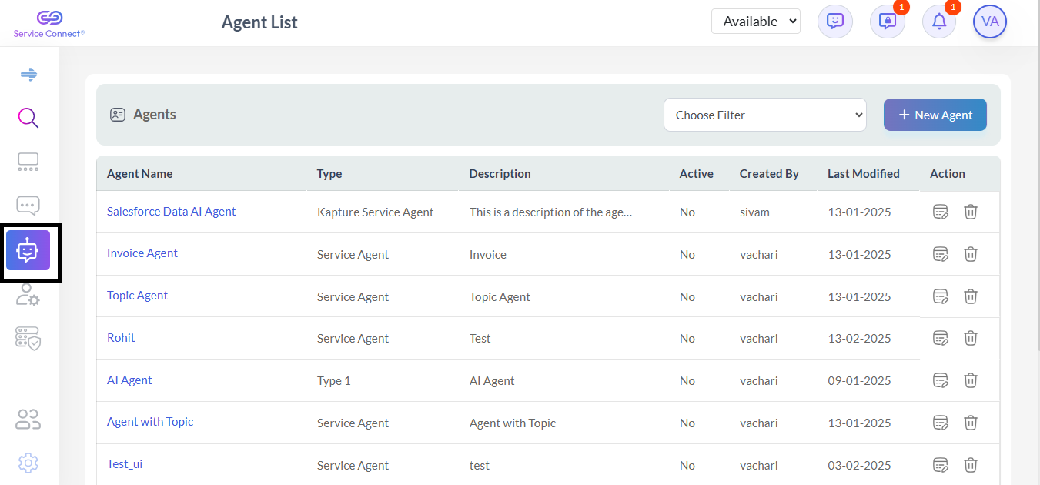

Click on the Icon as shown in above in the Screenshot, following screen will come. Click on ‘New Agent’:

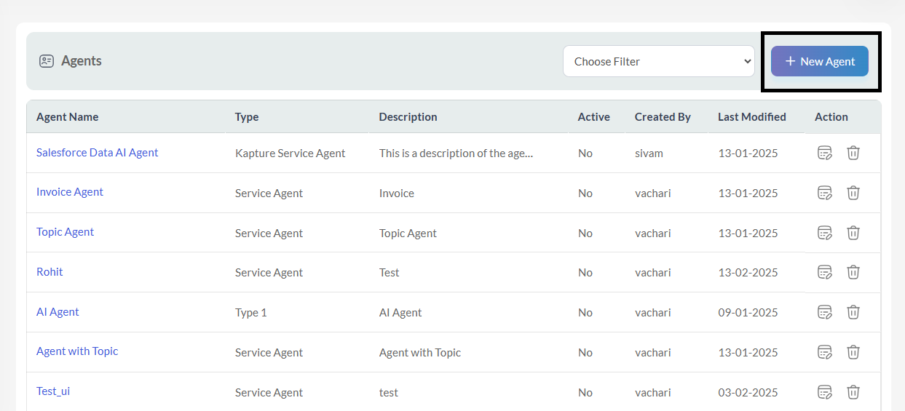
Select “Kapture Service agent” and click on “Next”
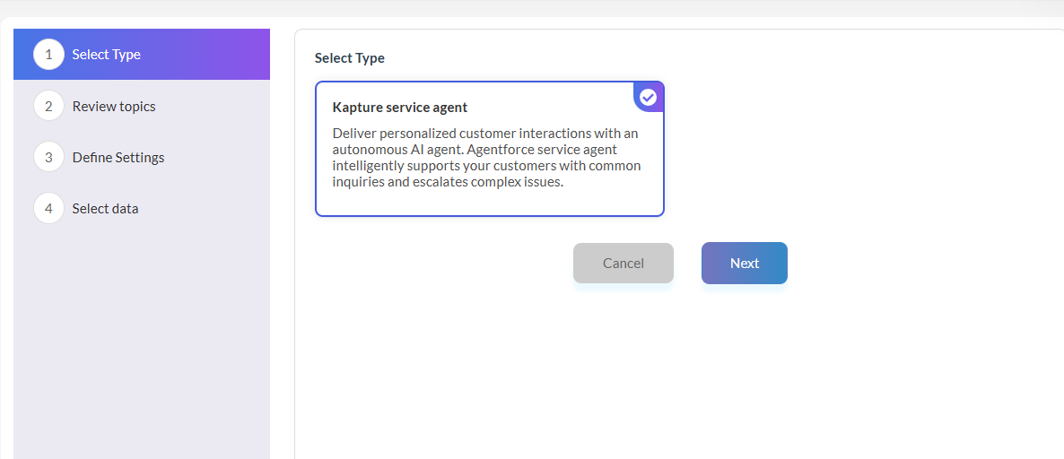

Select the Topic “General FAQ” and click “Next”:
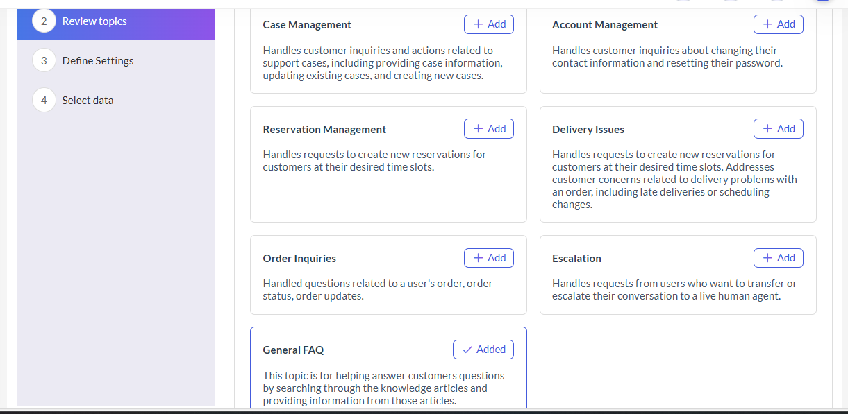

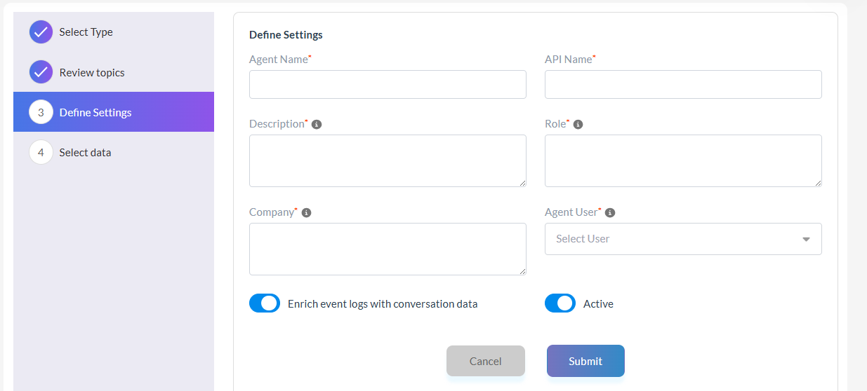

In the above screenshot fill the details as follows:

Agent Name*- Kapture AI Agent Bobcat
API Name*- kapture_ai_agent_bobcat
Description*- This is agent is responsible to provide the answer for bobcat product related query
Role*- It provides the information about the equipment types product list product details equipment sub types
Company*- Bobcat offers a wide range of material handling solutions for businesses including forklifts telehandlers and warehouse equipment It offers a rich set of experiences.
Agent User*- Select it from Dropdown

Click on Submit. Your Agent will be created as shown in below screenshot:

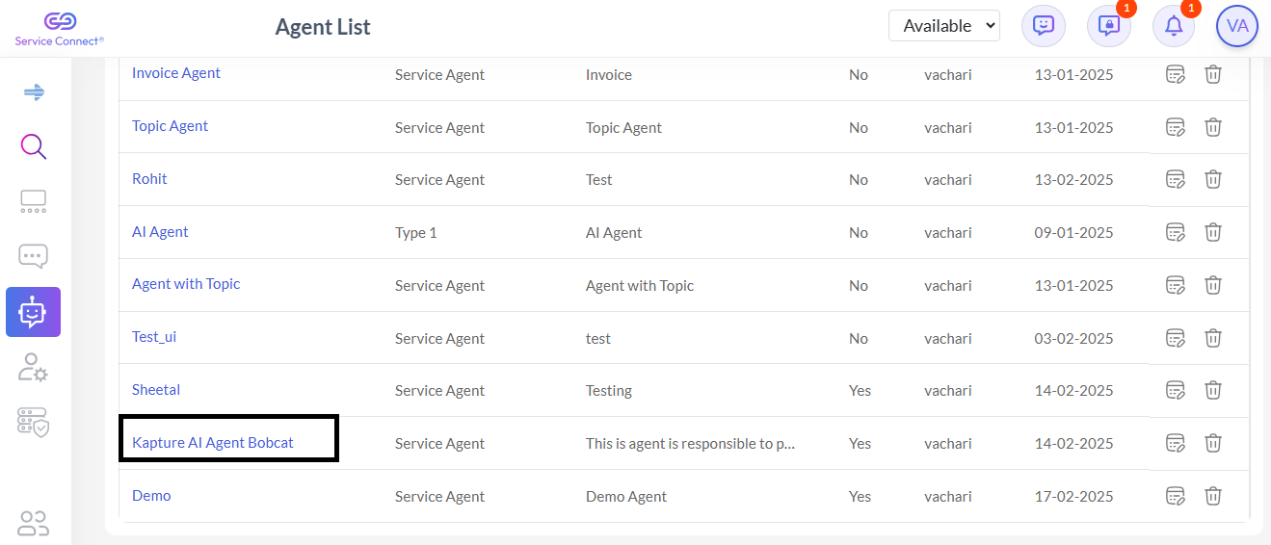

Click on the Agent name ‘Kapture AI Agent Bobcat’, following screen will appear:

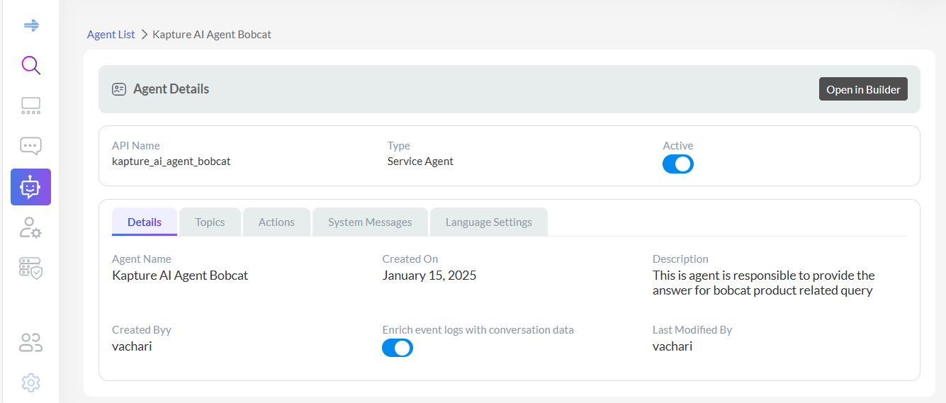

Click on System Messages Tab, following screen will come:

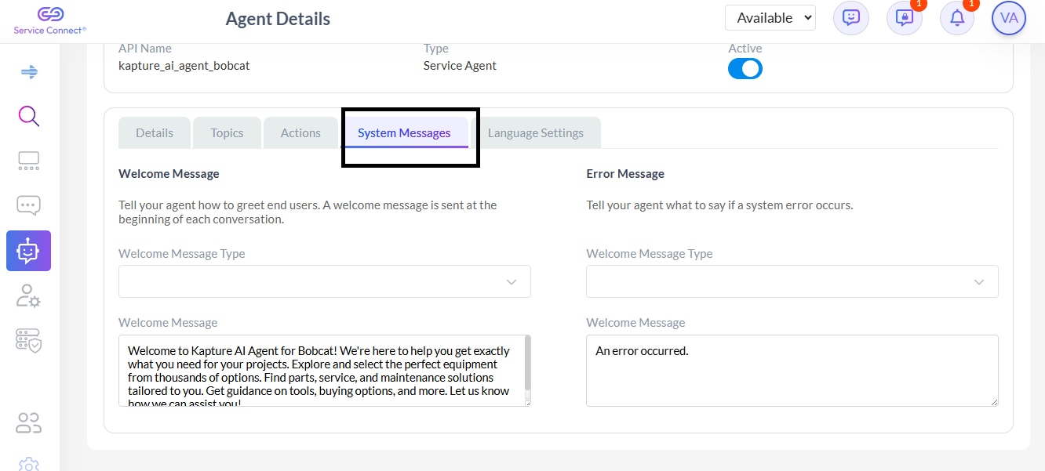

User can enter his customized message inside ‘Welcome Message’ Text Box.

Creating Topics for the Kapture –Bobcat AI- Agent

This is very important step in which user will create different Topic and it’s respective details like instructions under the umbrella of Agent.

Firstly, click on the icon as shown in below screenshot:

After clicking on the above icon, all Agent list is displayed.

Then, Click on the Agent name ‘Kapture AI Agent Bobcat’, as shown in below screen:

Click on the Agent name ‘Kapture AI Agent Bobcat’, following screen will appear:

Now, Disable the ‘Active’ switch and click on ‘Open In Builder’, following screen will appear:

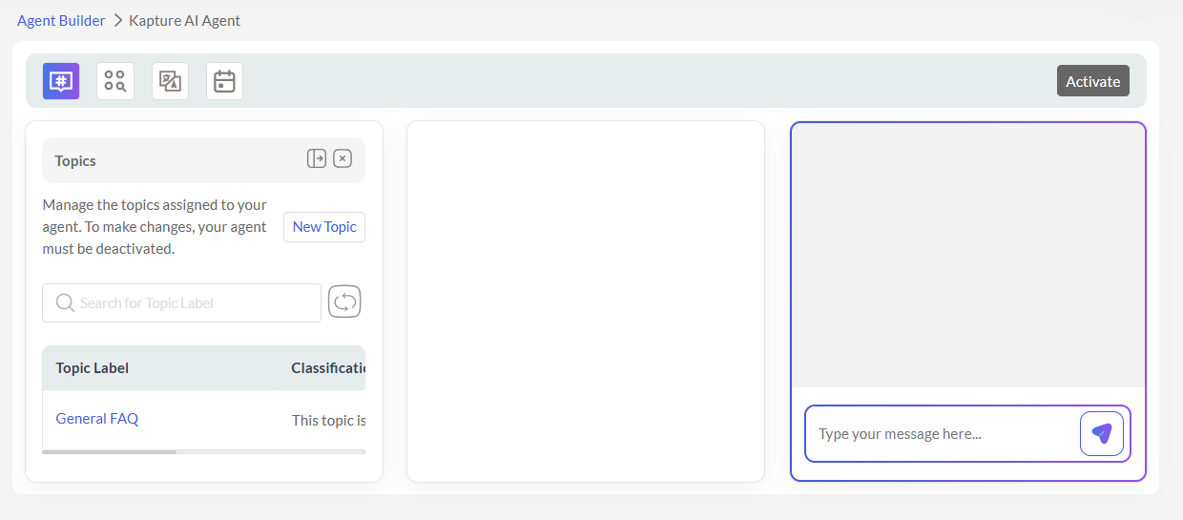

From the above screen, click on the icon ‘New Topic’, following screen will appear:

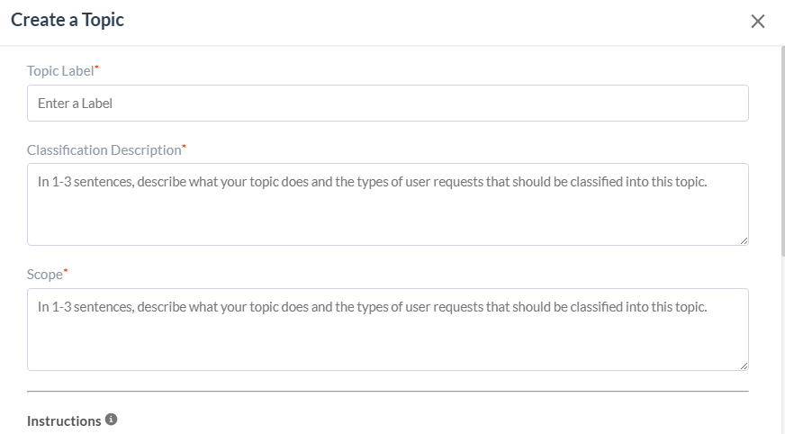
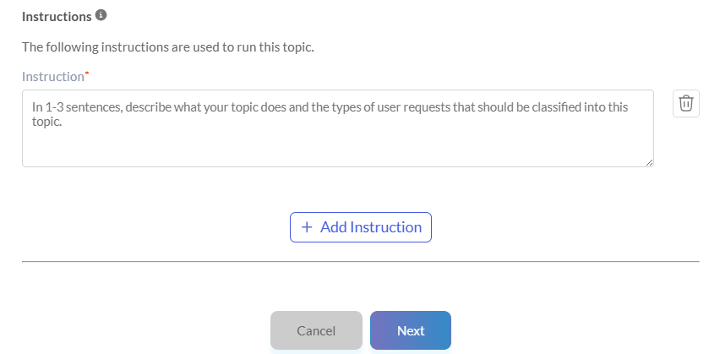

Using above Screen, Create following Topics:

- Product Details:

Topic Label*- Product Details

Classification Description* - Queries related to fetching and providing product details.

Scope*- Recognizes queries that mention product types or names, such as machinery and construction equipment. It should be able to handle one-word product references or detailed requests for information on specific products, providing details like specifications, models, and availability. Fetches product information from external APIs or predefined datasets.

Instructions-

You are an intelligent assistant tasked with identifying user intent and calling appropriate tools to fetch equipment types, product types, product lists, or product details. Always consider the full conversation context, and respond based on previous interactions, ensuring continuity and relevance in all responses. If the user's input contains 5 words or fewer, treat it as a query requesting specific data like details, types or list and respond accordingly. Strictly call all the tools , if other tool fails to fetch the data. Follow these rules strictly:

Instructions-

"1. **Equipment Types**: If the query or word/words is about available equipment types, call `equipment_type_tool`."

Instructions-
"2. **Product Types**: If the query or word/words involves product types:"
" - Check if an equipment type is mentioned."
" - If mentioned, call `product_type_tool` with the specified equipment type."
" - If not mentioned, prompt the user to provide an equipment type and list all available types by calling `equipment_type_tool`."

Instructions-
"3. **Product List**: If the query or word/words asks for a product list:"
" - Check if a product type is mentioned."
" - If mentioned, call `product_list_tool` with the specified product type or product types."
" - If not mentioned, prompt the user to provide a product type and list all available equipment types by calling `equipment_type_tool`."

Instructions-
"4. **Product Details**: If the query or word/words requests product details:"
" - Check if a product name is mentioned."
" - If mentioned, call `product_details_tool` with the specified product name."
" - If not mentioned, prompt the user to provide a product name and display relevant product types or equipment types if necessary."

Instructions-
"5.**Special Cases**: For queries or word/words combining attributes (e.g., highest horsepower in 'Loaders'):"
" - Extract the equipment type from the query and validate it by calling `equipment_type_tool`."
" - If the equipment type is valid, call `product_type_tool` with the specified equipment type."
" - If `product_type_tool` returns multiple product types:"
" - Sequentially call product_list_tool for each product type returned."
" - Combine the product lists into a single result set without skipping any product type."
" - For each product in the combined result set, call `product_details_tool` to retrieve detailed information about the product."
" - Use the detailed information to filter,rank or compute results based on the attributes specified in the query (e.g., highest horsepower)."
" - Ensure results are presented comprehensively, especially when dealing with multiple product types, to address the query accurately."

Instructions-
"6. For all tool outputs related to product lists or details, display them in a tabular format with HTML tags."

Instructions-
"7. Always aim to clarify missing information before proceeding to ensure accurate results. "

- General Query:

Topic Label*- General Query

Classification Description* - General questions not specifically related to invoices or products.

Scope- Broad; may include questions requiring clarification or redirection.

Instructions- Identify intent and respond appropriately using default capabilities.

- Frequently Asked Questions:

Topic Label*- Frequently Asked Questions

Classification Description* - Addresses common inquiries related to Bobcat products, parts, services, purchasing, safety, security concerns, inventory tracking, and discontinued items.

Scope- Includes questions about product serial numbers, parts purchasing, service manuals, equipment pricing, used equipment availability, stolen equipment reporting, submitting product ideas, safety data sheets (MSDS), tracking new equipment inventory reservations and information on non-current or discontinued products.

Instructions- If the query is about frequently asked questions, call `faq_answer_tool`

Adding Action/s under the Topics

For adding Action/s for the particular Topic following flow should be followed:

Firstly, click on the icon as shown in below screenshot:

After clicking on the above icon, all Agent list is displayed.

Then, Click on the Agent name ‘Kapture AI Agent Bobcat’, as shown in below screen:

Click on the Agent name ‘Kapture AI Agent Bobcat’, following screen will appear:

Now, Disable the ‘Active’ switch and click on ‘Open In Builder’, following screen will appear:

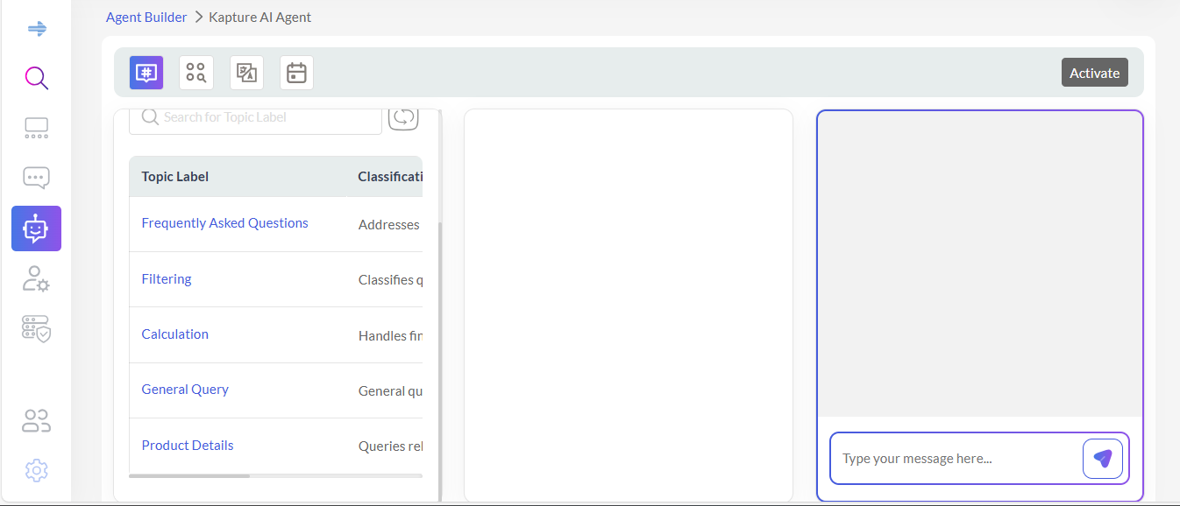

User will see the Topics which they have created. Like ‘Product Details’, Frequently Asked Questions’ and ‘General Query’.

Now, we will add Actions under Topics ‘Product Details’. Follow the below steps:

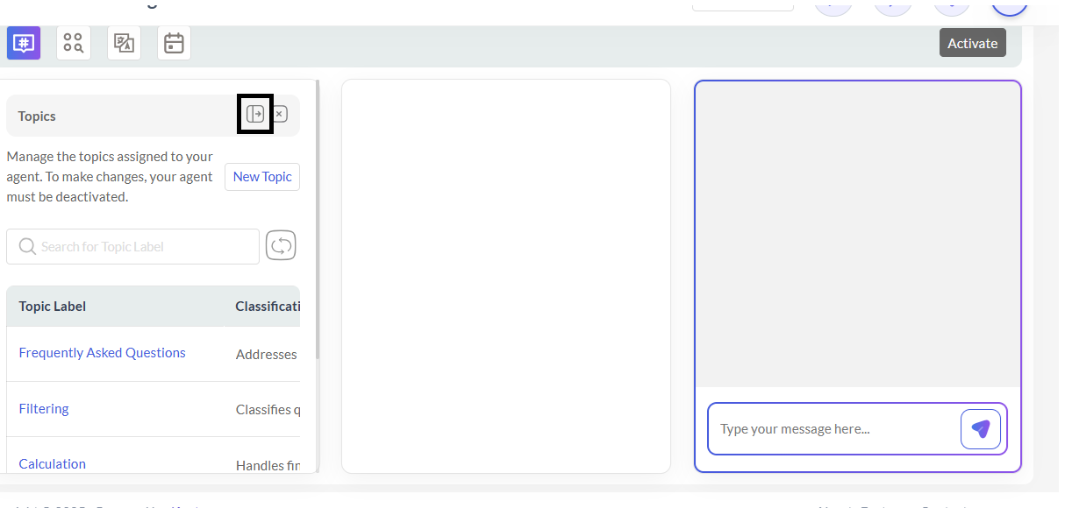

Click on the expand icon from above screen. Following screen will appear:
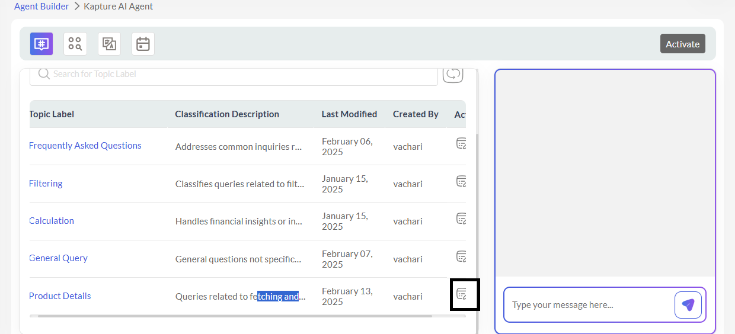

From above Screen, click on Edit button infront of ‘Product Details’, following screen will appear:

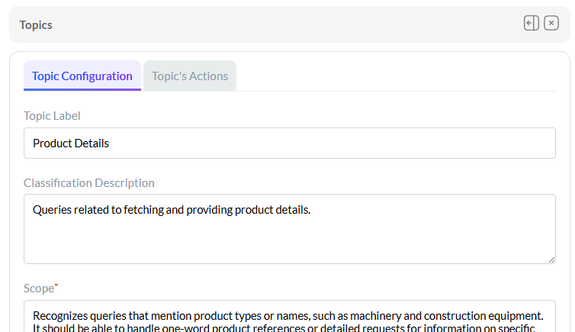
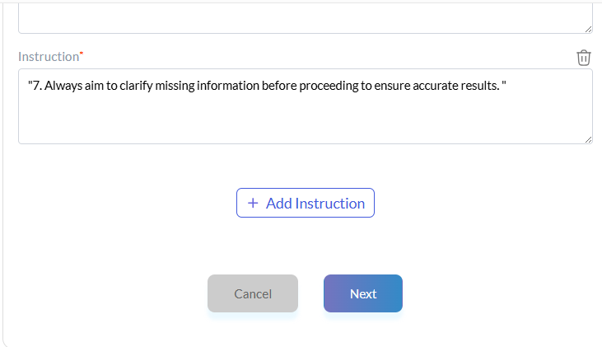

Click on ‘Next’ button so that, following screen will appear:

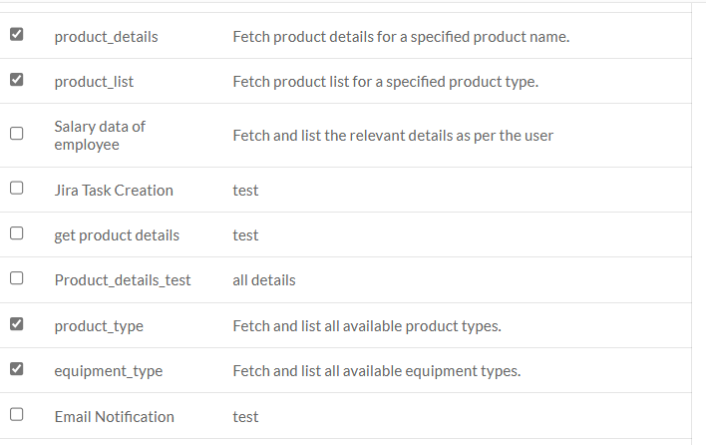


Check the above Four Actions, and click on Finish, Topic will be updated with Actions Added into it.

Now, we will add Actions under Topics ‘Frequently Asked Questions’. Follow the below steps:

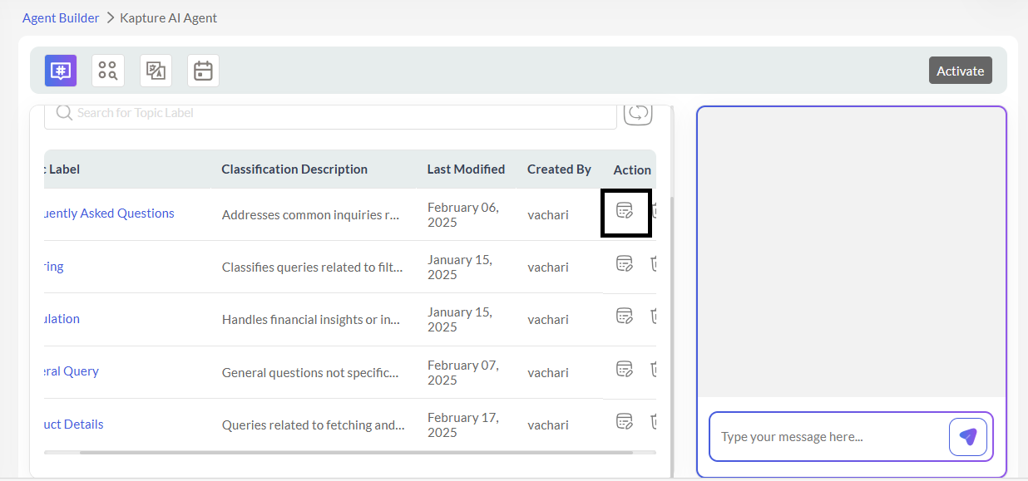

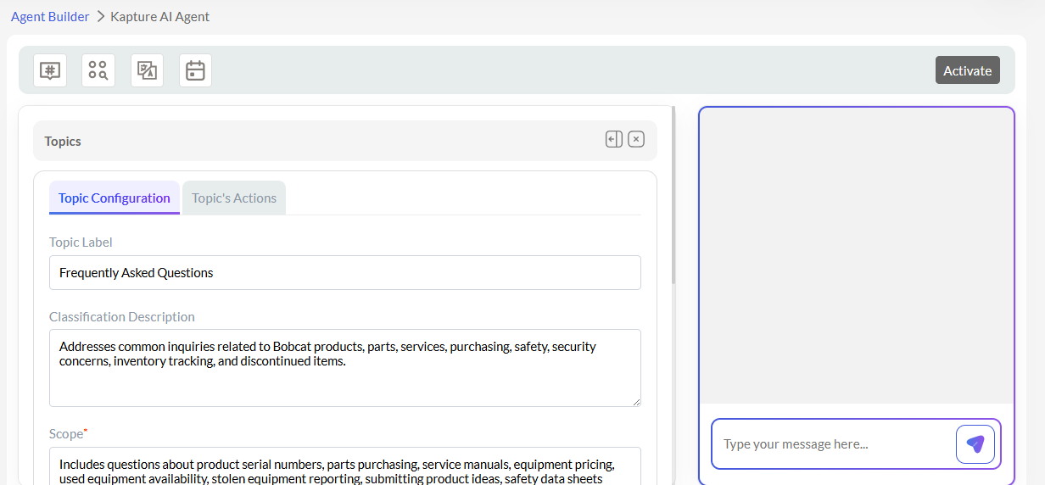
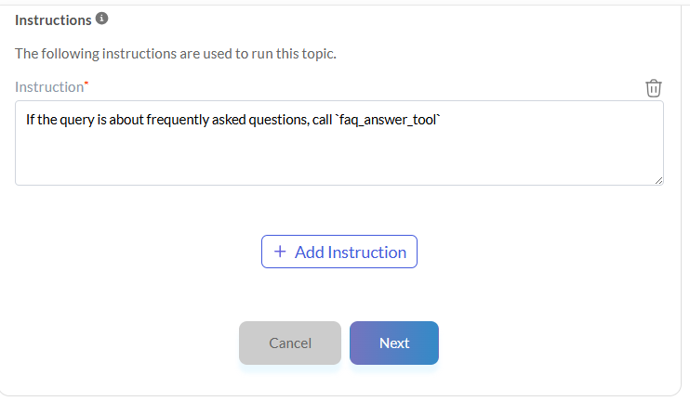

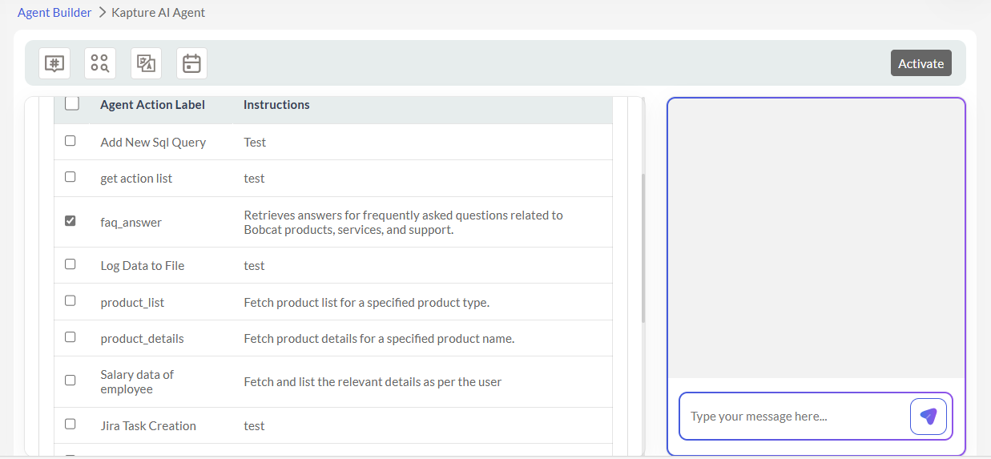


Check the above one Action, and click on Finish, Topic will be updated with Actions Added into it.

