Service Connect (OFB)

Survey Form – Requirement
When a case is being closed, we need to show a feedback form page (public access) to the user to enter feedback for the service provided on the case created by the user.
Place to show:
- In email that is sent to user on case status change (status as “Waiting for closure”) with a new template.
- In Chat window in contact-support page when status is “Waiting for closure”.
asking user to submit one feedback form with a public feedback form page URL and afterwards changing case status to “closed” as per user confirmation.
PUBLIC FEEDBACK FORM PAGE on access will prompt a dialog box if user wants to “CLOSE” or “REOPEN” the case.
Clicked on CLOSE -> FEEDBACK FORM will appear for feedback with user email, device id, case number auto populated.
BASIC FLOW DIAGRAM:

API requirements:
- Whenever there is an email triggered to a user/contact, it should generate an encrypted string mapped to the contact email and case details like case number that should be sent with the feedback form URL to fetch case details for auto-populate.
- An open API to submit a response and update the case status.
- API to get feedback(s) for a logged-in user or to an admin user.
- Filter survey – need to analyze after form fields.
UI Requirements:
- A feedback form page with public access, prompting users to select 'reopen' or 'close'.
- A page/screen to view feedback(s) and filter.
- API integrations.

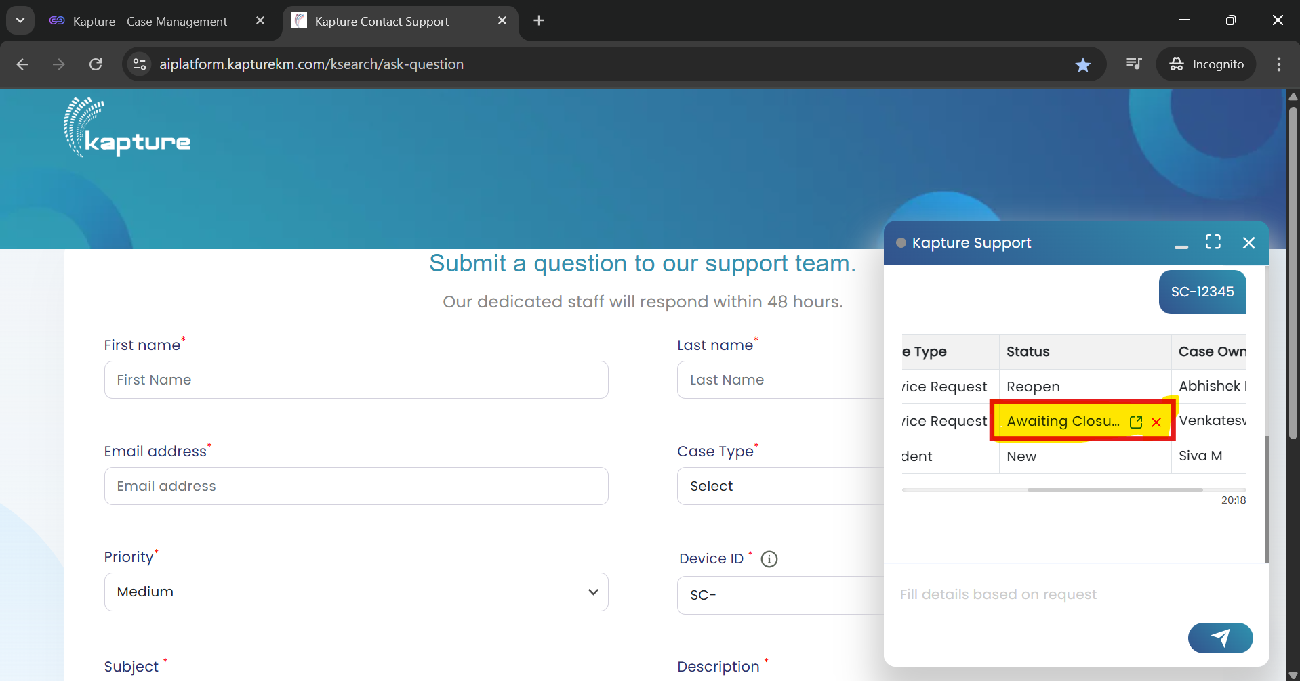
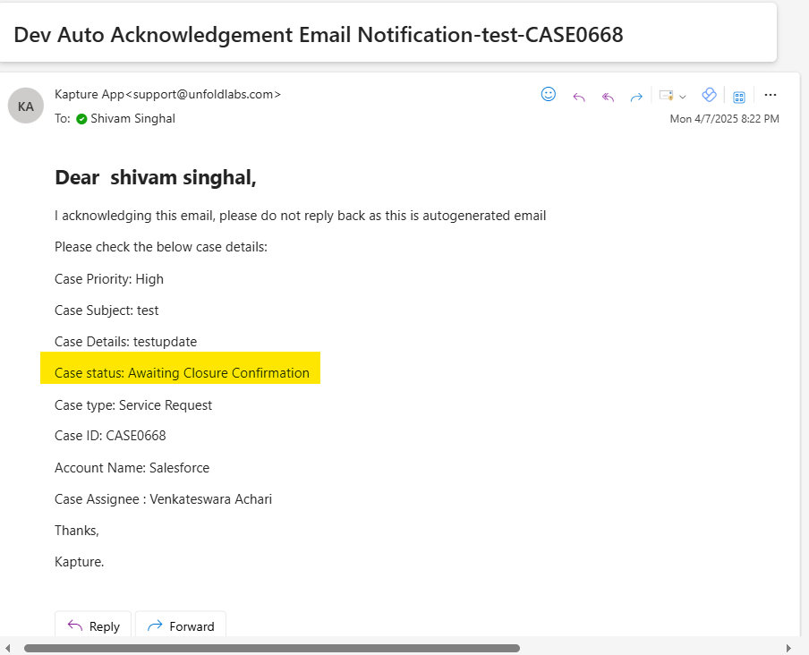

A screen to view feedback(s) in the service connect OFB build after login
To be discussed with UDAY

