Kapture-User Story-77-Enable / Disable Checkout Option at Content/Channel Level


Contents

Introduction 3
Overview 3
Requirements 3

Introduction
This document defines the features to enable & disable Check-out option for an Article in kAuthoring module.

Overview
In kAuthoring module, the articles can be check-out by Authors, and it will not allow others to modify the content until it is checked in.
Enable a check-out and check-in process for articles for specific Content Type. When check in/out is enabled, multiple users can edit records without creating conflicts.

Requirements
Check-Out and Check-in option can be enabled at Configuration section of kAuthoring module. This feature can be enabled for each content Type or Channel type and based on the selection Kapture gives option for Authors to check-out the article.
- At Content Type creation screen, need a new field called Enable/Disable Check-Out option with a Switch button.
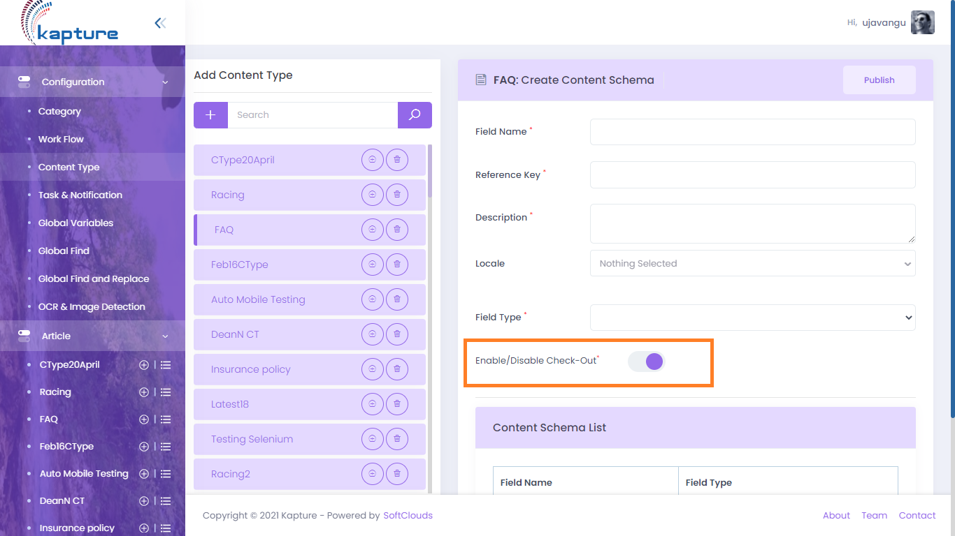
- When an article is Viewed, we can display below action icon if the option is enabled for specific Content Type.
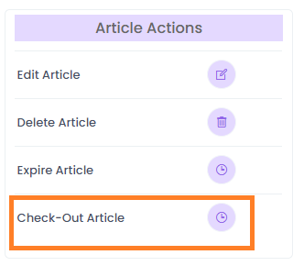
- If the Author selects this option, the document cannot be edit by others and under Check-Out option, we should display the respective User details who checked-out the article.
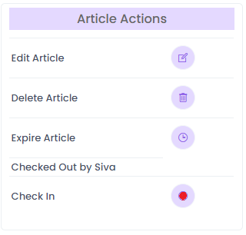
- User can modify the article and check-in after modifications, Check-in option should remove the restrictions on article updates to other users. Upload modified document when user clicks on Check-in action.

