
OKM Upgrade

Design Document

Prepared By: SoftClouds LLC
10-22-2020

Introduction
The purpose of the Design Document is to:
- Provide a visual representation of the process and design of the Oracle Knowledge Management Upgrade.

Version Control
Version | Change Description | Modified By | Date
1.0 | Initial Document | SoftClouds Team | 10/22/2020
2.0 | Updates in the document based on Spirent feedback | SoftClouds Team | 10/23/2020
Reference Documents
Document | Description
Statement of Work (SOW) | Overview of project methodology, scope, and level of effort.
Project Plan | Overall High-level Project Activities
Stone Cobra Operations Manual | Reference guide for day-to-day operations about the Spirent's Oracle Knowledge Installation
CSC Operations Manual | Design document for Customer Support Center (CSC)

Table of Contents
Introduction 1
Version Control 1
1 Project Overview 3
1.1 Project Background 3
1.2 Project Objective 3
1.3 Project Benefits 3
2 High-Level Design 4
2.1 Environments And Platforms 4
3 Project Technical Approach 5
3.1 DEV Environment 5
3.1.1 Platform Upgrade 5
3.1.2 Installation 5
3.1.3 Migrate 6
3.1.4 Recompile 8
3.1.5 Deploy & Test 9
3.2 Prod Environment 11
3.2.1 Platform Upgrade 11
3.2.2 Install 11
3.2.3 Migrate 12
3.2.4 Deploy & Test 12
4 Risks 13
5 APPENDIX 14
5.1 Glossary 14
5.2 Bugs Fixed 14

Project Overview

Project Background
Spirent has the Oracle Knowledge applications running on platforms with Operating systems on Red Hat Linux 6.8 and Database versions 11.2.0.4. These are reaching the End of life support from Red Hat and Oracle, respectively. There is a need to upgrade these platforms to a higher version, as indicated by the Spirent Infrastructure team.

Apart from this, the Oracle Knowledge applications are running on versions 8.6.1. Since the platform upgrade is essential, it would be the best opportunity to plan the applications' upgrade. As a part of this upgrade, we will also achieve both the platform upgrade to the supported versions of the Oracle Knowledge application and the applications by upgrading to the latest point versions and the application patches.

Due to various configurations, customizations to business processes, upgrades need significant regression testing and development to resolve issues. Historically, upgrades have consisted of iterative sets of installation, patches, testing and bug fixes until testing is signed off. SoftClouds will perform the initial Testing with already existing test cases from Spirent.

Project Objective
The project's main objective is the Platform Upgrade and Application layer upgrade. As a part of the upgrade, the SoftClouds team will perform the upgrade for the following components –

- Operating System
- Database system
- Oracle Knowledge Application and its patches
- Oracle Knowledge Analytics
- Java
- Apache Tomcat
- Oracle WebLogic
- Oracle Data Integrator
- Oracle Business Intelligence Enterprise Edition

Project Benefits
The support for Oracle Database version 11.2.0.4 on which Oracle Knowledge application exists ends by the End of December 2020. Also, the Operating system Red Hat Linux 6.8 reached EOL by the end of November 2020. In case of a major failure, Oracle/Red Hat may choose to force an upgrade before providing any support.
This project will upgrade Oracle Database with Operating system and related applications to the latest versions and application patches.

High-Level Design

Environments And Platforms
Spirent current platform consists of Development and Production Environments. Since we are doing a Platform and the application upgrade, SoftClouds has suggested Spirent can perform a parallel upgrade. It doesn't disrupt the existing environments and would give enough time to complete the upgrade without any risks to current environments seamlessly.
The SoftClouds Team will upgrade the Software versions to the following -

Component​ | Current Versions​ | Target Versions​
Operating System | Red Hat Linux 6.8 | Red Hat Linux 7.8
Database System | 11.2.0.4 | 19.0.0.0.ru-2019-07.rur-2019-07.r1(12.2.0.3)
Apache Tomcat | 7.x | 8.5
Oracle Knowledge Application | 8.6.1 | 8.6.5
Oracle Knowledge Analytics | 8.6.1 | 8.6.5
Oracle WebLogic | 12.1.3 | 12.2.1
Oracle Data Integrator | 11.1.1.7 | 12.2.1.3
Oracle Business Intelligence Enterprise Edition | 11.1.1.7.181016 | 12.2.1.3

Project Technical Approach
The SoftClouds team will not make any changes to the existing architecture, and it remains the same. New upgraded servers will replace the current existing servers. The upgrade process includes the installation and application of patches as needed.
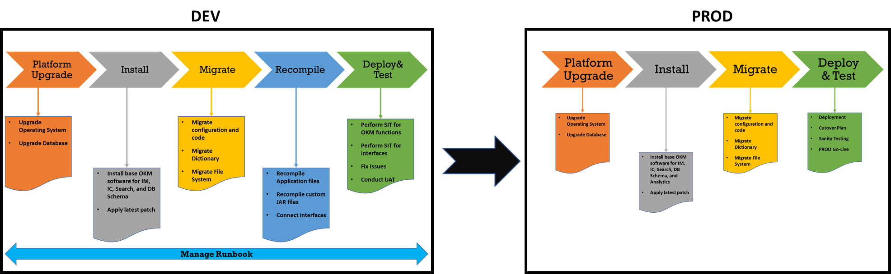

DEV Environment

Platform Upgrade

Application and Database Servers
Spirent IT would be responsible for the provision of the servers along with upgraded Operating System and Database Upgrade. New Linux servers with Red Hat 7.8 will be provided with all necessary packages installed.
For the RDS database upgrade, Spirent would take the snapshot approach and upgrade the database to 12.2.0.3 and provide access to SoftClouds for further application upgrade. The new database would contain all the existing schemas which would be used for InfoManager Installation and Search installation and its patches

Installation

Install Base
The SoftClouds Team would initiate the installation of Oracle Knowledge 8.6 applications and apply subsequent patches up to 8.6.5 in the development environment. The installation also includes any pre-requisites software's that need to be installed. Oracle Knowledge application uses Apache Tomcat as the Application server, and we will upgrade it to Apache Tomcat 8.5.
The Following are the components that will be installed
- Installation of Java
- Installation of Tomcat
- Installation of InfoManager/ InfoCenter
- Installation of Search Indexer
- Installation of Search Work Clients
- Installation of Search runtimes

Apply Patches
As a part of the upgrade process, Oracle Knowledge applications will need to be upgraded to the latest versions. The current version of the patch on the current environment is 8.6.1, which will be upgraded to 8.6.4 à8.6.5 based on the patch set instructions provided by Oracle in each patch set.
Oracle releases point versions as patch sets that need to be applied. Bugs fixed in 8.6.2, 8.6.3 will be covered if we apply the patch 8.6.4. But for applying patch 8.6.5, the pre-requisite is to apply patch 8.6.4. So, we shall be moving from 8.6.1 à8.6.4 à 8.6.5
The bugs fixed in respective patches are listed in Appendix A

Migrate

InfoManager/InfoCenter Configuration
The current configuration of the Oracle Knowledge InfoManager and InfoCenter will be migrated to the new server. No changes in the repository configuration or the batch jobs that are currently running.
The InfoManager Home exists in a separate folder for each environment. As per Oracle's recommendation, we will change it to a common location, but in case of any requirement that we are unaware of as per the existing environment, we shall continue to use the separate location.

Search Configuration
Search Configuration from the current environment can be bundled up into a file and deployed onto a new server. Search includes configuration and Dictionary rules and synonyms, which allows application users to get search results.
The following are the different components of search that will be migrated
- Custom.xml
- Intallation.xml
- Propagation bundle.zip
- Dictionary Manager
- System Manager
- Browser tool
It is recommended that Spirent business users perform Performance Testing on Search Configuration.

Development and Integration Check
After the application of patches, the patches provide the latest deployable application folders such as InfoManager, InfoCenter, iConnect, IMWS. These applications contain fixes for any bugs that were observed in the previous releases.
Spirent current environment contains custom jars deployed in these applications and custom JSP files, which helps customize the applications as per the business needs.
For the application integrations and customizations to work without any disruption, the development team would be working on merging the existing 8.6.1 Oracle Knowledge custom jars and JSP's into the 8.6.5 version. The development team will identify and customize the current code to make it compatible with the latest version.

Merging Custom Code into your environments
Custom code for the SFDC integration and SAML authentication should be deployed again as a JAR. The custom code will have to be recompiled into the new patch version. There are environment-specific properties in the application.properties file. Except for environment-specific variables, the code for development and production will be the same.
We shall be compiling separate environment specific deployable for each application to be deployed into development and production environments.

Propagation Procedures
The typical propagation path in OKM installation is from Development to Production. It allows business users to test the dictionary and configuration changes in Development before it is propagated to the Production environment.
There is a job created in the System Manager application for the respective operation (Propagate to Production). This job is to be run when there aren't any jobs running on the source & target environments.

File System
During the installation and upgrade process, the application requires a file system where any static content is stored. The file system is currently presently on S3 on the AWS environment and is available to the production server as a mount point. Whereas for development, the local file system is being used.
For the development environment, we shall continue to use the new local file system. But the production environment will make the changes to point to Mount point during the Go-live activities.

Recompile

Recompile Application Files
The following process can be followed to upgrade the application files:
- Once the patch has been applied to a new directory, the old and new should be compared to identify the changes caused by the update.
- After identifying the system files which were affected by the upgrade, the custom folders need to be checked to see which of these files are being utilized there.
- Based on the outcome of the last step, the custom files need to be modified to include the new system code.
- The custom application files and jars will have to be moved from the old version to new version.
- The above process should be performed for the following application folders:
- iconnect
- imws
- infocenter
- infomanager
- runtime
- indexer

Recompile Custom JAR Files
The following custom JAR files need to be recompiled post upgrade:
- Applications: /opt/okm/IM/instances/im/appserverim/webapps
- iconnect:
- subscriptiontool.jar
- spirent-wsdl.jar
- spirent-iconnect.jar
- spirent-auth-dev.jar
- spirent-custom-api.jar
- imws:
- spirent-wsdl.jar
- spirent-iconnect.jar
- spirent-auth-dev.jar
- infocenter:
- spirent-wsdl.jar
- spirent-iconnect.jar
- spirent-custom-api.jar
- spirent-auth-dev.jar
- sc-ok-imutils-0.2.jar
- sc-ok-getusergroups.jar
- printfilter.jar
- ebs-integration.jar
- force-wsc-35.2.7.jar
- infomanager:
- spirent-wsdl.jar
- spirent-iconnect.jar
- spirent-auth-dev.jar
- force-wsc-35.2.7.jar
- Runtime: /opt/okm/Search/instances/idxrt1/appserver/webapps/inquiragw
- SFLibCrawler.jar
- SalesForce_SOAP_API.jar
- inquira.jar
- Indexer: /opt/okm/Search/instances/idx/appserver/webapps/inquirawb.war
- SFLibCrawler.jar
- SalesForce_SOAP_API.jar
- inquira.jar

Integration Checkpoints
- The iConnect application code is where the integration of salesforce happens with OKM.
- The following are the APIs which are a part of that integration, which can be seen in CSC:
- Channel Subscriptions
- Get IM Security
- Get Document Detail
- Get Currently Published Documents
- Get Most popular Documents
- Channel Browse
- Search OKM
- Subscribe/Unsubscribe to a channel.

Deploy & Test

Deploying Code Changes
The entire directory can be dropped onto the corresponding server. After the changes have been deployed, the instances must be restarted and updated in the following manner:
- InfoManager instances
  - Restart InfoManager
- Search and Runtime instances
  - Access the ICE prompt for the instance
  - The ICE prompt will display a message that the application has been updated (i.e., the lib folder has new jars in place) and that you must run two scripts to apply the changes
  - Stop the instance
  - Run the first script, buildApp.sh
  - Run the second script, deployApp.sh
  - Start the instance

Testing and Fixes
The SoftClouds team will perform end-to-end testing of the application with Spirent's existing test cases to validate that there is no impact on the daily activities.
Business Team users shall execute UAT on the delivered development environment from the SoftClouds Team.
The development team will fix any issue found during the testing process immediately. Spirent's business users and SoftClouds QA team will verify fixes before deploying into the production environment.
To validate the applications, the Spirent IT team will provide all the necessary test scripts.

Test Strategy
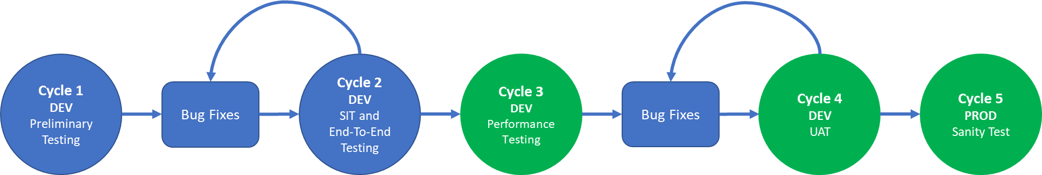
There are multiple test cycles necessary for this project.
- Cycle 1 – First install and preliminary Oracle Test (DEV environment)
- Cycle 2 – End to end integration and SIT Test (DEV environment)
- Cycle 3 – Spirent Business performs Performance Testing on Search Configuration (DEV environment)
- Cycle 4 –Spirent Business users to execute UAT with end to end business validation scenarios. SoftClouds QA team will also perform final validation test. (DEV environment)
- Cycle 5 – Spirent users execute Sanity Testing (Smoke Testing) after new PROD server Upgrade (PROD environment)

Prod Environment

Platform Upgrade
Refer to the section 3.1.1

Install
Refer to the section 3.1.2

Analytics
Oracle Knowledge analytics allows business users to understand the application's usage pattern, enables analysis, and helps with any business decisions. Analytics is set up only in the production environment, and for the new environment, it will be set up in the production environment.
Analytics involves three major components. Refer to the following Analytics Architecture -
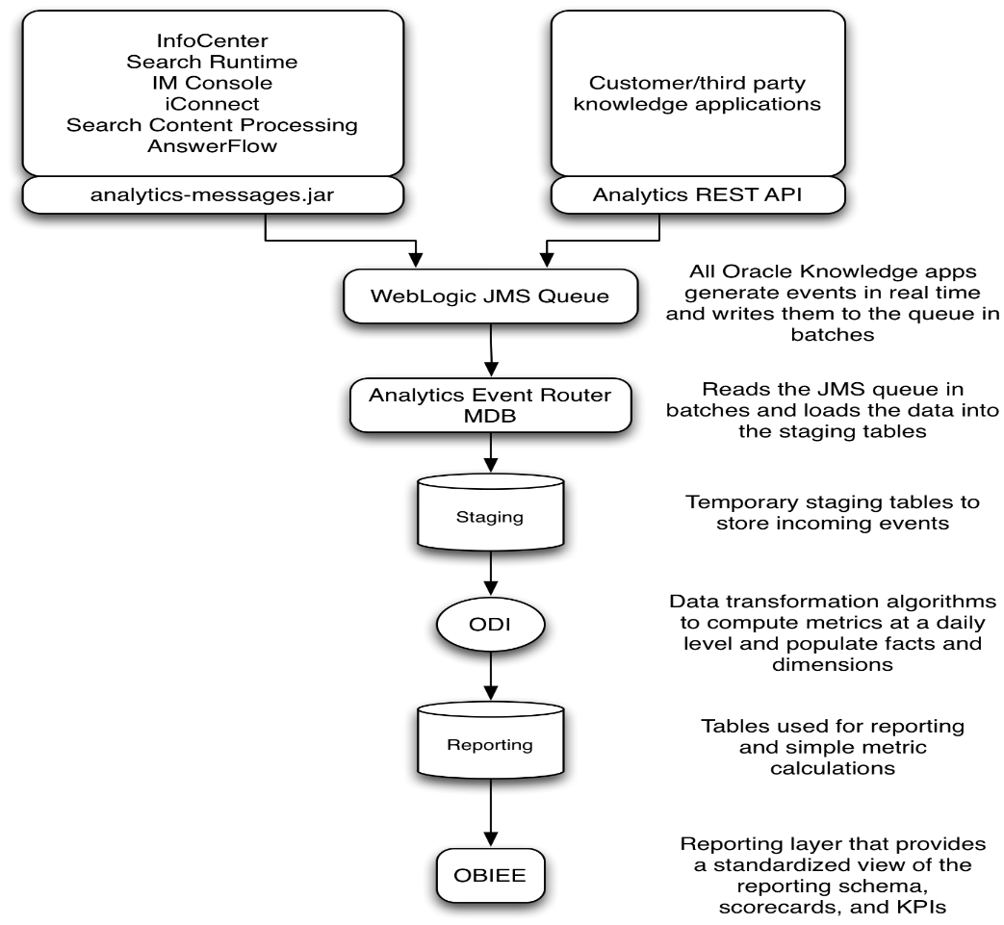
It will be installed on the Oracle WebLogic Server. The Event Router gathers all the transactional data from the InfoManager, InfoCenter, and Search Runtime and stores in the database.

Analytics Event Router
The Oracle Knowledge Analytics JMS Event Router is deployed to a WebLogic Server. Therefore, you must install the WebLogic Server when installing Analytics. The WebLogic version used for installing the event router is 12.1.3. This will be upgraded to 12.2.1. The Event Router comes as a part of Oracle Knowledge installer components.
JMS Queue is a critical component during this set up which gathers all the transactional data from InfoManager, InfoCenter, and Search Runtime and stores in the staging database

Oracle Data Integrator
This tool processes the transactional data into analytical data and stores in the Analytical database. The current version of ODI is 11.1.1.7, which will be upgraded to 12.2.1.3. Installations that generate a large volume of analytic data require installing additional Java agents on additional servers to process the data transformation efficiently. As part of the Analytics installation process, you must install and configure an instance of ODI as a standalone agent and at least one Java agent.

OBIEE
The processed analytical data can be made available to business for all analytical data using Oracle Business Intelligence Enterprise Edition. The current version of OBIEE is 11.1.1.7, which will be upgraded to 12.2.1.3. Oracle Knowledge analytics patch releases a new rpd file as a bundle. The new rpd file will have to be merged with the current existing rpd file. This can be done using the OBIEE Administration tool

Migrate
Refer to the section 3.1.3

Deploy & Test
Refer to the section 3.1.5

Cut Over Planning
The SoftClouds and Spirent IT teams will plan the cutover activities, and any required changes on the network side for Dev Environment Readiness and Production Go live.
List of Activities:
- Ensure all development activities are deployed to a new environment
- Endpoints of webserver/load balancer will be pointed to new environment Servers
- Shut down legacy servers
- Take Backup/snapshots of application and database environments as needed
- Prepare a backup strategy to revert to the previous environment.
- Schedule the indexing and batch jobs

Risks
Design is based upon the Operations Manual (Stone Cobra, & CSC) and any analysis completed. Anything not included in the Operations Manual may have a design impact as we go forward.

APPENDIX

Glossary
Term | Description
OKM | Oracle Knowledge Management
SFDC | Sales Force Dot Com
SAML | Security Assertion Markup Language
ICE | Integrated Common Environment
JAR | Java Archive
OBIEE | Oracle Business Intelligence Enterprise Edition
ODI | Oracle Data Integrator

Bugs Fixed

Patch 8.6.5
- Bug 31796062 - Security vulnerability fixes and tech upgrades

Patch 8.6.4
InfoManager:
- 27439047 - InfoManager loading LOGOUT_URL on SSO authentication error on 8.6.1
- 28708839 - CVE-2017-14735: ANTISAMY UPGRADE TO 1.5.7 OR LATER
- 26190610 - CVE-2007-2353,CVE-2012-5784,CVE-2014-3596,CVE-2019-0227:Upgrade Axis to Axis 2
- 30189361 - Translate - Copy all from Source is updating live content
- 29791526 - CVE-2019-11358: JQUERY UPGRADE TO 3.4.1 OR LATER
- 30177416 - WebSphere upgrade to 9 or 8.5.5 to support Java 8
- 30177433 - IBM jdk 8 support
- 26266090 - CVE-2013-4002 apache-xerces : xercesImpl : 2.7.1 in OK 8.6.1
- 26190818 - CVE-2013-5960 org.owasp.esapi : esapi : 2.0.1 in OK 8.6.1
- 29318650 - CVE-2018-17197: APACHE TIKA UPGRADE TO 1.22 OR LATER
Search:
- 28368371 - JQUERY UPGRADE TO 3.4.1 OR LATER
- 30659014 - Upgrade Axis to Axis 2 version 1.7.9
- 26266090 - CVE-2013-4002 apache-xerces : xercesImpl : 2.7.1 in OK 8.6.1
- 26190818 - CVE-2013-5960 org.owasp.esapi : esapi : 2.0.1 in OK 8.6.1

Patch 8.6.3
InfoManager/InfoCenter:
- 27153852 - IM "Compare Versions" page uses browser default font/size, not from IM CSS
- 27089982 - Upgrade java to 1.8 in IM in 8.6.3
- 27008914 - CREATEDATE column is set to NULL when a doc is reverted to a previous version
- 26954881 - Generate Client Library jars from 1.5 to 1.8 java version.
- 26913431 - SQL Server 2016 certification for InfoManager
- 26913419 - Upgrade WebLogic 12c and java 8 for InfoManager
- 26913381 - Upgrade tomcat to 8.5 and java 8 for InfoManager
- 26878772 - Localization wipes out title from schemaattributeresoure table
- 26867320 - Upgrade ckfinder to version 2.6.2.1
- 28669493 - Upgrade ckeditor to version 4.10.1
- 26792755 - InfoManager is not encoding diacritic characters after 861 patches
- 26738166 - Workflow Progress Notifications are sent ONLY when IM doc is self-approved
- 26668386 - Re translate after revert does not work
- 26633580 - Adding 1200 user roles causing InfoManager to perform slowly
- 26331084 - First time console user not created correctly after patch 8.6.1
- 25987528 - Bulk update process queued shows 0 count when has not started yet
- 25692681 - Unusual behavior of Clear Check Out privilege
- 25321307 - Value of SKIP_CSRF_VALIDATION not picked from repository config.properties
- 25309682 - Bug 25264657 - Attachments not getting Saved in IM. Backport to 8.6.2
- 24794106 - Few components of the CK Editor are not working in Edge browser
- 24716473 - Not able to see Delete user option for Default Admin Role in 8.6
- 24612879 - Modified date is getting updated without saving the article and sort in IM
- 24516431 - Users with view only security role can request translations and bulk update
- 27653191 - Configure LDAP Connection Timeout for IM and IC
- 26025034 - Error Deploying when patching IMWS only instance to 8.6.1
- 27715662 - Bug 27669229 - lucene search error GFR BooleanQuery$TooManyClauses fix in 8.6.3
- 28130489 - Cookies wosid/woinst Do Not Contain "HTTPOnly" Attribute
- 28286212 - JSESSIONID/wosid/woinst cookies do not contain "secure" attribute

Search:
- 23643976 - Outside in Technology/stellent 8.5.3 upgrade
- 25780803 - PDF is failing to be prepped due to large number of open temp files
- 24692179 - PDF files with large graphics fail Prep and leave large files in /tmp
- 24692162 - *.opt file is left in Home/user dir in linux
- 26781436 - Config values in #.xml is getting auto-set for Protected WebCrawler
- 27106946 - Upgrade Ant to 1.10.1 for Search
- 27106923 - Upgrade Java to 1.8 for Search
- 27123155 - Derby upgrade for tomcat
- 24698081 - Search Analysis - incorrect locale was sent from search
- 25758808 - Workclient Issue - Failing Job at Content Update due to Concurrent Modification Error
- 26913502 - Upgrade tomcat to 8.5 for Search
- 26913509 - Upgrade WebLogic 12c for Search

iConnect:
- 26923626 - Successful Custom IM Rating Returns IC User To Home Page
- 26918776 - Certify iConnect on Tomcat 8.5
- 26918784 - Certify WebApps on Tomcat 8.5
- 26918803 - Certify iConnect on WebLogic 12.2.1.3
- 26918807 - Certify WebApps on WebLogic 12.2.1.3
- 26918825 - Certify iConnect with Java 1.8u144
- 26918837 - Certify WebApps with Java 1.8u144
- 26918851 - Certify iConnect with MSSQL Server 2016 SP1
- 26918879 - Certify WebApps with MSSQL Server 2016 SP1
- 26427372 - Author can rate his own document
- 26883596 - How to display more than 10 user groups on article page
- 24794106 - Few components of the CK Editor are not working in Edge browser
- 26867336 - Upgrade ckfinder to version 2.6.2.1 in WebApps
- 26867330 - Upgrade ckfinder to version 2.6.2.1 in iConnect
- 28669518 - Upgrade ckeditor to version 4.10.1
- 25911579 - Recommend as Solution is not working
- 26246310 - Provide a way to disable the X-Frame-Options
- 24492102 - When either 'First Name' or 'Last Name' of user contains '&' char , search fails
- 25952107 - Recommend as Solution wrong warning message
- 25104233 - Error Page not being displayed on URL injection
- 27101503 - Upgrade Ant to version 1.10.1 with WebApps
- 27101509 - Upgrade Ant to version 1.10.1 with iConnect
- 27247073 - Issue with manage content recommendations in IM
- 26166492 - provide a signed version (strong name) of the latest IQServiceClie
- 24654000 - OOTB http req parameter 'url' accepting rogue URL change
- 20889003 - Mandatory fields ignored when creating draft content
- 25081950 - Contribute content not putting secure attachments in secure folder
- 26161743 - Article's action section is not open in the english UI
- 24575484 - Rating text message through Client Library API
- 24435160 - Support for innovation packs 2015/2016 and ootb iconnect for Siebel
- 27653191 - Configure LDAP Connection Timeout for IM and IC
- 25161845 - Linked answers are not displayed on clicking expand in results on edge browser
- 13675104 - CONTENT RECOMMENDATION GETS SUBMITTED AS "GUEST USER" IF SESSION HAS TIMED OUT
- 26587997 - Guest User can rate Internal Articles

Patch 8.6.2
- 26224129 - CVE-2016-1000031,CVE-2016-3092 commons-fileupload:commons-fileupload:1.3.1
- 26190476 - CVE-2015-1832 org.apache.derby : derby : 10.2.2.0 in OK 8.6.1
- 26186985 - CVE-2016-2141 org.jgroups : jgroups : 3.6.6.Final in OK 8.6.1
- 26186830 - CVE-2014-0114 commons-beanutils : commons-beanutils : 1.8.0-BETA in OK 8.6.
- 25892701 - xxstream-1.4.3.jar file vulnerabilities in 8.5.1.5
- 26387936 - Upgrade of xalan to 2.7.2
- 26187041 - CVE-2015-0254 taglibs : standard : 1.0 upgrade to 1.2.3
- 26186802 - CVE-2013-7285 & CVE-2016-3674 com.thoughtworks.xstream : xstream : 1.4.3
- 26186947 - sonatype-2008- 0013, sonatype-2007-0013 org.apache.derby :derby :10.2.2.0

- This patch addresses security issues in Search
- 26266059 - CVE-2015-1832 org.apache.derby : Derby jars upgrade to 10.12.1.1 in Search
- 26266037 - CVE-2016-1000031,CVE-2016-3092 commons-fileupload jar upgrade to 1.3.2 in search
- 26266126 - CVE-2014-0114 commons-beanutils jar upgrade to 1.9.2 in Search
- 26389069 - issue in the xalan-2.7.0.jar in 8.5.1.5 – search, upgraded to 2.7.2

