Kapture-User Story-108- kAdmin – CMS Roles and privileges



Contents

Introduction 3
Overview 3
Requirements 3
Content Types – Privileges 4
Specifying Workflow Step Privileges 5

Introduction
This document defines the feature of enhancing the Kapture CMS roles and privileges at Content Type level and Workflow based.

Overview
In the current system, we have a mechanism of creating the roles and privileges at whole system, now with this user story we are introducing the strict restrictions to the Content and Privilege at Content Type & Workflow level.

Requirements

In kAdministration module, under kAuthoring Administration we have provided list of privileges for different areas of Content and their visibility while accessing by User in kAuthoring module. Existing Add CMS Role API’s to be modified.
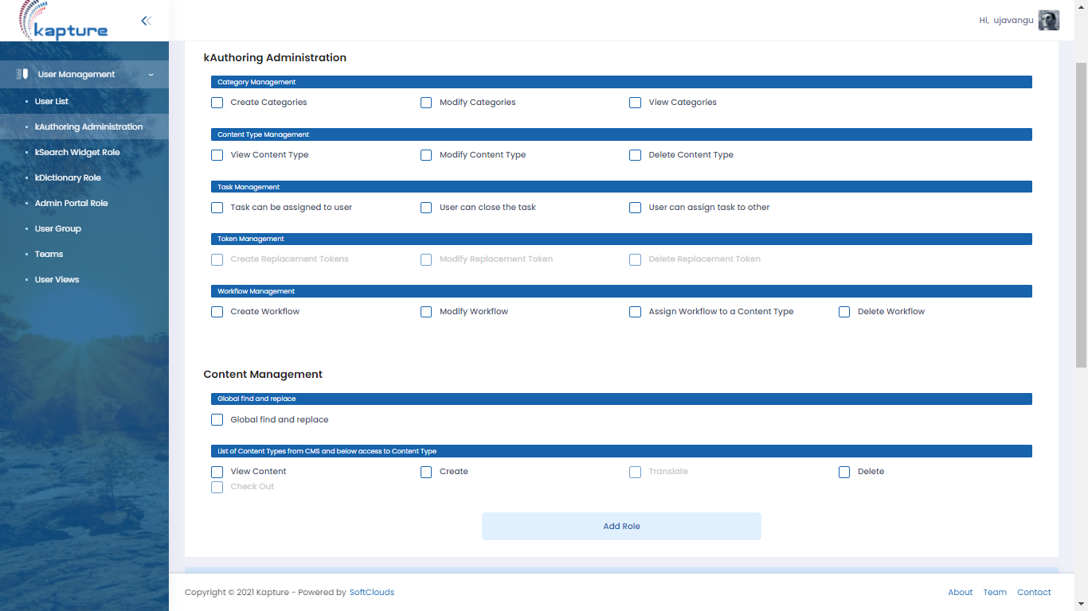

Now under Content Management Section, we are introducing two additional options to assign the privilege
- Content Types – Privileges
- Specifying Workflow Step Privileges

Content Types – Privileges
For creating a different security roles, called Author, Reviewer & Publisher that provides permissions to view and manage tasks, view, modify, and manage the articles in a particular content type, and approve the Author step in the Publish workflow.
To achieve this, we should display all existing Content Types available in kAuthoring module with set of privileges shown below.
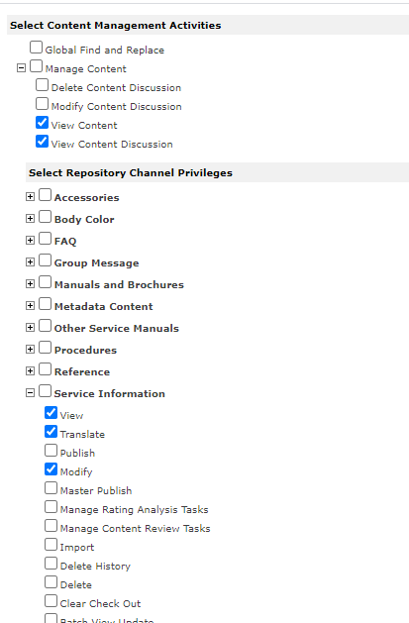

Specifying Workflow Step Privileges
The workflow approval steps section lists each of workflows exists within the kAuthoring module that has defined workflow steps. You can assign each step to one or more security roles. If the user is authorized to perform the workflow step for the selected Content Type.
