Kapture Multilingual Support


Contents
Introduction 3
Overview 3
Requirements 3
Multilingual functionality 3
Identifying the languages to support 3
Internationalization & Localization 4
Setup Translations: 4
Content Translations: 5

Introduction
This document details the feature of making Kapture as Multilingual Support for all the Kapture modules / applications.

Overview
To apply Translations for Kapture application localization w.r.t Content and UI Labels in across modules.

Requirements

Multilingual functionality
To enable translation features, below steps to be analysed for following multilingual capabilities:
- Identifying the languages to support
- Localization of Content
- Support languages that require Unicode characters, such as Japanese
- Identify when users might need language translation at Content level and UI level.

Identifying the languages to support

Supported Locale | Locale Code
English - Australia | en-AU
English - Great Britain | en-GB
English - India | en-IN
English - Ireland | en-IE
English - United States | en-US
Finnish - Finland | fi-FI
French - Belgium | fr-BE
French - Canada | fr-CA
French - France | fr-FR
Czech - Czech Republic | cs-CZ
Danish - Denmark | da-DK
Dutch - Netherlands | nl-NL
Dutch - Belgium | nl-BE
German - Germany | de-DE
German - Austria | de-AT
Hungarian - Hungary | hu-HU
Italian - Italy | it-IT
Japanese - Japan | ja-JP
Korean - Korea | ko-KO
Norwegian - Bokmål Norway | no-NO
Polish - Poland | pl-PL
Portuguese - Brazil | pt-BR
Portuguese - Portugal | pt-PT
Romanian - Romania | ro-RO
Russian - Russia | ru-RU
Spanish - Spain | es-ES
Swedish - Sweden | sv-SE
Turkish - Turkey | tr-TR
Ukrainian - Ukraine | uk-UA

Internationalization & Localization
Using i18N, we can add ability to localize the Kapture application. Using specific “locale”, application can feature with specific language.

Setup Translations:
To make Kapture as a multi-lingual application, the first step is to implement to make use of locale field for all the UI labels.
- Setting up I18N
- Adding support for multiple languages
- Storing Language Files and using translations
- Datetime localization
- Switching the locale
Identify all UI labels from entire application, create language files with translations and enable locale property for the fields on UI.
Providing a list of languages that user profile had with, keep a provision to change the locale for localizing the application.
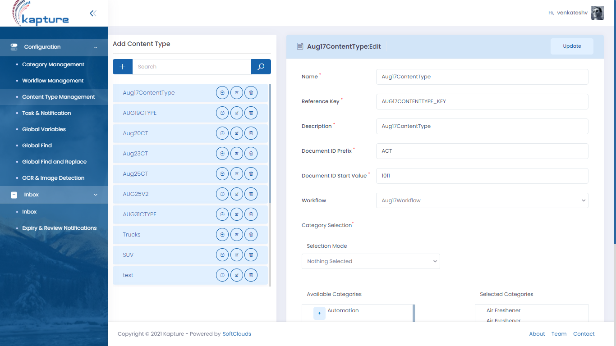
Locale
English US

Content Translations:
Based on User Profile – Default locale, the below areas will be updated accordingly.
- Content Schema Creation
- Categories Translation
Content Schema Creation:
For Content schema localization – We can store data in below two different formats.
- Row localization – Adding each row for specific locale. (Locale, Fieldname)
- Field localization – Adding each column for each locale (FieldName_locale)
Categories Translation:
User profile with his associated locale, the translations can be updated, and REFERENCE_KEY remains same for all locales.
- Categories
- Categories Translations
Workflow Translation:
Workflow step names will be translated to user profile specific locale. And reference keys would remain same as it includes in validation process of publishing articles.

