Defining Work Team Sub-teams & Views in kAdmin



Contents
Introduction 3
Overview 3
Requirements 3
Defining Work Team Sub-teams 3
Managing Work Team Members 4
Find Users Page 4
Creating Repository Views 5

Introduction
This document details the Work Teams, Sub Teams and Views creation in Kapture Administration module.

Overview
Each Content Type had a visibility and managed by different users. This is controlled by assigning User View and Work teams.

Requirements

Defining Work Team Sub-teams
You can define work team sub-teams to further refine task assignment and reporting by teams within your organization. Work team sub-teams are branches that you can define as children of an existing work teams to sort users within the team. You can assign users and content channels to any branch of a work team; any branches below the assigned team will also be assigned.
To define work team sub-teams:
- Select List under Work Teams:
The Management Console displays the Team Management page
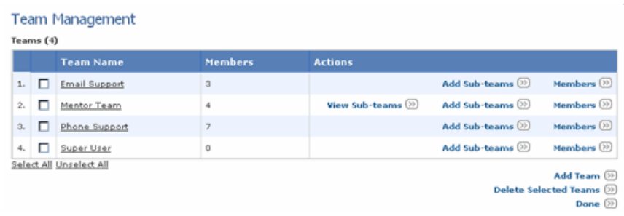
- Select the check box for the teams to which you want to add sub-teams, then select the Add Subteams option:
The Management Console displays the Add Team page:
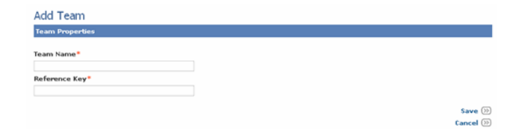
- Specify the properties for the sub-group, or branch as follows:
Team Name :
Reference key :

Managing Work Team Members
The Team Members page lists team members for the current work team. Use the Team Members page to view details for a team member, edit member user properties, add team members, or remove members from a team.
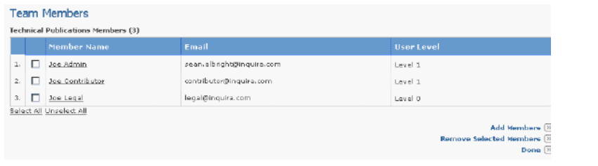
To view or edit properties for a team member:
- Click on the member’s name in the list
  - This should navigate to User Profile View (Non edited mode)
To add members to a team:
- Select the Add Members option
- When Add Members option selected, navigate to “Find Users” Page, from where you can locate the users to add to the team.

Find Users Page
You can locate individual users or groups of users by name and user ID using the Find option.
To locate users
Enter required information to find the users as below:
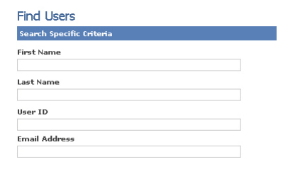
To remove members from a team:
• Select the members to remove using the checkbox next to their names
• Select the Remove Selected Members option and confirm the deletion at the prompt.

Creating Repository Views
Repository View Properties page:
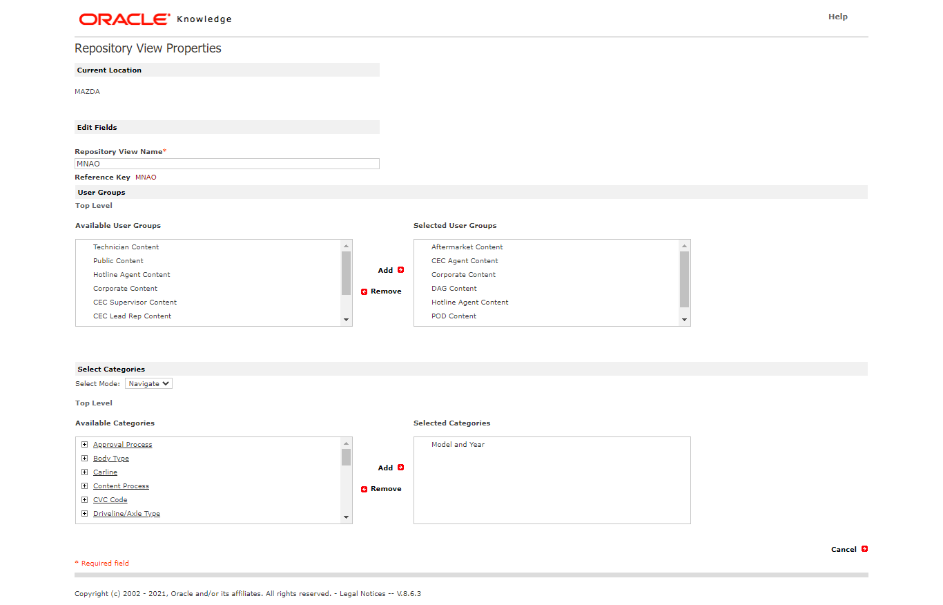
Specify the following repository view properties as show in the figure.

