Kapture-User Story-27- Review an article as a Reviewer


Contents

Introduction 3
Overview 3
Requirements 3

Introduction
This document defines the article review process in Kapture.

Overview
A user with reviewer privilege, can review an article that is available in his/her list.
A Reviewer can accept the content as it is, edit the article.
Add comments to the workflow, approve/reject the Article for next steps.

Requirements
When an article is submitted for review, an email notification will be sent to the reviewer who had privilege on the specific Content Types.
Under kAuthoring module, when an article is being reviewed there should be a provision for user to add comments and perform actions on the content.
- Reviewer can add comments before reviewing the article.
- Either Reviewer can add just comments.
- Show history of past comments.
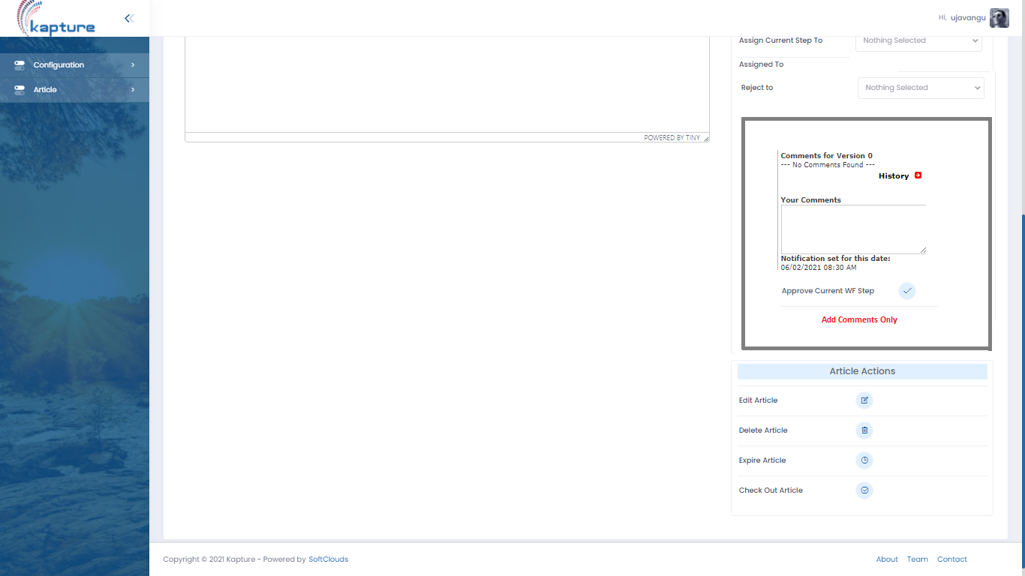
If user selects, “History”
Date | User | Ver | Action | Workflow | Comments
05/28/2021 08:30 AM | Westley | 0.1 | Created | Draft |  | View

