Kapture-User Story-25-Compare Versions of Articles


Contents

Introduction 3
Overview 3
Requirements 3

Introduction
This document defines the feature of Comparing the current version of article with older version of article.

Overview
Author can view article differences by comparing with older versions. When a specific version is chosen, that article should display the differences made between the versions.
The changes should display the difference in highlighted. For ex: any content deletion should be displayed as strikethrough text, any content additions, updates should be displayed in different colors.

Requirements
In Kapture, the advanced diffing mechanism should be included to highlight the exact changes made to an article with visual representation of the content that was added and removed in a specific version.

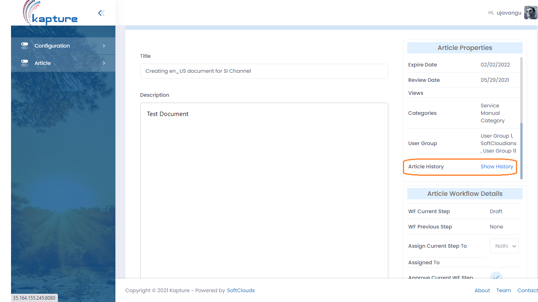

“Show History” Link should display audit of the article in a table with all the older version of the current article. To find out who made the changes and what changes were made.

Date | User | Version | Comments | Action
06/14/2021 20:00:45 | ujavangu | 0.3 | Test comments | Compare
06/14/2021 17:00:00 | ujavangu | 0.2 | Test | Compare

To display the differences, we can display a panel side by side and showcase the difference between the versions selected.

Left Side : Version dropdown (0.3) - View Right Side : Newer Version (1.0) - View
Content || Metadata

Add a toggle button to display the differences.

