Attachments-kauthoring


Contents
Introduction 3
Overview 3
Requirements 3

Introduction
This document defines the attachment features in editor as well as attribute level.

Overview
The document can have multiple file attachments of type pptx, xlsx, docx, mp3, mp4, pdf, jpeg, png. Also, Editor should be having the options to upload images and videos.

Requirements
Below are the modules within authoring.
- Attachments at Attribute Level:
  - Create an attribute named “Attachment” of type “File”.
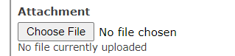

  - Click on Choose File and upload the file. Below attachments types should be allowed:
pptx, xlsx, docx, mp3, mp4, pdf, jpeg, png.

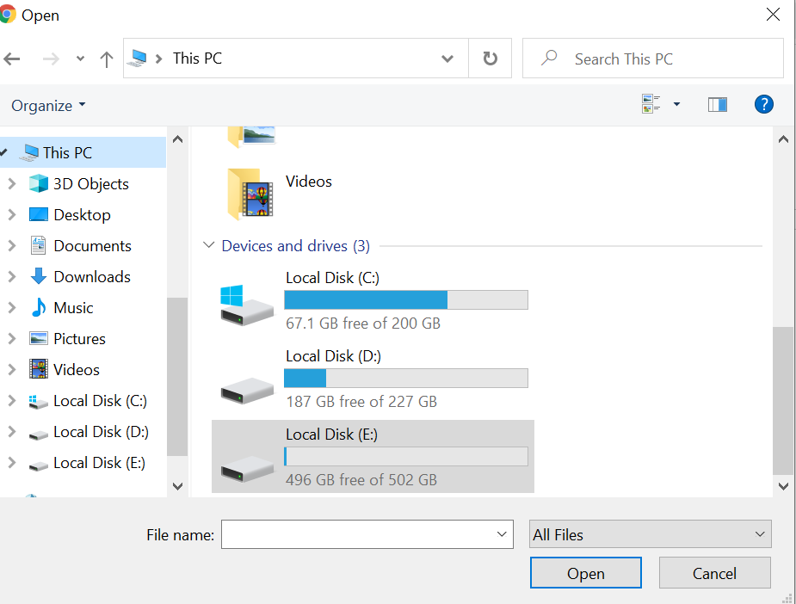

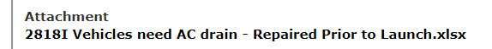

- Attachment at Editor level:
  - The Editor should have the ability to provide options to Insert Images, videos, Links.

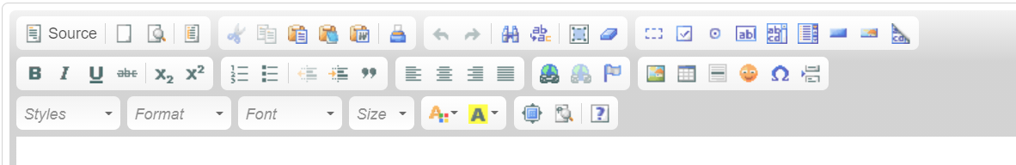

Insert Image
Insert Video
Insert Link

  - Click on Insert Video would allow to attach mp4 files to the attribute :

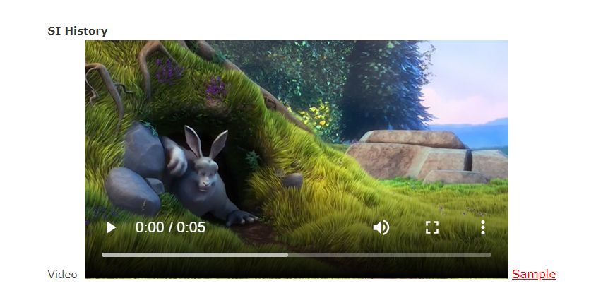

  - Click on Insert Image should give below options:

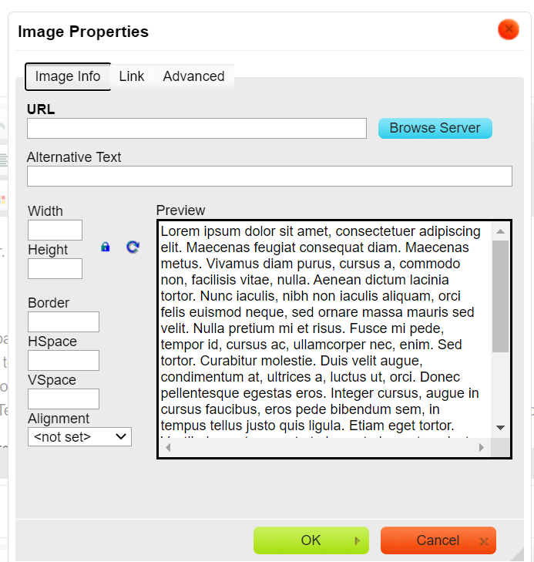

  - Click on Insert Url allows to add url to the attribute:

