Kapture-User Story-38 -Copying Existing Article


Contents

Introduction 3
Overview 3
Requirements 3

Introduction
This document defines the features of making a copy of existing article to do adjustments and having a backup of article.

Overview
Documents can be copied / duplicated by Authors and can be adjusted later with attachments etc.,

Requirements
The Copy/Save as new feature in Kapture gives Authors to re-create the same article with new document id and that can be adjusted based on their requirement.
- When user Edits the Article Actions – We should introduce new action – “Save as New” action that will re-create the article with new document ID.
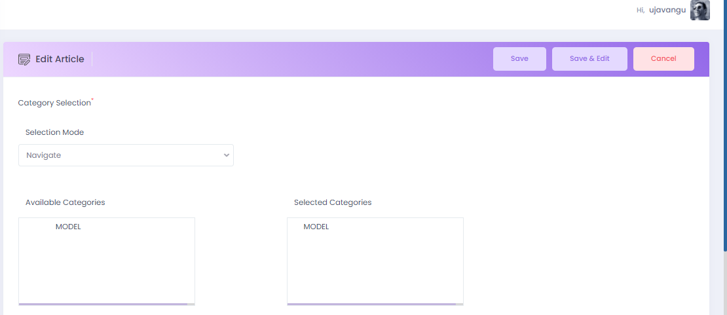
Save As New
- Article will be created with EDIT mode; user can make required adjustments (Category changes, adding attachments etc.,) and save the article.
- If the Content Type of the article had any workflow, it has to process the flow and publish the article.
- Created article should be searchable in kSearch.

