Conditional Section


Contents
Introduction 3
Overview 3
Requirements 3

Introduction
This document details the Conditional Section in Kapture CMS.

Overview
There are two ways we can define conditional section to an article. Conditional section to the entire document or to the attributes level. This will ensure the data is secured and who so ever is assigned the user group will only be able to access the content or the sections within the content while doing the search.

Requirements
Below are the modules within authoring.
- User Group
  - Create/Add User Groups in kadmin
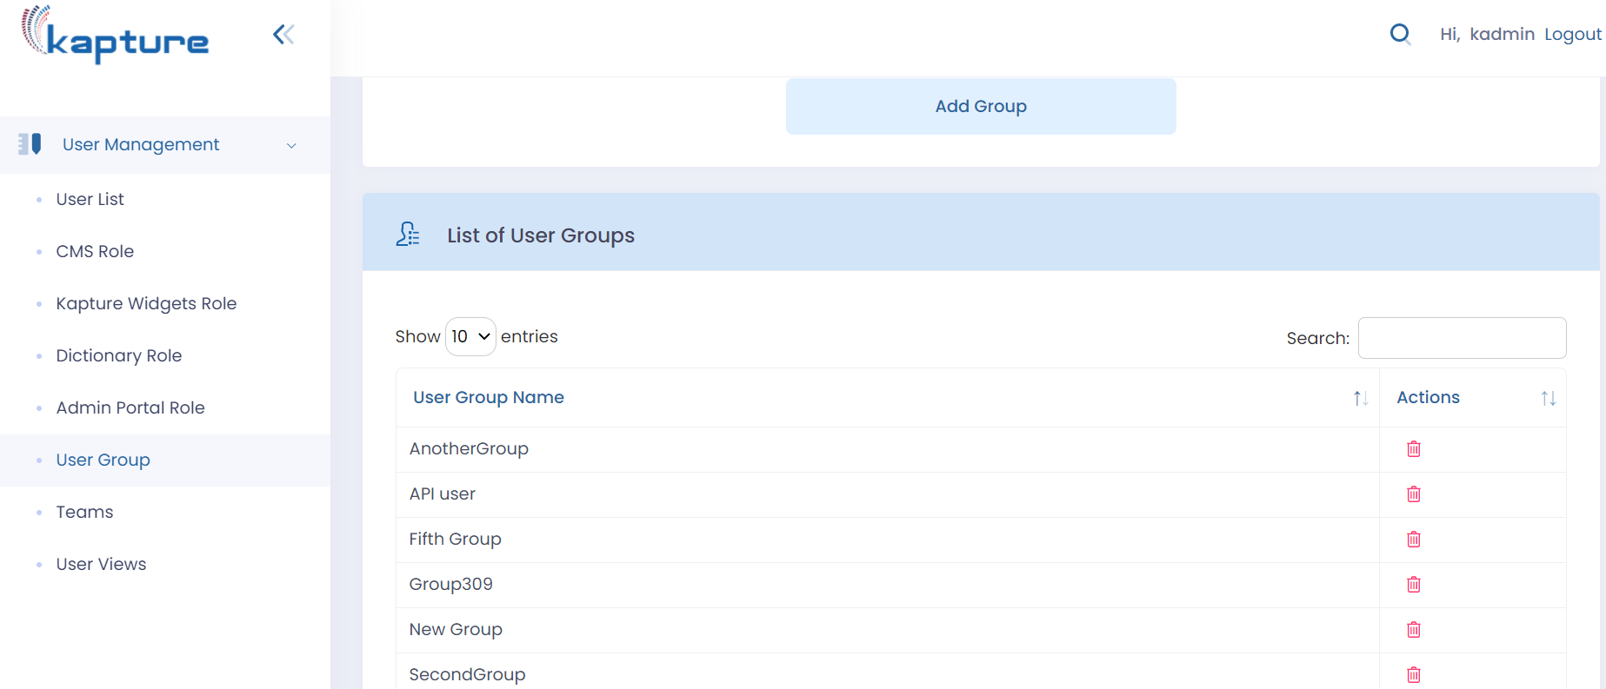
  - Add User Group to the content type. This will ensure that the entire content would be available to the end users based on the user group assigned to their user profile.
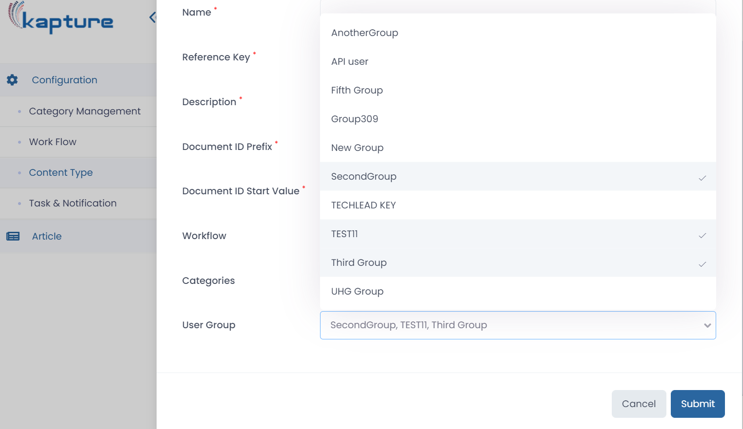

  - Define the Insert conditional section option within the editor.

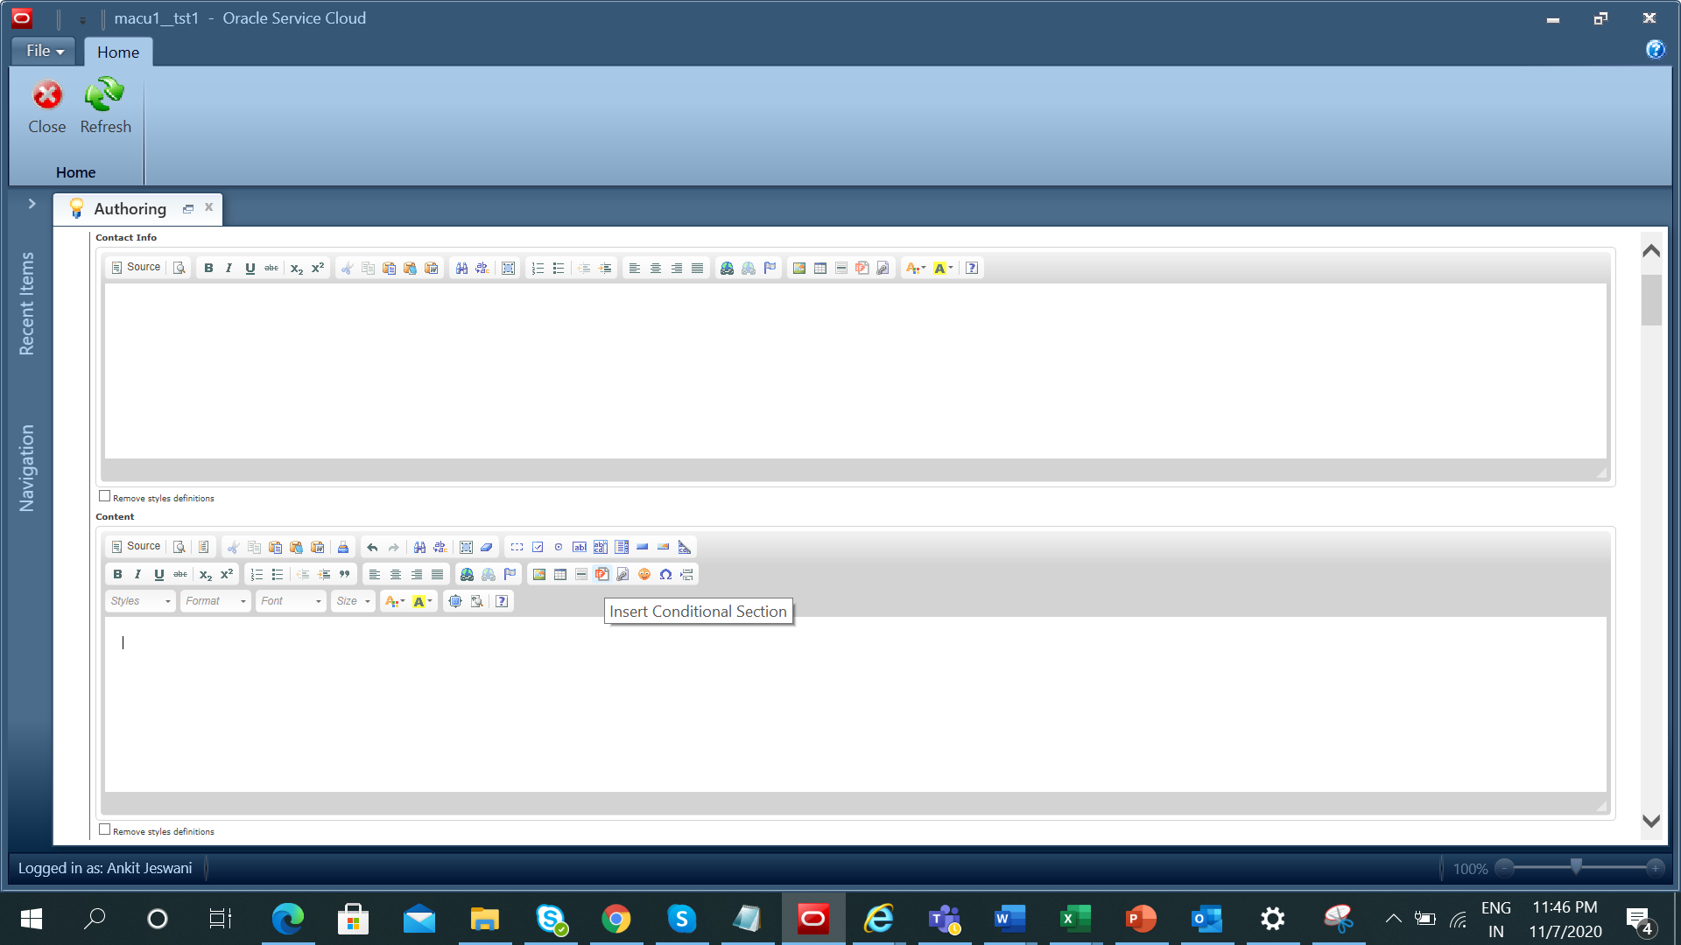

  - When we click on “Insert Conditional Sectional” it will display the list of usergroups assigned to the content type.
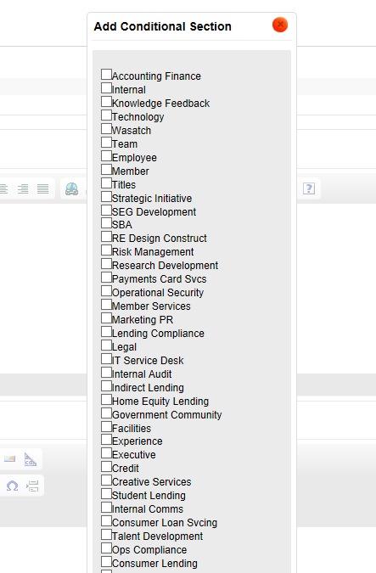
  - We can select multiple conditional sections within the specific attribute. The user with specific usergroup would be able to access the specific information within the attribute. Below there are two conditional sections assigned to the attribute called Content. The information in the Internal section would be accessed by the user with Internal Usergroup and the information in the Employee section would be accessed by the user with Employee Usergroup. This feature would ensure that the data is secured and is available to the limited audience.

