Automated Expiring Article & Review Notification


Contents
Introduction 3
Overview 3
Requirements 3

Introduction
This document details the auto expiration of Articles & Review date in Kapture CMS.

Overview
Every Content Type had a Review Date & Expiration Date while creating articles. The article fields should be validated by specific given time as per the Job properties defined for a Content Type.

Requirements
Automated Expiring Article & Review Date Notification (API's & Email notification)
- Article Expiry Date: On the specified date article will be expired.
- Article Review Date: On the specified date article review notification will be send to article owner (email).
Kapture Jobs: Tab - Display the list of Jobs available in the System:
List of Jobs:
- Expiration Articles
- Content Review Articles
Expiration Articles
For both the jobs – add few parameters to specify the no. of days prior to send email notification before the Expiration / Review date approaches.
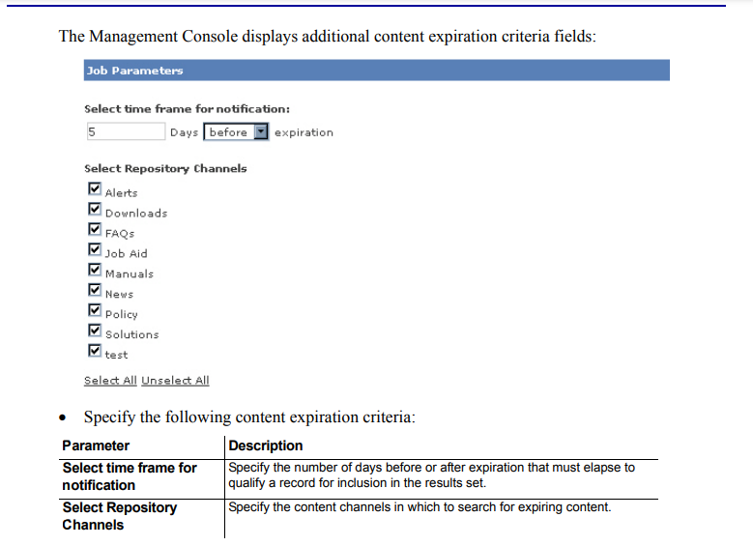
List of Content Types
On Expiry date lapsed, the article will not be searchable in kSearch.
Content Review Articles
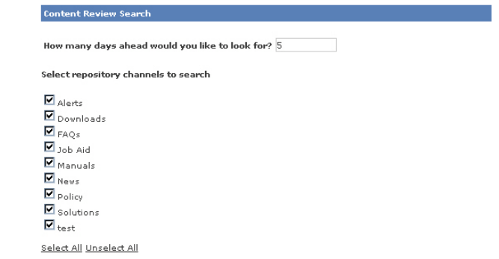
List of Content Types
