Epics and User stories

Kapture Salesforce App Exchange Product

Epic 1: Setup and Configuration inside Salesforce Org
Objective: Enable Admins to Set Up Kapture within Salesforce

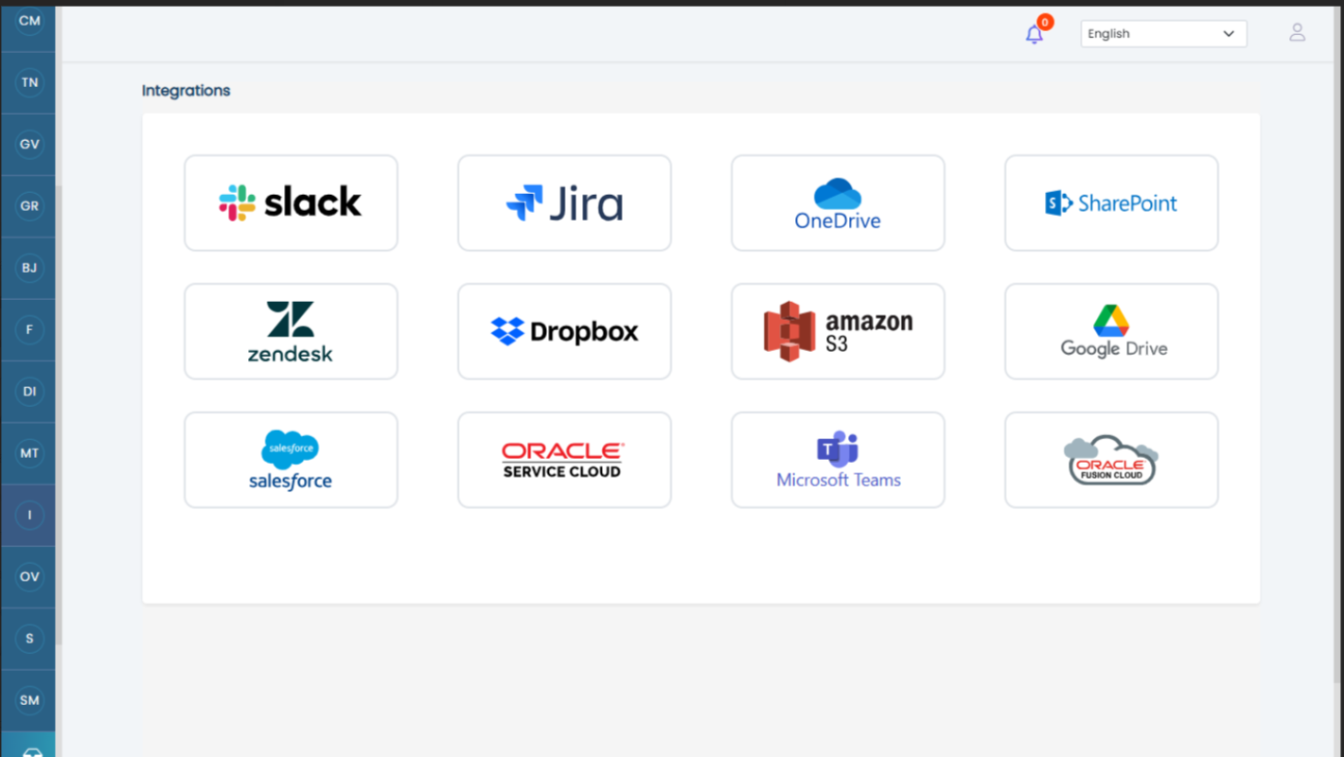

User Story 1: Admin Login and Setup Access
Description: As an admin, I need to log in to Salesforce and access the Kapture setup page so that I can configure the app for my organization. These details will be stored in custom object ( table)
Acceptance Criteria:
- Login Access: Admin users can log in using their Salesforce credentials securely.
  - Authentication may leverages Salesforce’s Single Sign-On (SSO) or OAuth or could be directly via UI. -- please refer to user story 4 under epic 4
- Navigation: The Kapture setup page is accessible via the Salesforce App Launcher.
  - The setup page is labeled as “Kapture Configuration” and is visible to specific profile , will be defined in security settings.
- Creating a custom object for storing all the settings related data in salesforce object.
- Page Availability:
  - The setup page is designed with Salesforce Lightning UI standards.
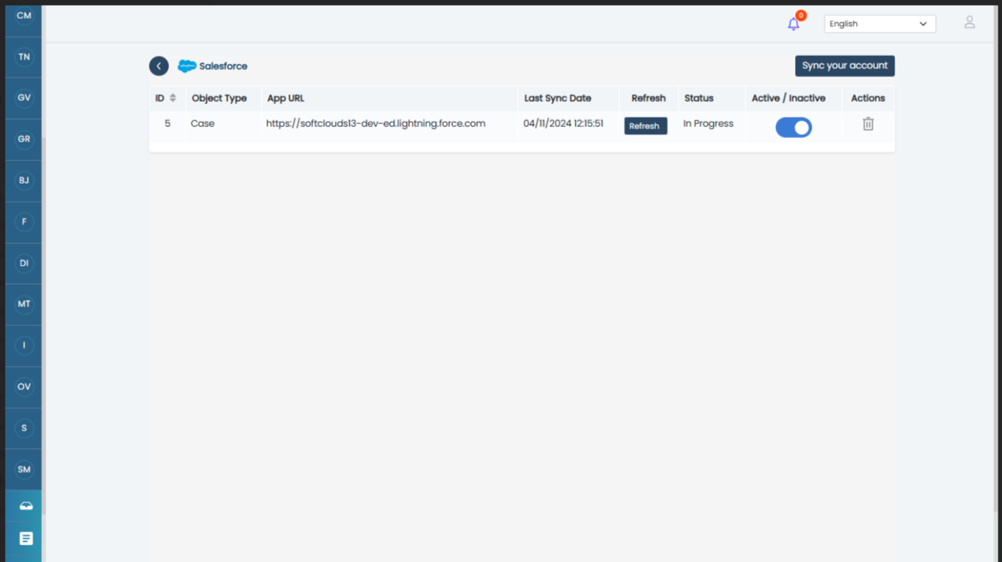
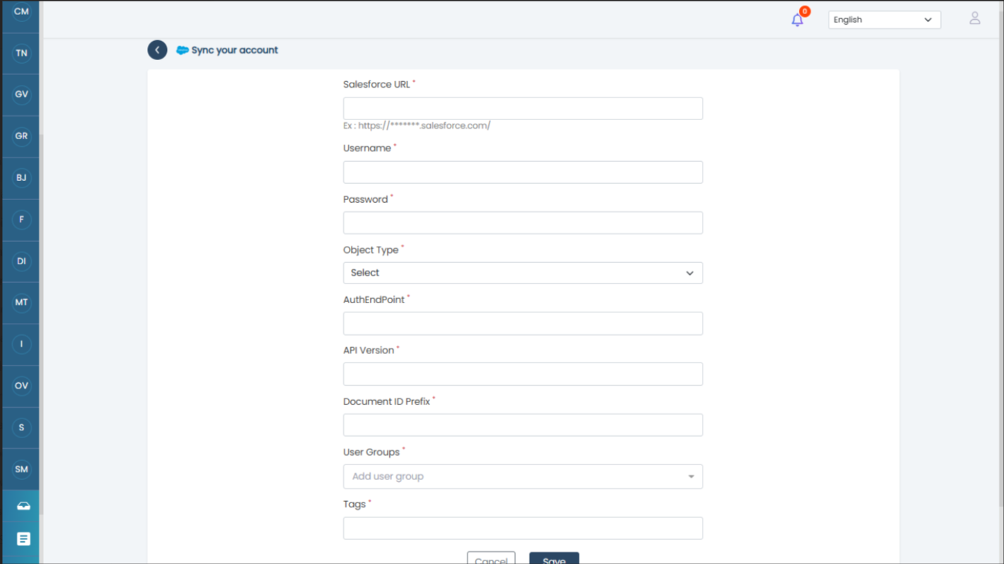

User Story 2: Configure Integration Fields and Endpoint Details for fetching results from Salesforce and Sharepoint ( MVP1) .. Other sources ( MVP2)
Description: As an admin, I should be able to configure a form to select different fields, such as object type, document ID prefix, auth endpoint, user groups ,tags and API version. Some fields should be auto-populated once the account is configured for one org with the Kapture tool, ensuring seamless integration.
Acceptance Criteria:
Salesforce
- Form Interface:
  - Admin can access a user-friendly form to configure integration details.
  - The form displays fields for:
    - Object Type (standard or custom objects).
    - Document ID Prefix (a unique identifier for documents).
    - Auth Endpoint (used for API authentication).
    - API Version (e.g., v1.0, v2.0).
    - User group
    - Tags
- Field Behavior:
  - Object Type:
    - Admin can view a searchable dropdown list of all available standard and custom objects in Salesforce.
    - Admin can select one or multiple objects from the list.
    - Selected objects are highlighted and stored for future sessions.
  - Document ID Prefix:
    - Admin can manually input a unique prefix for documents.
    - Field auto-validates for uniqueness across the org.
  - Auth Endpoint:
    - Admin can input the authentication endpoint.
    - The system validates the endpoint for correct formatting (e.g., HTTPS).
    - We need to fetch from the current instance so that it is easy to populate
  - API Version:
    - Default value is auto-populated based on the org’s configuration.
    - Admin can override the value manually if needed.
- Auto-Populated Fields:
  - Fields such as Auth Endpoint and API Version are auto-populated after initial account configuration with the Kapture tool.
  - Admin can review and edit these values as necessary.
- Validation and Error Handling:
  - On form submission:
    - The system checks for missing or incorrect field values.
    - Validation errors are displayed with clear and actionable error messages.
    - Errors are logged for troubleshooting.
  - Upon successful validation, a confirmation message is displayed.
- Confirmation and Save:
  - Admin can save the configured fields.
  - Changes are stored in the database and applied to the Kapture integration.

Sharepoint

User Story 3: Configure Additional Settings for the Integration – MVP 2
Description: As an admin, I should be able to configure additional settings related to the integration, such as defining crawl schedules, field mappings, and other relevant settings.
Acceptance Criteria:
- Crawl Schedule Configuration:
  - Admin can define the frequency of data crawls (e.g., daily, weekly, monthly).
  - The system supports custom scheduling with time and date options.
  - Admin receives a confirmation of the saved schedule.
- Field Mapping:
  - Admin can map fields from Salesforce objects to corresponding fields in Kapture.
  - Mapping includes drag-and-drop functionality for ease of use.
  - Unmapped fields are highlighted for the admin’s attention.
User Story 4: Enable Basic Salesforce Integration – will check for backup org for existing integrations
Description: As an admin, I want the system to be compatible with Salesforce's AppExchange compliance, ensuring that all configurations can be managed within Salesforce without external tools.
Acceptance Criteria:
- AppExchange Compatibility:
  - The Kapture app is installed and available via Salesforce AppExchange.
  - Installation follows Salesforce’s standard guidelines and security protocols.
- Seamless Integration:
  - All configurations (e.g., object crawling, scheduling, field mapping) are managed within the Salesforce environment. To be decided
  - No external applications are required to complete the setup.
- User Interface (UI):
  - The UI adheres to Salesforce Lightning Design System (SLDS).
  - All configuration options are intuitively organized and accessible.
- Error-Free Deployment:
  - Admins can deploy the integration without encountering critical errors.
  - The system provides a deployment readiness check before finalizing configurations.

User Story 5: Security Configuration for Admin Access – Need review - Venkat and Subhashree will research and refine it further
Description: As an admin, I should be able to define security settings for the integration, ensuring that only authorized users can configure and manage Kapture’s settings.
Acceptance Criteria:
- User Role Assignment:
  - Admins can assign user roles to control access to Kapture configuration settings.
  - Role assignment includes predefined roles (e.g., Admin, Read-Only User) and custom roles.
- Permission Sets:
  - Permission sets are created to grant or restrict access to configuration components.
  - Only users with appropriate permission sets can modify or view settings.
- Audit and Logging:
  - All changes to configurations are logged with details (e.g., user, timestamp, changes made).
  - Audit logs are accessible only to users with appropriate privileges.
- Data Protection:
  - Sensitive data (e.g., endpoint URLs, credentials) is encrypted and stored securely.
  - The system complies with Salesforce’s security and data protection standards.
- Access Restrictions:
  - Unauthorized users attempting to access configurations are denied with a custom error message.
  - Admins are notified of unauthorized access attempts through alerts.

System Design Considerations :
- Custom Object for Admin Data:
  - A custom object stores admin configuration details (e.g., selected objects, endpoint URLs, crawl schedules).
- Configuration UI:
  - Build a Lightning Web Component (LWC) for managing configurations.
  - Include a dashboard to visualize the status of configurations and crawls.
- Security:
  - Implement Salesforce-native security features (e.g., Profiles, Permission Sets).
  - Encrypt sensitive data using Salesforce Shield or other encryption mechanisms.
- Validation and Error Handling:
  - Ensure all user inputs are validated before saving configurations.
  - Display user-friendly error messages and guidance for corrections.

Epic 2 Kapture Tool Integration and Configuration

This epic is primarily focused on configuring and integrating the Kapture tool with Salesforce, establishing OpenSearch functionality, and ensuring seamless data synchronization. The activities aim to enable efficient content capture, data handling, and search capabilities.

User Story 1: Configure Connection Between Kapture Tool and AppExchange Product - could be a repeat of story as in Epic 1
Description:
As an admin, I want to set up and validate the connection between the existing Kapture Tool and the new Salesforce AppExchange product to enable seamless communication.
Acceptance Criteria:
- Endpoint Configuration:
  - End point APIs would be provided to salesforce team
  - A success message is displayed upon successful validation.
- API Key Setup:
  - Admin can input and save API keys required for secure communication between Kapture and the AppExchange product.
  - API keys are encrypted and stored securely in the system.
- Connection Testing:
  - Teams can test the connection between the Kapture Tool and AppExchange product.
  - A success or error message is displayed based on the test results.
- Audit Logs:
  - Connection setup actions (e.g., endpoint URL changes, connection tests) are logged with timestamps and admin details.

User Story 2: Configure Data Endpoint URLs- Kapture Tool : Configuration but if some issues come then both devs will work together
As an admin, I want to configure and validate the data endpoint URLs from the Kapture Tool to pull data from the Salesforce AppExchange product and objects.
Acceptance Criteria:
- Define Endpoint URLs:
  - Admin can input multiple endpoint URLs for specific data objects (e.g., Accounts, Contacts, Opportunities) in the Kapture Tool.
  - The system validates the endpoint URLs upon submission and displays actionable error messages if invalid.
- Object Mapping:
  - Admin can map the endpoint URLs to corresponding objects in the AppExchange product.
- Testing and Validation:
  - Admin can trigger a test fetch of data using the configured endpoint URLs.
  - The system confirms the successful retrieval of data or logs errors for failed requests.
- Audit Logs:
  - Changes to endpoint configurations are logged with timestamps and admin details.

User Story 3: Set Up Data Synchronization Schedules in Kapture Tool – both teams will be working - mvp 2 for full fledge only standard sync (
Uday’s team will be providing standard configuration
Description:
As an admin, I want to configure the data synchronization schedule in the Kapture Tool to regularly sync data between Kapture and the Salesforce AppExchange product.
Acceptance Criteria:
- Schedule Configuration:
  - Admin can set up synchronization intervals (e.g., hourly, daily, weekly).
  - Admin can specify start times for the scheduled jobs.
- Validation:
  - The system validates the scheduling inputs (e.g., valid frequency and time format).
- Monitoring:
  - Admin can view a list of completed and upcoming synchronization jobs in the Kapture Tool with their status (e.g., “Success,” “Failed”).
- Error Handling:
  - If a synchronization job fails, the system provides detailed error logs and retry options.
- Audit Logs:
  - Synchronization schedule changes are logged with timestamps and admin details.

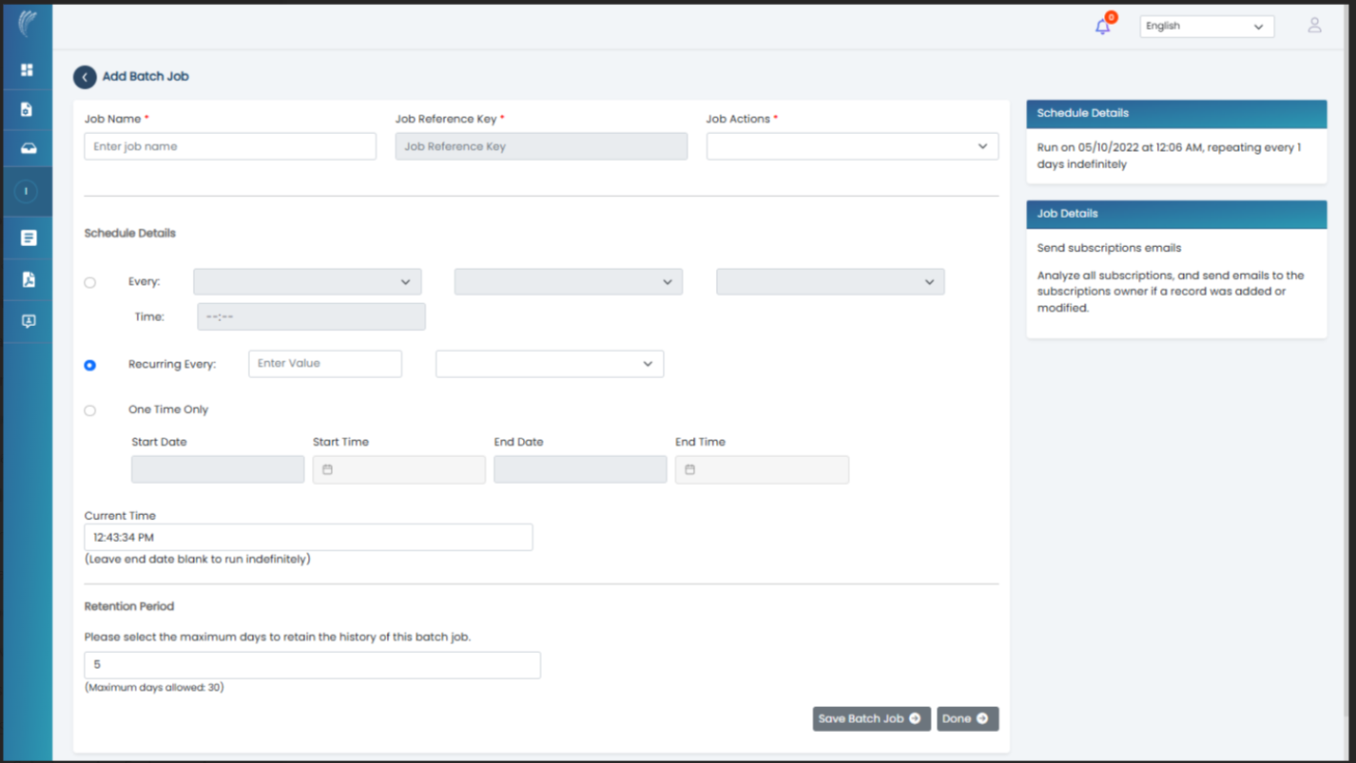

User Story 4: Enable Field Configuration for OpenSearch Indexing
We will go forward with standard fields of the sf objects , if there is some new object to be integrated then uday and himanshu can work together on this
Description:
As an admin, I want to configure the fields in the Kapture Tool that should be indexed in OpenSearch to optimize the search experience for Salesforce agents.
Acceptance Criteria:
- Field Selection:
  - Admin can view all available fields for synchronized objects in the Kapture Tool.
  - Admin can select or deselect fields to be indexed in OpenSearch.
- Auto-Population:
  - Some fields (e.g., document ID prefix, API version) are auto-populated in the Kapture Tool based on the endpoint configuration.
- Field Validation:
  - The system validates the selected fields to ensure compatibility with OpenSearch.
  - Admin is notified of any validation issues.
- Audit Logs:
  - Changes to indexed fields are logged with timestamps and admin details.

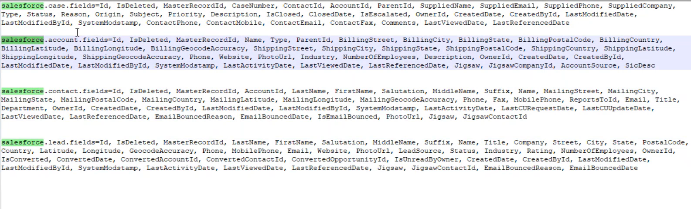

User Story 5: Validate End-to-End Data Flow Between Kapture Tool and AppExchange Product – QA story could be taken up at the end
Description:
As an admin, I want to validate the entire data synchronization flow between the Kapture Tool and the Salesforce AppExchange product to ensure all configurations are working correctly.
Acceptance Criteria: Putting a way for validation , can be modified
- Batch Job Execution:
  - Admin can manually trigger a batch job in the Kapture Tool to synchronize data with the AppExchange product.
  - Real-time progress updates are displayed during job execution.
- Data Validation:
  - Admin can compare synchronized data between Kapture and the AppExchange product to confirm accuracy.
- Error Reporting:
  - Detailed error logs are generated for failed batch jobs, including timestamps, error codes, and troubleshooting suggestions.
- Confirmation:
  - Admin receives a success message upon the successful completion of the batch job.

User Story 6: Configure OpenSearch Connection in Kapture Tool – Validation by uday’s team after salesforce app excahage development
Description:
As an admin, I want to set up and validate the connection between the Kapture Tool and OpenSearch for indexing synchronized data.
Acceptance Criteria:
- Connection Setup:
  - Admin can input and save OpenSearch endpoint URLs in the Kapture Tool.
  - Admin can configure authentication credentials for OpenSearch.
- Connection Testing:
  - Admin can test the connection to OpenSearch and receive success or error messages.
- Validation:
  - OpenSearch connection configurations are validated for correct formatting and connectivity.
- Audit Logs:
  - Changes to the OpenSearch connection settings are logged with timestamps and admin details.

Epic 3: Enterprise Search Integration
Description:
This epic focuses on building the search UI in Salesforce using LWC (Lightning Web Components). The UI will include a search box, filters, a search results section, and categories. The search results will be powered by the integration with the Kapture Tool and OpenSearch, as configured in Epic 2. The goal is to fetch and display search results from Kapture/OpenSearch into Salesforce seamlessly.

User Story 1: Create a Search Box in Salesforce LWC and consuming search api
Description:
As a Salesforce agent, I want to use a search box in the Salesforce interface to perform keyword-based searches across indexed data.
Acceptance Criteria:
- Search Box UI:
  - A search box is available in the LWC simialr to Kapture tool.
  - Agents can enter keywords to perform searches.
- Search Functionality:
  - The search box triggers a query to Kapture and then to OpenSearch when an agent presses "Enter" or clicks the "Search" button.
  - Results are fetched and displayed in the search results section.
- Error Handling:
  - If no results are found, a "No results found" message is displayed.
  - If there’s an issue with the query, an error message is shown with troubleshooting suggestions.
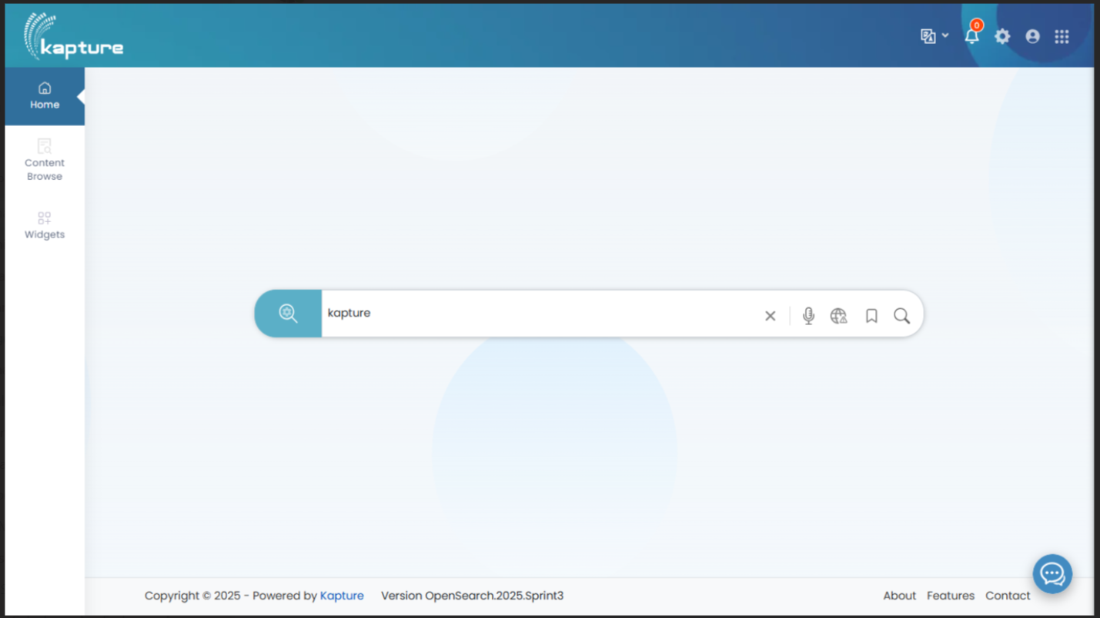

User Story 2: Build a Filters Section in LWC
Description:
As a Salesforce agent, I want to filter search results based on predefined criteria to narrow down the data displayed.
Acceptance Criteria:
- Filter Options: To be defined
  - The filters section allows agents to filter results based on criteria like object type (e.g., Account, Contact, Opportunity), date range, and categories.
  - Filter options are dynamically fetched from Kapture via OpenSearch.
- Real-Time Filtering:
  - Results update in real-time as agents apply or modify filters.
- Clear Filters Option:
  - Agents can clear all filters to reset the search.
- Error Handling:
  - If an invalid filter is applied, the system displays a relevant error message.

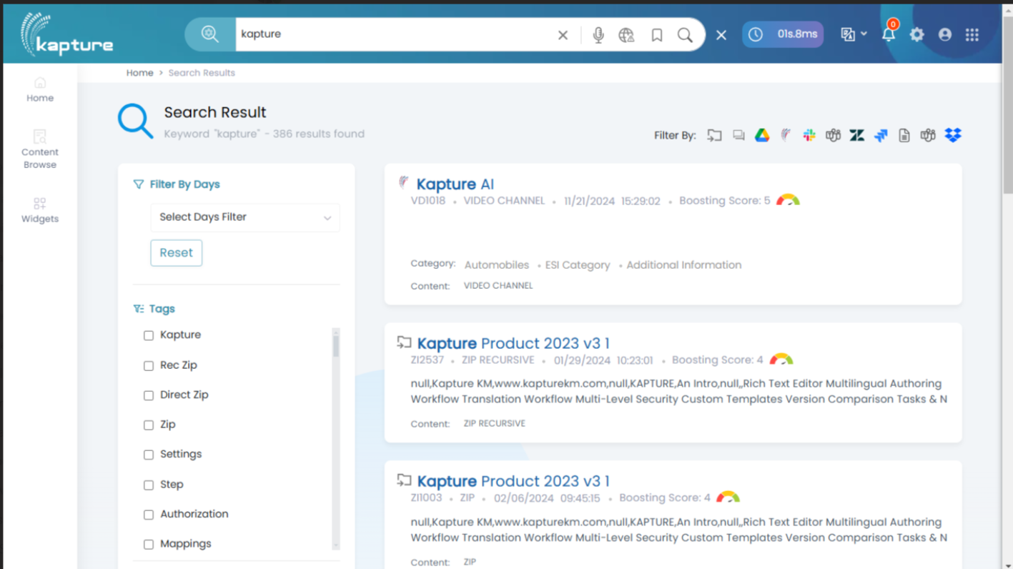User Story 3: Display Search Results in Salesforce LWC
Description:
As a Salesforce agent, I want to view search results in a well-organized and interactive interface in Salesforce.
Acceptance Criteria:
- Results Display:
  - Search results are displayed in a paginated list below the search box.
  - Each result includes key fields (e.g., Name, Type, Date Modified) fetched from Kapture.
- Interaction:
  - Agents can click on a result to view detailed information (via a modal or a navigation link).
- Pagination:
  - The results section supports pagination, with a configurable number of results per page.
- Error Handling:
  - If results cannot be fetched, a fallback error message is displayed.

User Story 4: Add Categorization to Search Results TBD to be taken up in MVP 1 or MVP2
Description:
As a Salesforce agent, I want to view search results grouped by categories (e.g., Accounts, Contacts, Opportunities) for better organization.
Acceptance Criteria:
- Category Grouping:
  - Results are grouped into predefined categories (e.g., Account, Contact, Opportunity).
  - Each category header shows the count of results within that category.
- Expand/Collapse Functionality:
  - Agents can expand or collapse categories to focus on specific types of results.
- Dynamic Loading:
  - Categories and counts are dynamically fetched from Kapture via OpenSearch.

Epic 4: AppExchange Listing and Integration
User Story 1: Create Managed Package and Ensure Salesforce Integration
- As a Salesforce Developer,
- I want to create a managed package for Kapture and ensure seamless integration with Salesforce,
- So that the app is ready for distribution on AppExchange and functions correctly with Salesforce.
  - Acceptance Criteria:
    - Package includes all required components and is versioned.
    - Integration with Salesforce objects is tested and error handling is in place.
User Story 2: Define and Implement Security Considerations (Technical & Non-Technical)
- As a Salesforce Architect,
- I want to ensure that Kapture meets both technical and non-technical security requirements,
- So that it complies with Salesforce security guidelines and user data is protected.
  - Acceptance Criteria:
    - Secure coding practices applied (no SOQL injection, field-level security).
    - Privacy policy and compliance documentation provided.
    - Encryption at rest and in transit.
User Story 3: Prepare AppExchange Listing and Compliance
- As a Product Owner,
- I want to prepare the AppExchange listing content and ensure compliance,
- So that the app can be approved for listing and customers understand its features.
  - Acceptance Criteria:
    - Listing includes features, benefits, installation instructions, and security details.
    - Compliance checklist completed, security review passed, and app approved for listing.

User story 4 -- Design Approach for Authentication Flexibility in an AppExchange Product
- Provide a Configuration Interface in Your App
  - Build a Kapture Setup Page (Lightning App) where customers can:
    - Select their desired authentication method (Standard Login, OAuth, SSO).
    - Enter necessary configurations for OAuth or SSO (e.g., endpoint URLs, client secrets).
  - Steps to Implement:
    - Use a Custom Metadata Type or a Custom Object (e.g., KaptureAuthSettings) to store authentication configuration details.
    - Include fields like:
      - Authentication Type (Picklist: Standard Login, OAuth, SSO).
      - OAuth Client ID and Client Secret.
      - SSO Identity Provider (IdP) URL and Metadata file upload.
- Authentication Options Provided via Setup Guide
  - Deliver a post-installation setup guide (document or video) that explains:
    - How to enable Standard Login (enabled by default).
    - How to configure OAuth using their API credentials.
    - How to set up SSO using Salesforce SAML settings.
- Standard Login Configuration
  - No Additional Setup Needed:
    - Customers can log in using their existing Salesforce credentials immediately after app installation.
    - Standard Login is the default fallback if OAuth or SSO isn't configured.
- OAuth Configuration
  - Provide UI to configure OAuth settings:
    - Client ID and Secret fields for OAuth apps.
    - Redirect URLs (predefined in your app).
  - Steps to Implement:
    - Add these fields to the Kapture Setup Page.
    - Use Salesforce's Named Credentials feature to store OAuth credentials securely.
    - Include a custom UI or flow to test the OAuth connection.
- SSO Configuration
  - Guide customers to set up their SAML Single Sign-On:
    - Provide a downloadable metadata XML file from your app (preconfigured for their org).
    - Guide them to upload your app’s SAML metadata file into their Salesforce SSO Settings.
  - Your app should also:
    - Allow storage of Identity Provider (IdP) URLs and attributes for user mapping.
    - Use Login Flow or Apex Auth Providers (if applicable) to process SSO tokens.
- Post-Installation Settings for the Customer
  - Permission Sets for Admins:
    - Create a Permission Set that grants access to the Kapture Configuration page and related objects.
  - App Exchange Post-Install Script:
    - Add a script that sets default access for app components, ensuring smooth onboarding.
  - Custom Metadata Setup:
    - Use Custom Metadata Types for admin flexibility, ensuring all authentication configurations are editable post-installation.

Key Deliverables in the AppExchange App
- Kapture Setup Page:
  - Allows customers to select and configure their authentication method.
- Custom Metadata for Authentication Settings:
  - Stores configurations securely and allows admins to edit them later.
- Guides and Documentation:
  - Include a detailed setup guide to help customers configure OAuth, SSO, or use Standard Login.
- Error Handling and Fallbacks:
  - Ensure that if OAuth or SSO fails, the Standard Login is the default option.

