GPU Server Details Page

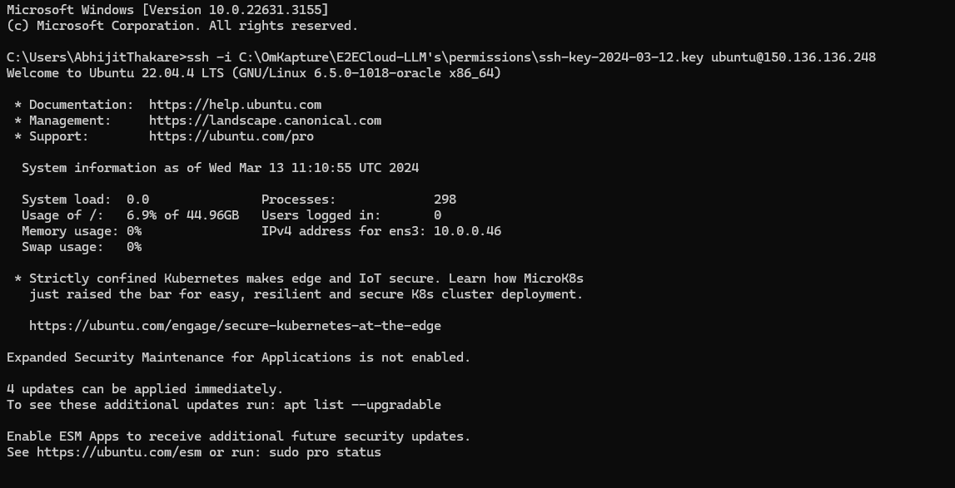

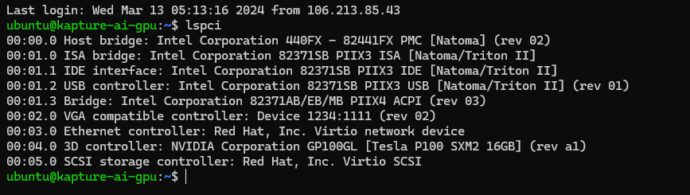
Cloud Provider: Oracle Cloud
GPU Server: Tesla P100 SXM2 16 GB
Proposed LLM model to be used: mistralai/Mistral-7B-Instruct-v0.2 from Hugging Face
https://huggingface.co/mistralai/Mistral-7B-Instruct-v0.2

List of Softwares:
- Install CUDA Toolkit: Depends on GPU Model, Operating Systems, CUDA Compute capability etc.

https://developer.nvidia.com/cuda-toolkit --- Operating System Link- Done

https://www.nvidia.com/Download/index.aspx?lang=en-us --- Nvidia Drivers for specific GPU’s – Done

- Install cuDNN : https://developer.nvidia.com/cudnn - Done

- Install Hugging Face Library (To install this following are dependencies):

- Install Python and Dependencies: Ensure that Python is installed on your server along with pip, the Python package installer. – Done
- Installation of VNC viewer in GPU server and client versions - Pending

- PyCharm Community Edition: For writing Python Code - Pending

https://www.jetbrains.com/pycharm/download/?section=linux

- Deep Learning Framework: Pytorch Installation: PyTorch provides different installation commands depending on your system configuration (e.g., GPU,CUDA version, operating system). You'll need to select the appropriate command from the PyTorch website. For example, for a Linux server with CUDA 11.2 support and Python 3.8, you might use:

pip install torch==1.10.0+cu113 torchvision==0.11.1+cu113 torchaudio==0.10.0+cu113 -f https://download.pytorch.org/whl/cu113/torch_stable.html - Done

- Model serving framework: Triton Inference Server –By Nvidia - Done

