ORG CREDS:
URL: https://login.salesforce.com/
Username: venkatg@softclouds.com.partner
password: Winter@052025

If it ask for Token then Venkat’s email is registered.

KAPTURE LOGIN CREDENTIALS:(for Kapture Configuration and Kapture Search)
email: sivam@ctrlaltfix.co
Password: Siva@118

To be reviewed:

Note: The following branch is outdated and not updated with the latest code
Kapture-SF/force-app/main/default/classes/SalesforceIntegrationController.cls at main · sandeepn-softclouds/Kapture-SF

So the code in the Org is looked in to for code reviews

Type | Name Of Component | Reviewed By | Reviewer Comments
Apex Class | SyncSalesforceController | Sridharan Subramanian | - This is not part of the git branch  - Remove line 20 of the commented code  - There is no error logger to track what httpresponse was sent  - Line 25,26,27 are hardcoded  - 'appType' => 'kauthor',  'publicIp' => '27.6.121.87',  'userAgent' => 'chrome'  - Line 137 and 139 error logging is not present  - Line 148 hardcoded values in the code to be made configurable  - AND DeveloperName = 'Salesforce_Record_Type'//'Integration_Record_Type'
Apex Class | SalesforceIntegrationController | Sridharan Subramanian | - Insted of several return statements there can be only one and the map can be assigned to a variable before returned in the getIntegrationAccounts() method  - SalesforceAPISettings__c settings  This can be a global variable and it can be assigned in the constructor  - Remove the commented codes  - Errors/Exceptions should be logged through logger classes
Apex Class | TestDataFactory, HttpMockCallout | Sridharan Subramanian | Looks good..
Apex Test Class | SyncSalesforceControllerTest | Sridharan Subramanian | Looks good..
Apex Test Class | SalesforceIntegrationControllerTest | Sridharan Subramanian | Assert for the created account in every test method
LWC Component | salesforceIntegrationdetails |  | Reviewed
LWC Component | syncSalesforceAccount |  | Reviewed

List of Components:

Sr. No | Type | Name Of Component | Reviewer Comments
1 | Apex Class | SyncSalesforceController | Review comments mention in the Above table
2 | Apex Class | SalesforceIntegrationController | Review comments mention in the Above table
3 | Apex Class | SharePointIntegrationController | Review comments mention in the Above table
4 | Apex Class | SyncSharePointController | - Error logging need to be implemented  - Recordtype query hardcoded
5 | Apex Class | OneDriveIntegrationDetails | Line 13 - req.setEndpoint(settings.GetOneDriveAccEndpoint__c);  Check where ever the settings value mentioned in the class see if the value exist and not empty  Remove debug logs and do proper error logging using error log implementation
6 | Apex Class | SyncOneDriveController | Same comments as mentioned in SalesforceIntegrationController  And Check where ever the settings value mentioned in the class see if the value exist and not empty
7 | Apex Class | OauthLoginController | Hardcoded values.. Need to be fetched from the settings.
8 | Apex Class | JiraIntegrationController | Same comments as mentioned in SalesforceIntegrationController  And Check where ever the settings value mentioned in the class see if the value exist and not empty
9 | Apex Class | SyncJiraController | Same comments as mentioned in SalesforceIntegrationController  And Check where ever the settings value mentioned in the class see if the value exist and not empty
10 | Apex Test Class | SyncJiraControllerTest | Assert for the created account in every test method
11 | Apex Test Class | TestDataFactory, MockHttpCallout | Reviewed and looks good..
12 | Apex Test Class | SyncSalesforceControllerTest | Reviewed and looks good..
13 | Apex Test Class | SalesforceIntegrationControllerTest | Reviewed and looks good..
14 | Apex Test Class | SharePointIntegrationControllerTest | Assert for the created account in test method
15 | Apex Test Class | SyncSharePointControllerTest | Assert for the created account in every test method
16 | Apex Test Class | TestOneDriveIntegrationController | Same comments as mentioned in SalesforceIntegrationController  And Check where ever the settings value mentioned in the class see if the value exist and not empty
17 | Apex Test Class | SyncOneDriveControllerTest | Reviewed and looks good..
18 | Apex Test Class | OauthLoginControllerTest | Reviewed and looks good..
19 | LWC Component | NavigateToDashboard | Reviewed and looks good..
20 | LWC Component | kaptureCheckboxFlow | Reviewed and looks good..
21 | LWC Component | IntegrationLoginPage | Reviewed and looks good..
22 | LWC Component | integrationPage | Reviewed and looks good
23 | LWC Component | salesforceIntegrationDetails | Reviewed and looks good
24 | LWC Component | syncSalesforceAccount | Reviewed and looks good
25 | LWC Component | sharepointIntegrationDetails | Reviewed and looks good
26 | LWC Component | syncSharePointAccount | Reviewed and looks good
27 | LWC Component | JiraIntegrationDetails | Reviewed and looks good
28 | LWC Component | syncJiraAccount | Reviewed and looks good
29 | LWC Component | OneDriveIntegrationController | Reviewed and looks good
30 | LWC Component | SyncOneDriveAccount | Reviewed and looks good
31 | LWC Component | KaptureSearchBox | Reviewed and looks good
32 | LWC Component | KaptureSearchResults | Reviewed and looks good
33 | LWC Component | KaptureDocumentDetails | Reviewed and looks good
34 | Page Layout Name | Dropbox Integration Layout | Reviewed and looks good
35 | Page Layout Name | Salesforce Integration Layout | Reviewed and looks good
36 | Page Layout Name | Jira Integration Layout | Reviewed and looks good
37 | Page Layout Name | OneDrive Integration Layout | Reviewed and looks good
38 | Page Layout Name | SharePoint Integration Layout | Reviewed and looks good
39 | Page Layout Name | Slack Integration Layout | Reviewed and looks good
40 | Page Layout Name | Dropbox Integration Layout | Reviewed and looks good
41 | Record Type | DropBox Record Type | Reviewed and looks good
42 | Record Type | Salesforce Record Type | Reviewed and looks good
43 | Record Type | Jira Record Type | Reviewed and looks good
44 | Record Type | OneDrive Record Type | Reviewed and looks good
45 | Record Type | SharePoint Record Type | Reviewed and looks good
46 | Record Type | Slack Record Type | Reviewed and looks good
47 | Flow | Kapture Flow (Screen Flow) | Reviewed and looks good
48 | Custom Profile | API USER | Reviewed and looks good
49 | Permission sets | Kapture Access | Reviewed and looks good
50 | Lightning Experience App | Kapture Configuration | Reviewed and looks good
51 | Lightning Experience App | kapture Search | Reviewed and looks good
52 | Custom Field | Refer below table | Reviewed and looks good
53 | List View Filter | DropBox | Reviewed and looks good
54 | List View Filter | Salesforce | Reviewed and looks good
55 | List View Filter | Jira | Reviewed and looks good
56 | List View Filter | OneDrive | Reviewed and looks good
57 | List View Filter | SharePoint | Reviewed and looks good
58 | List View Filter | Slack | Reviewed and looks good
59 | Custom Settings | SalesforceAPISettings__c | Reviewed and looks good
60 | Custom Object | Integration_Configuration__c | Reviewed and looks good
61 | Remote Site Settings | KaptureAPI | Reviewed and looks good
62 | Lightning Component Tabs |  | Reviewed and looks good
  AmazonS3_Details, Dropbox_Details,
  GoogleDrive_Details, Integration_Details,
  Integration_Login_Page,
  Integration_Page, Jira_Details,
  MicrosoftTeams_Details,
  OneDrive_Details,
  OracleFusionCloud_Details,
  OracleServiceCloud_Details,
  SharePoint_Details, Salesforce_Details,
  Slack_Details, Sync_Account
  Sync_AmazonS3, Sync_Dropbox,
  Sync_GoogleDrive, Sync_Jira,
  Sync_MicrosoftTeams, Sync_OneDrive,
  Sync_OracleFC, Sync_OracleSC,
  Sync_Salesforce, Sync_Sharepoint,
  Sync_Slack, Sync_Zendesk
  Zendesk_Details
63 | Lightning Page Tab |  | Reviewed and looks good
  Kapture_Configuration
 | Lightning Page Tab |  | Reviewed and looks good
  Search_Page
 |  | Search_Login_Page | Reviewed and looks good

Object Model
Custom Object: Integration Configuration (Integration_Configuration__c)
Fields & Relationship
Field Label | Field Name | Data Type
Active | Active__c | Checkbox
API Version | API_Version__c | Number(3, 1)
App Key | App_Key__c | Long Text Area(32768)
App Secret | App_Secret__c | Long Text Area(32768)
Auth Endpoint | Auth_Endpoint__c | Text(255)
Created By | CreatedById | Lookup(User)
Document ID Prefix | Document_ID_Prefix__c | Text(255)
Import Source | Import_Source__c | Text(255)
Integration Configuration Name | Name | Auto Number
Jira Email | Jira_Email__c | Email
Jira URL | Jira_URL__c | URL(255)
Last Modified By | LastModifiedById | Lookup(User)
Meta Data Name | Meta_Data_Name__c | Picklist
Metadata Name | Metadata_Name__c | Text(255)
Object Type | Object_Type__c | Picklist
OneDrive Email | OneDrive_Email__c | Email
Org Name | Org_Name__c | Picklist
Organization | Organization__c | Text(255)
Owner | OwnerId | Lookup(User,Group)
Password | Password__c | Text(255)
Project | Project__c | Text(255)
Record Type | RecordTypeId | Record Type
Refresh Token | Refresh_Token__c | Long Text Area(32768)
SF URL | SF_URL__c | URL(255)
Slack URL | Slack_URL__c | URL(255)
Tags | Tags__c | Long Text Area(131072)
Token | Token__c | Long Text Area(32768)
User Groups | User_Groups__c | Long Text Area(32768)
Username | Username__c | Text(255)
Functionalities:
For Salesforce API: Screen shots of steps
Put your Salesforce login credentials: https://unfoldlabs.lightning.force.com/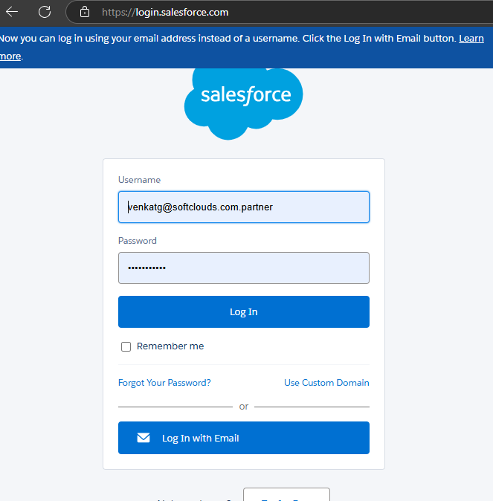
Kapture Welcome Screen, that is opened from Kapture configuration application
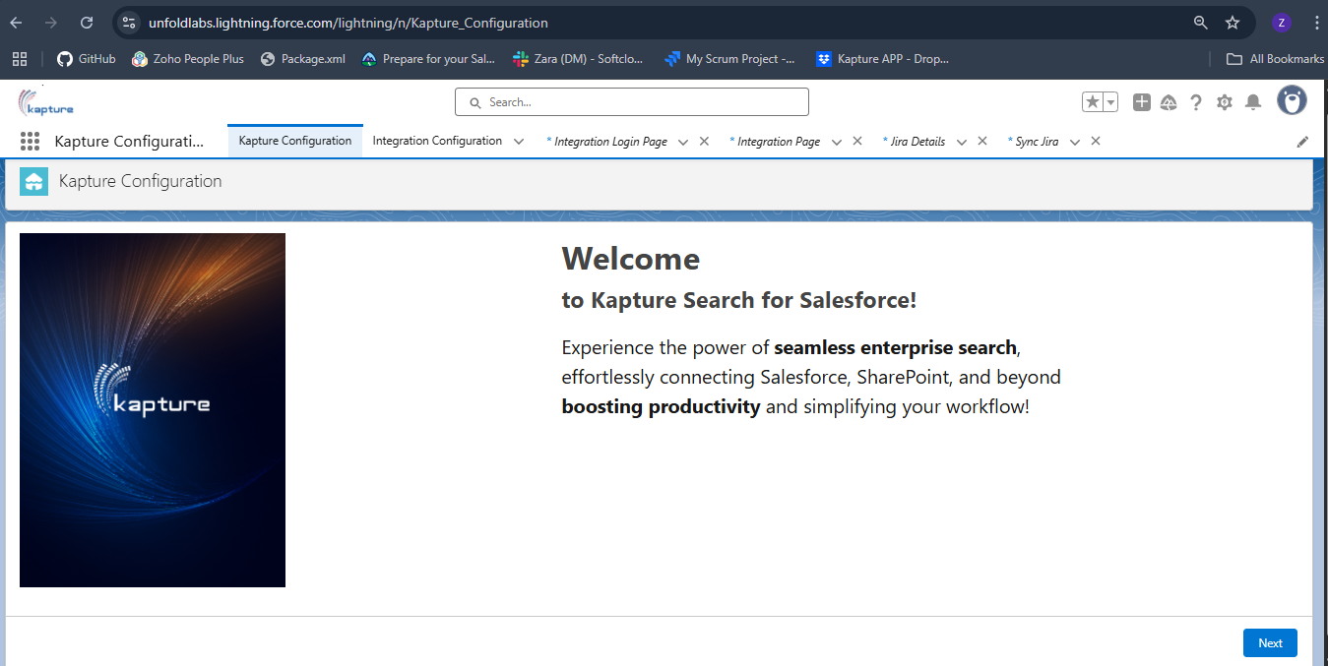
API Access for User consent, need to approve the API access to go to next screen
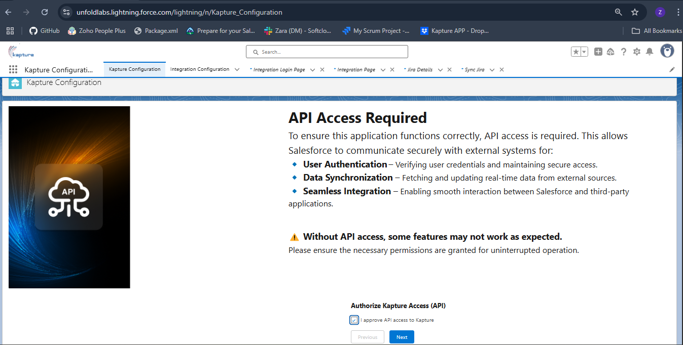
Setup Complete screen, click on Button to go to Kapture Dashboard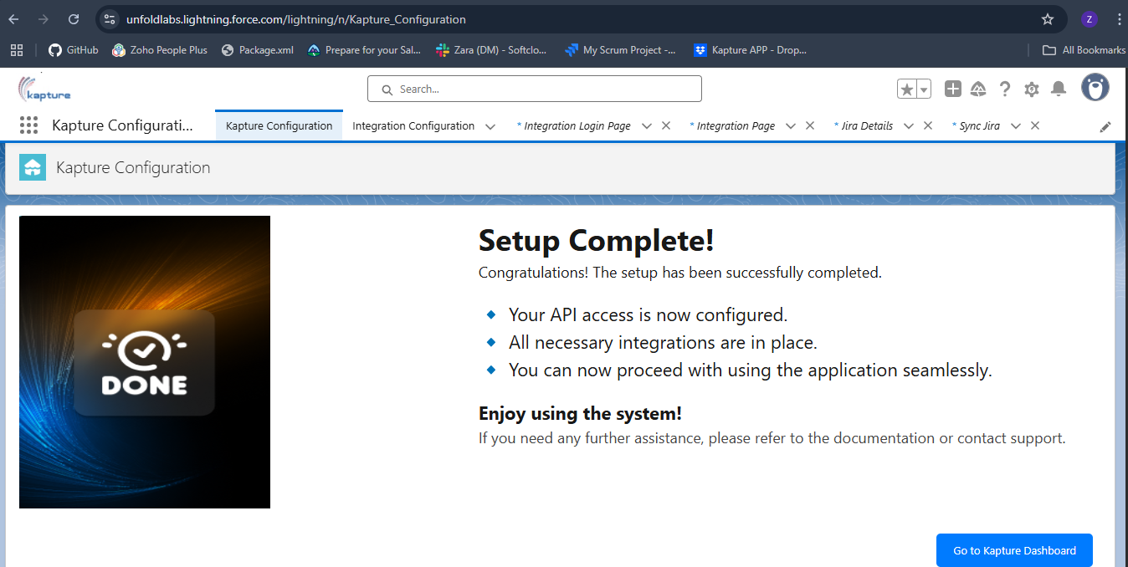

Need Kapture Login credentials => Id: sivam@ctrlaltfix.co pwd: Siva@118
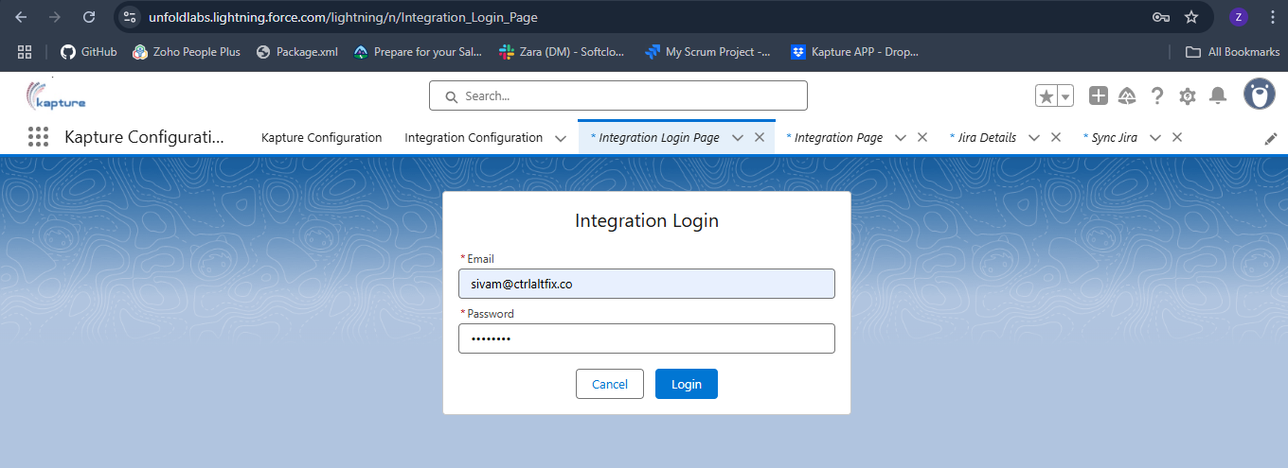
Kapture Dashboard
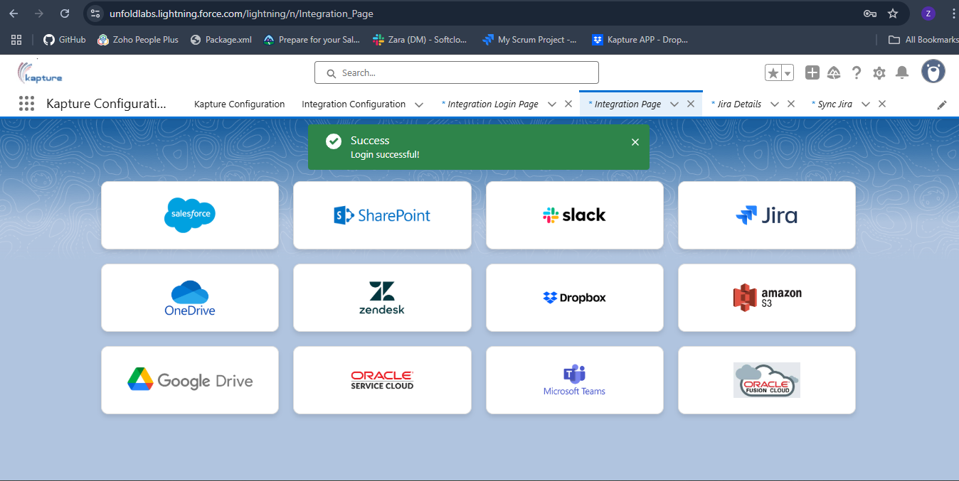
Click on Salesforce you’ll see all the Synced accounts(already existing accounts in Kapture)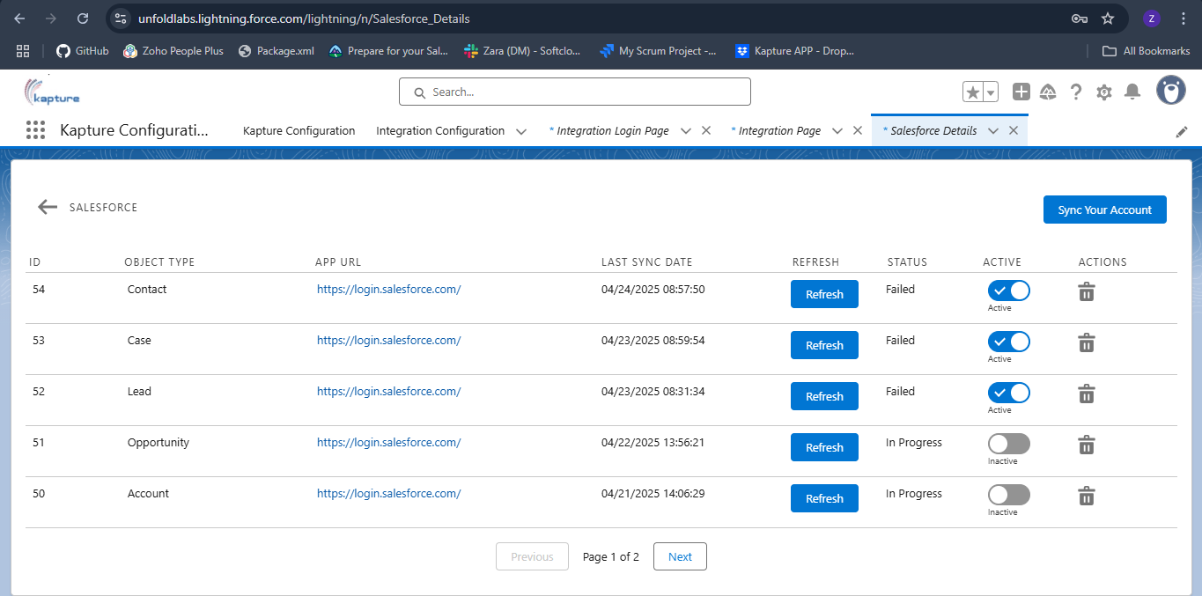

Refresh the Account
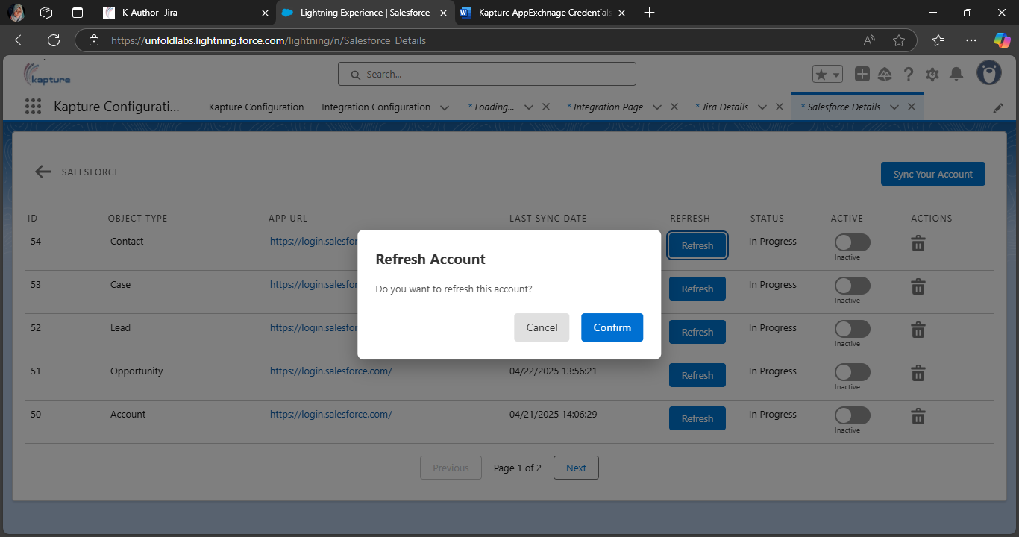
After confirmation successfully message will display
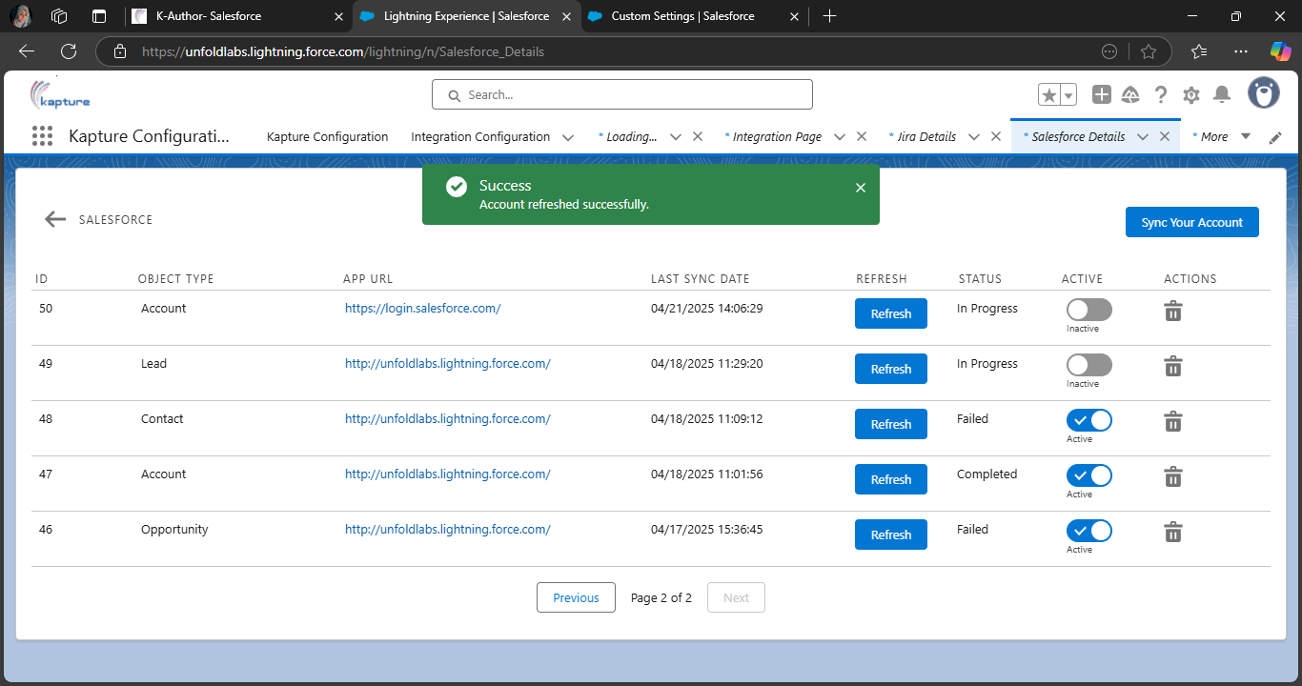
Activate or Deactivate the Account (if we modify and make it active then changes will modify in Kapture also)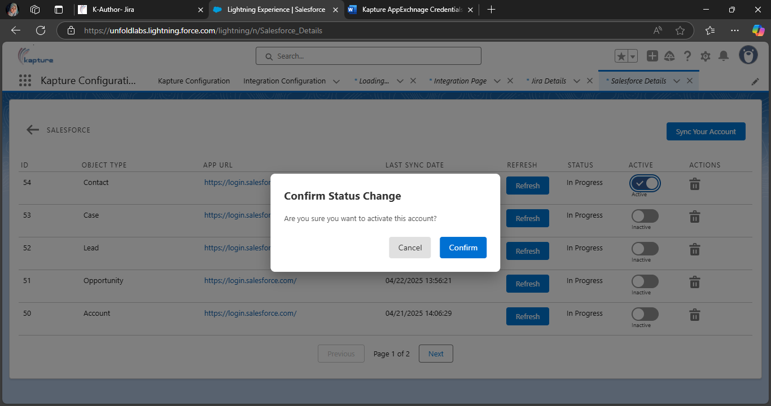
After confirmation successfully message will display
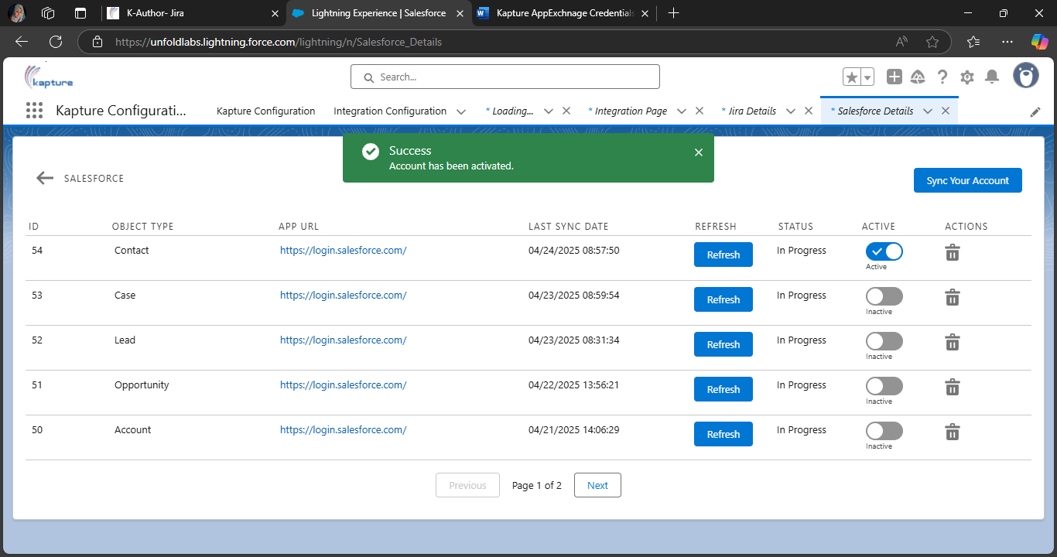
Delete the Account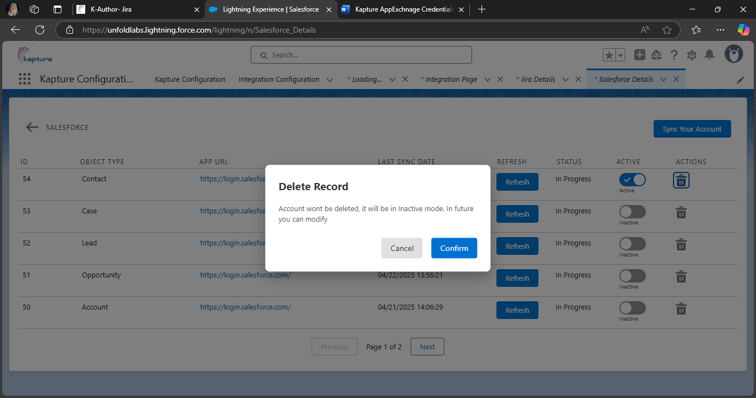
After confirmation account will be deactivate
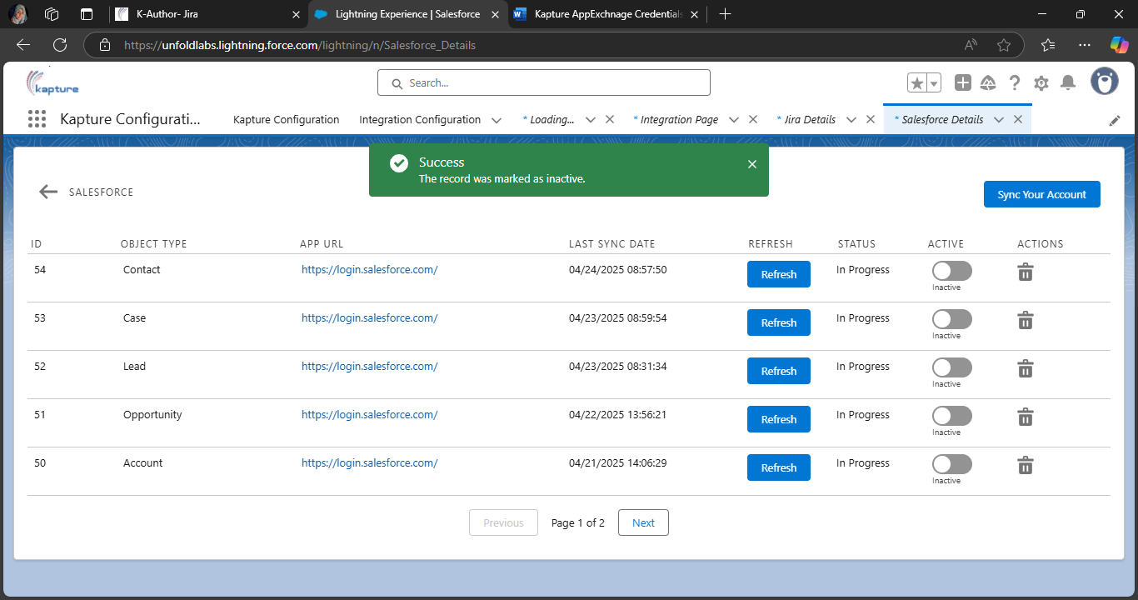
Click on Sync your Account button, need to add all the valid data in this form to sync your account
Data:
"sfUrl":"http://login.salesforce.com/",
"sfUsername":"venkatg@softclouds.com.partner",
"sfPassword":"Winter@2025Ok4CfXuSDeYaoPLdiwbY7R5a9",
"sfObjectType":"Lead",
"sfAuthEndPoint":"https://login.salesforce.com/services/Soap/u/63.0",
"sfApiVersion":"63.0",
"docIdPrefix":"DOC123",
"tags":[{"tagName":"Integration"},{"tagName":"Sync"}],
"userGroups":[{"userGroupName":"PUBLIC_GROUP_KEY"},{"userGroupName":"HOTLINE_AGENT"}]

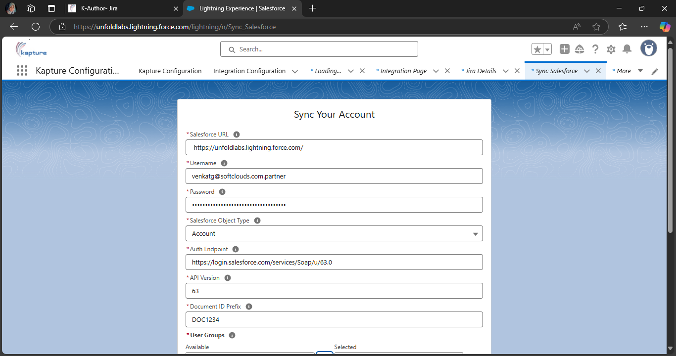
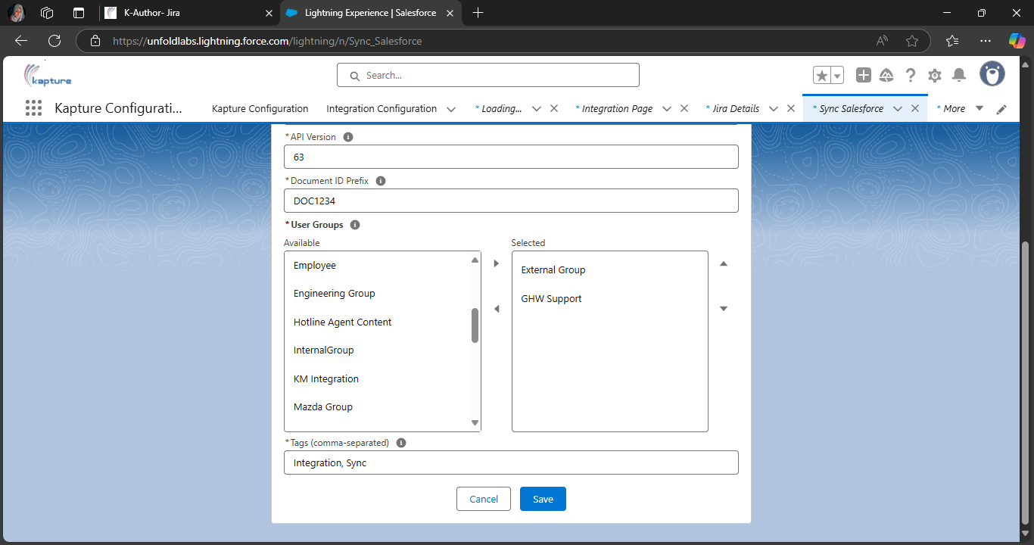

Ater successfully syncing the account
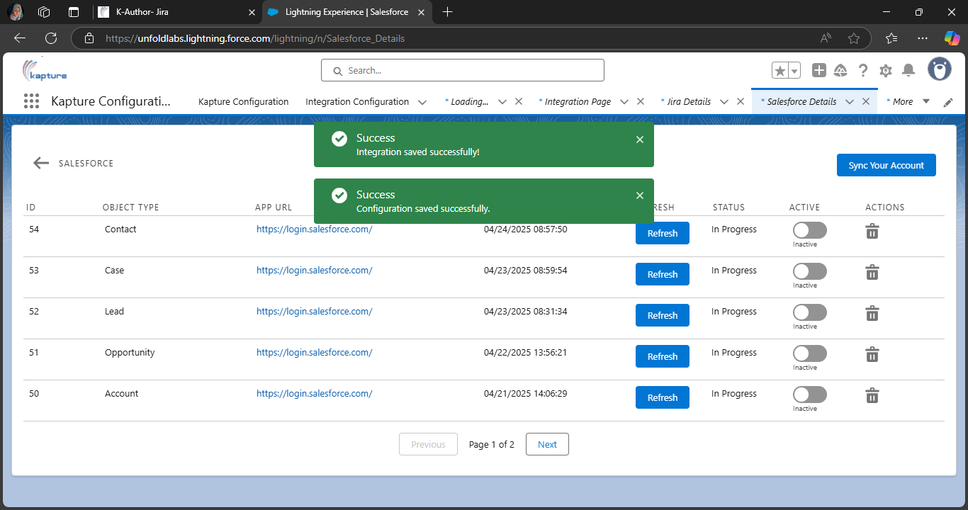
Newly added synced Account
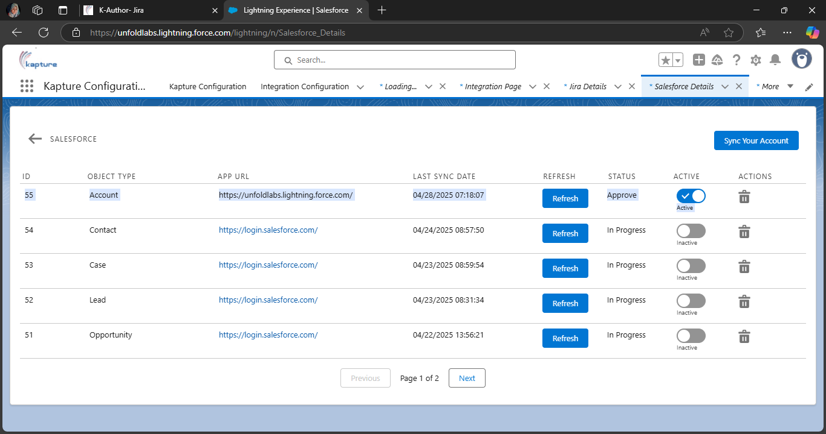
Apex class from where the token is
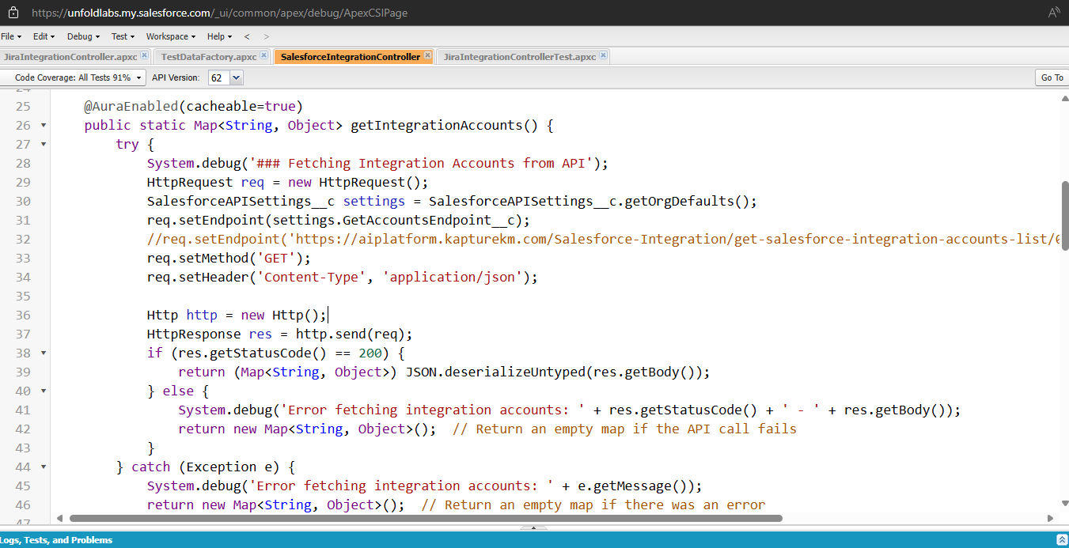
This is Just for testing purpose token generation is happening from apex class SyncSalesforceController. authenticateAndGetToken()

POSTMAN Screen Shots
GET Salesforce Account
GET: https://aiplatform.kapturekm.com/Salesforce-Integration/get-salesforce-integration-accounts-list/0/10
Authorization: Bearer + accessToken
Content-Type: application/json
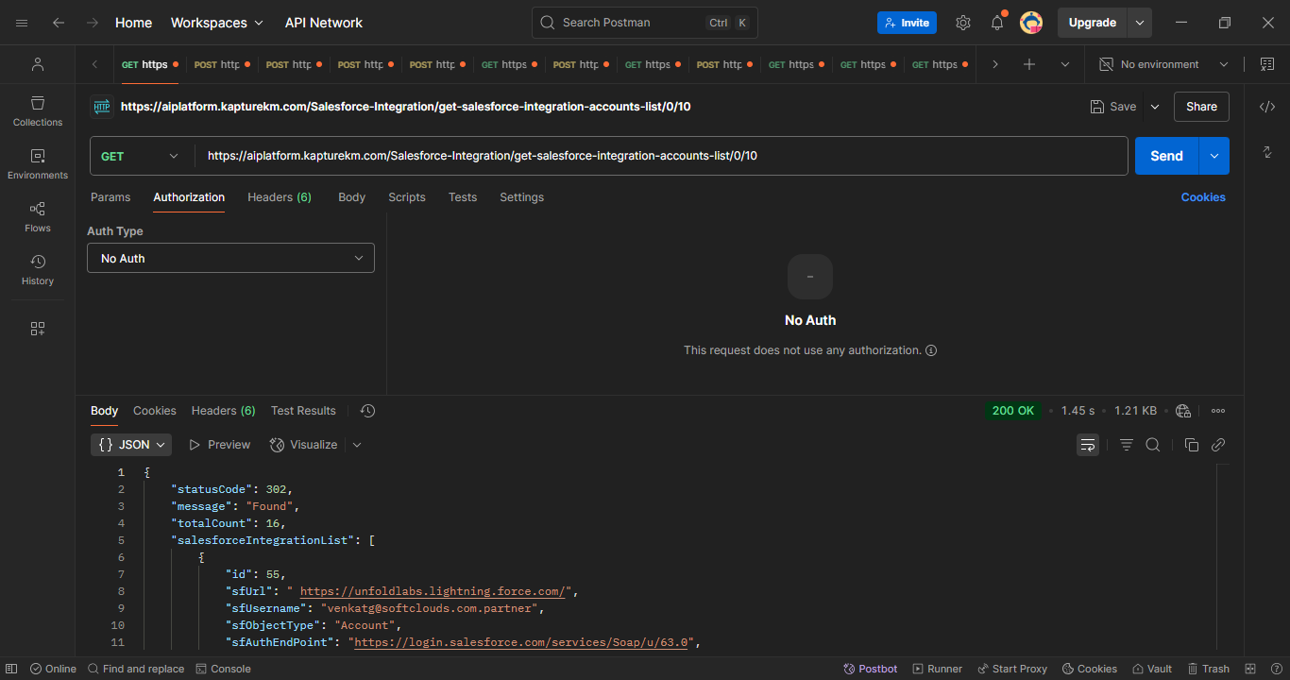
SAVE Salesforce Account
POST: https://aiplatform.kapturekm.com/Salesforce-Integration/save-salesforce-integration-account
{
"sfUrl":"http://login.salesforce.com/",
"sfUsername":"venkatg@softclouds.com.partner",
"sfPassword":"Winter@2025Ok4CfXuSDeYaoPLdiwbY7R5a9",
"sfObjectType":"Lead",
"sfAuthEndPoint":"https://login.salesforce.com/services/Soap/u/63.0",
"sfApiVersion":"63.0",
"docIdPrefix":"DOC123",
"primaryLocale": "en_US",
"createdBy": "VenkatG",
"tags":[{"tagName":"Integration"},{"tagName":"Sync"}],
"userGroups":[{"userGroupName":"PUBLIC_GROUP_KEY"},{"userGroupName":"HOTLINE_AGENT"}]
}

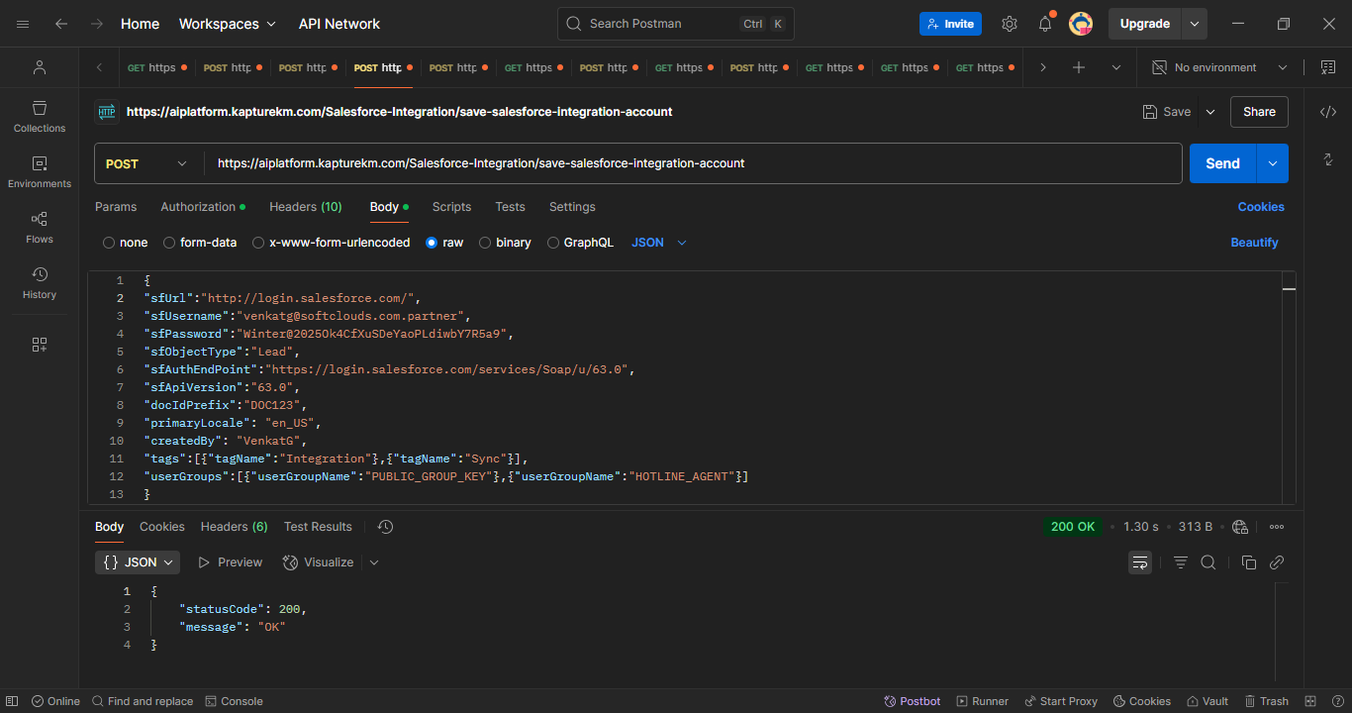
DELETE Salesforce Account
DELETE: https://aiplatform.kapturekm.com/Salesforce-Integration/delete-salesforce-account/47/SivaM
Authorization: Bearer + accessToken
Content-Type: application/json

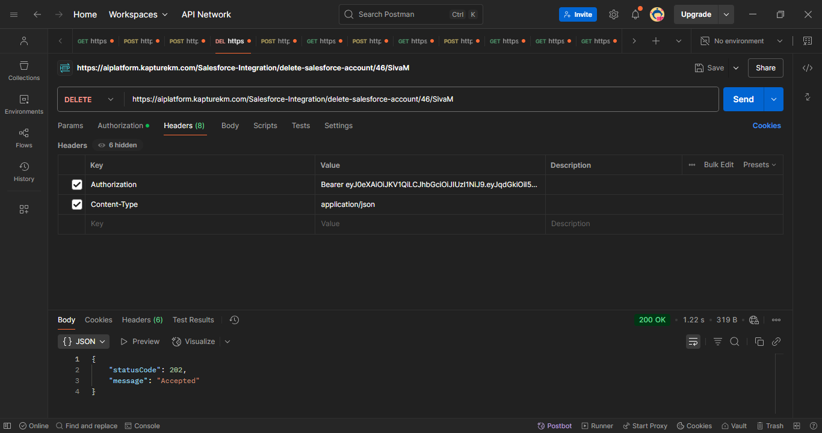
ACTIVE/INACTIVE Salesforce Account
PUT: https://aiplatform.kapturekm.com/Salesforce-Integration/active-inactive-salesforce-account/true/46/SivaM
Authorization: Bearer + accessToken
Content-Type: application/json

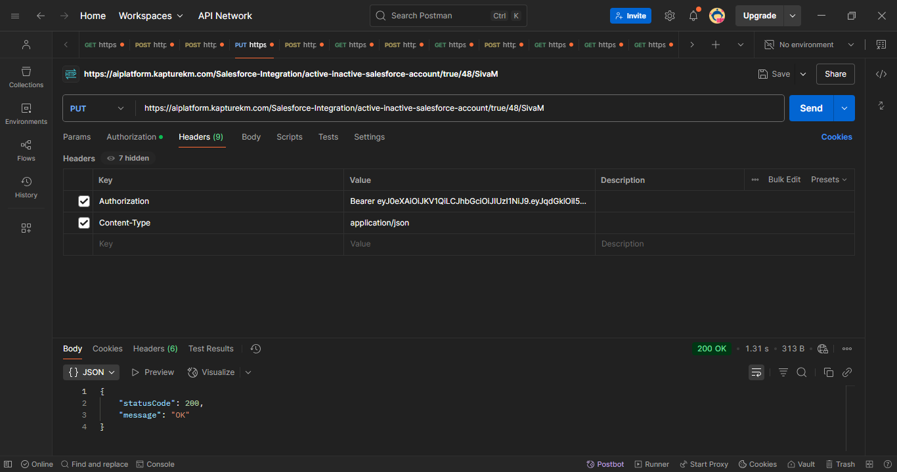
REFRESH Salesforce Account
GET https://aiplatform.kapturekm.com/Salesforce-Integration/refresh-salesforce-account/48/SivaM
Authorization: Bearer + accessToken
Content-Type: application/json
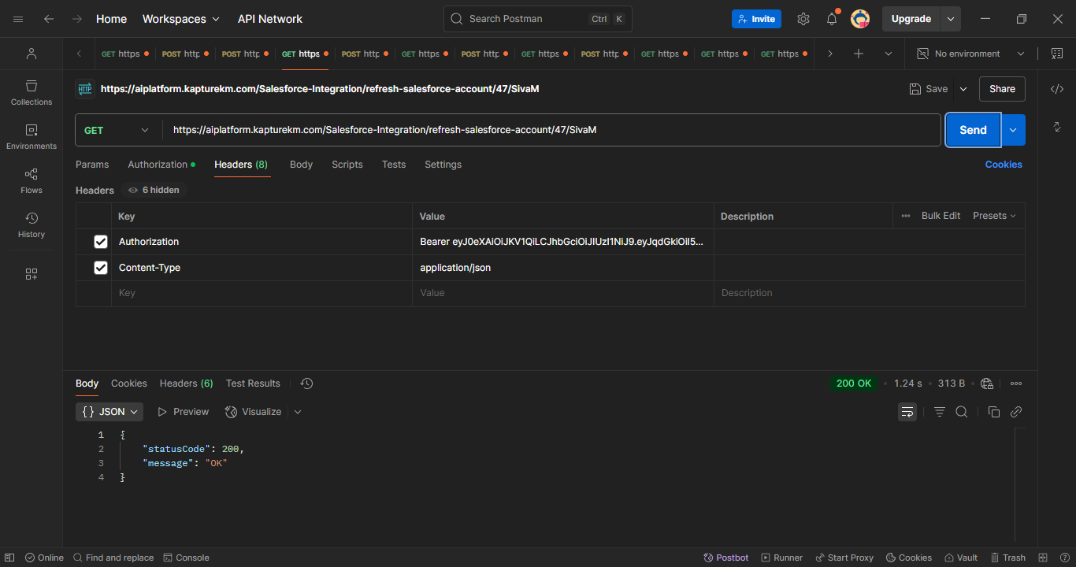
TestDataFactory
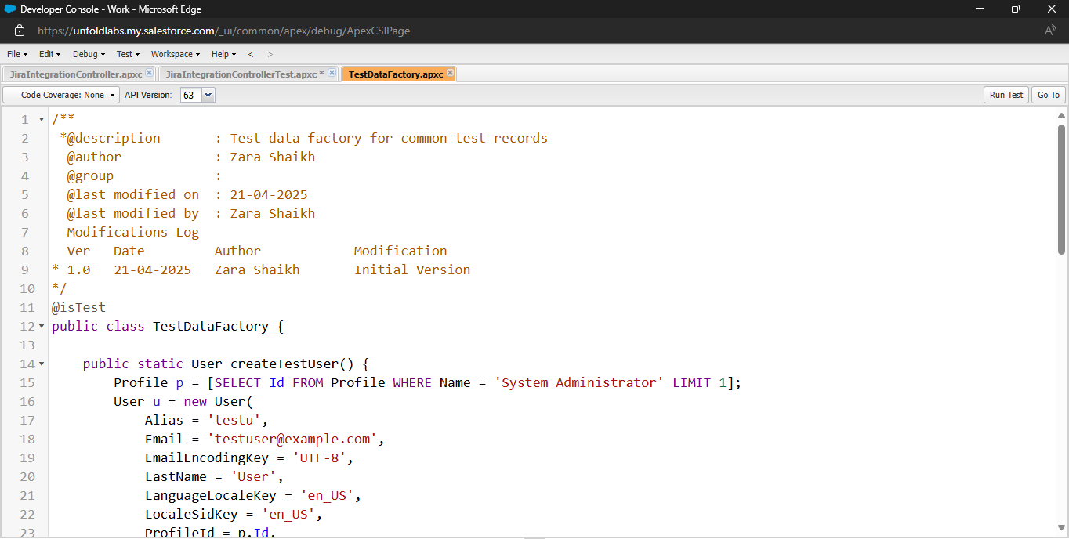
Kapture search Login credentials: Id: sivam@ctrlaltfix.co pwd: Siva@118
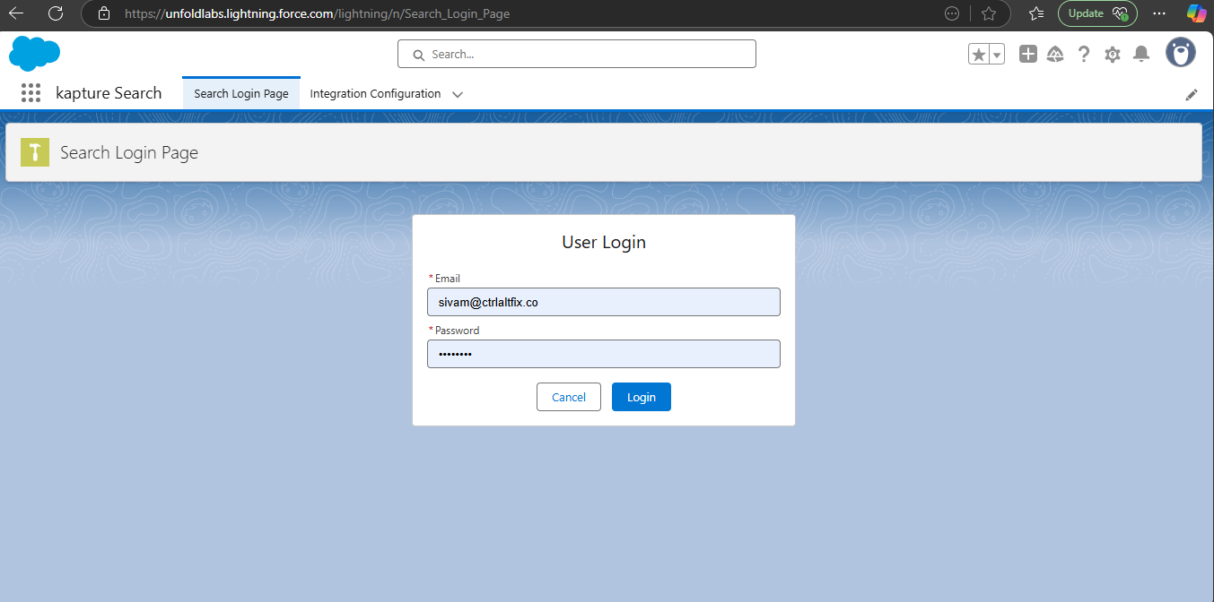
After successfully login, search page (based on 3 components: KaptureSearchBox, KaptureSearchResults, KaptureDocumentDetails)
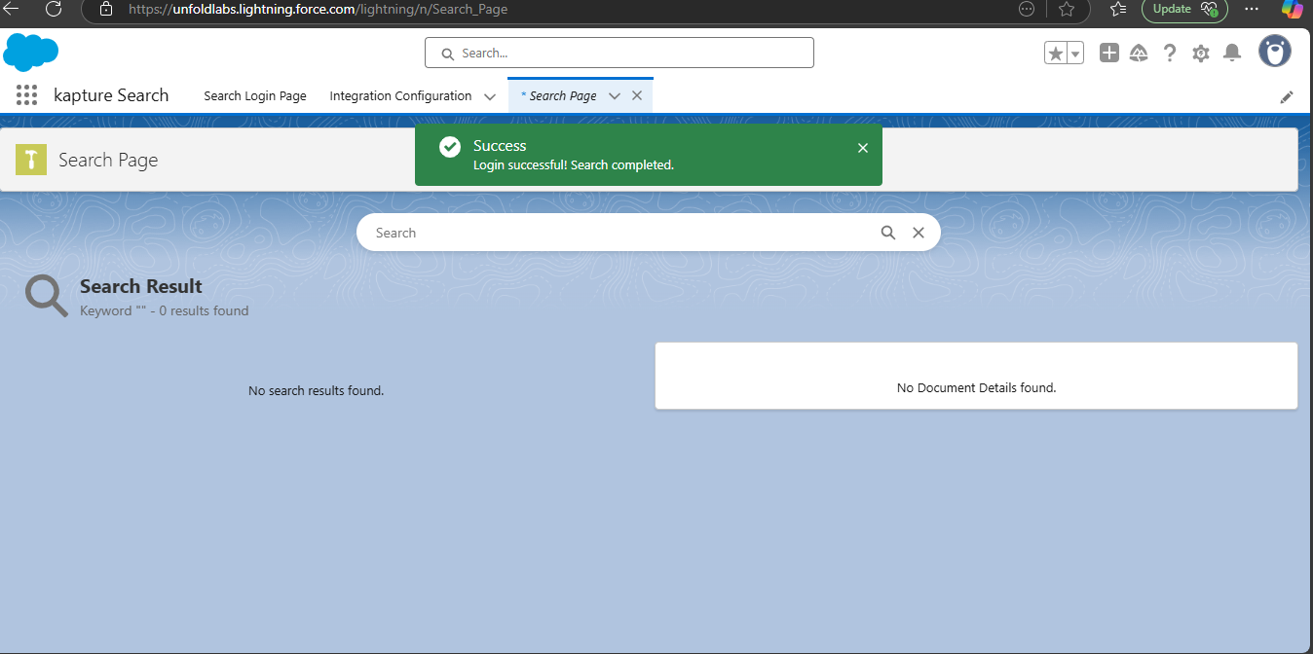
When we search Kapture in search box (KaptureSearchBox) all the kapture related search results will display in search results (KaptureSearchResults)
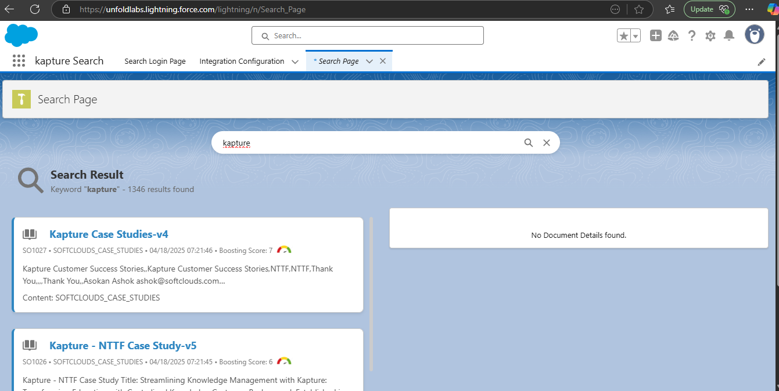
After that we click any one result the detail result will display in details result (KaptureDocumentDetails)
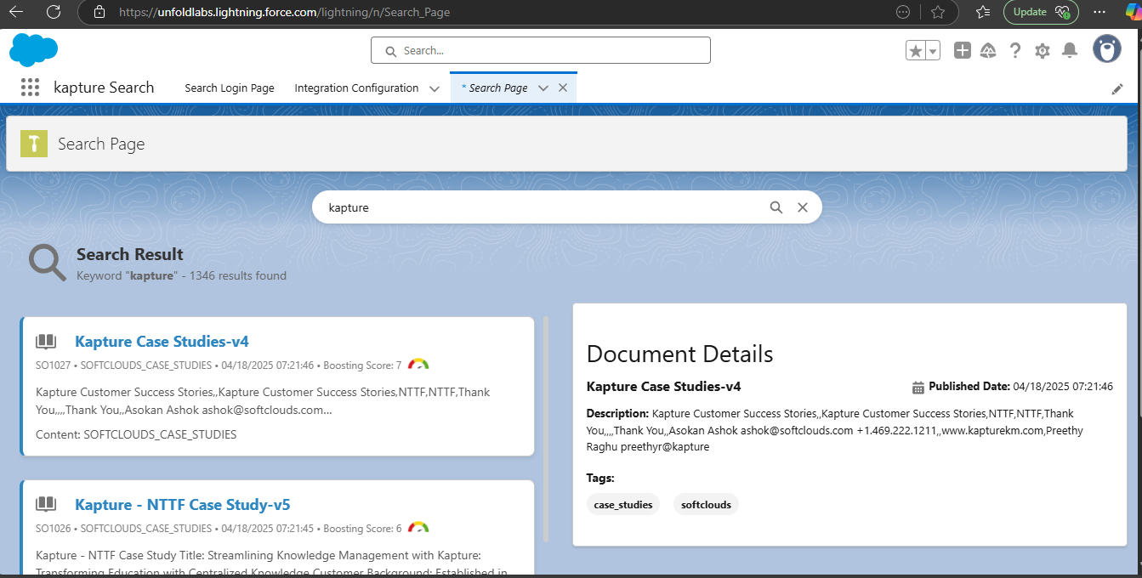
Flow:
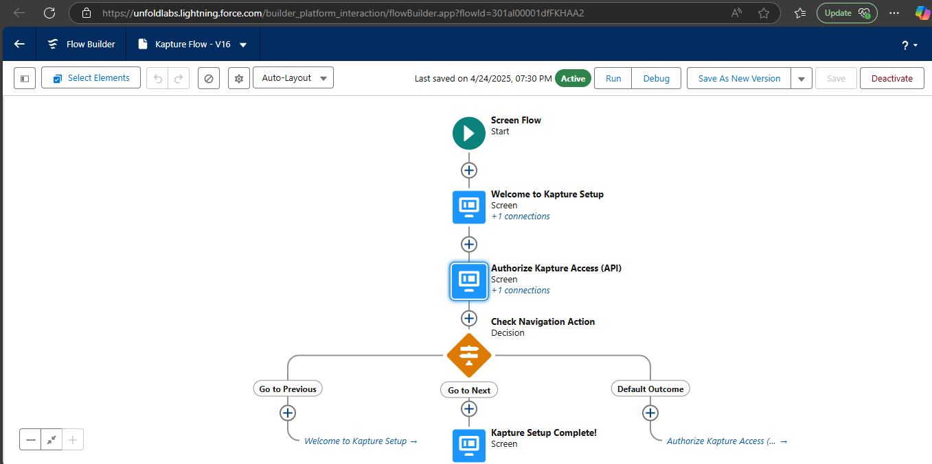
Test Coverage of SalesforceIntegrationControllerTest, SyncSalesforceControllerTest, JiraIntegrationControllerTest
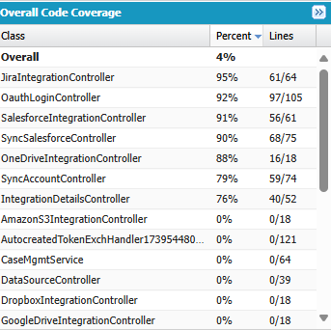
Custom settings for salesforce (SalesforceAPISettings)
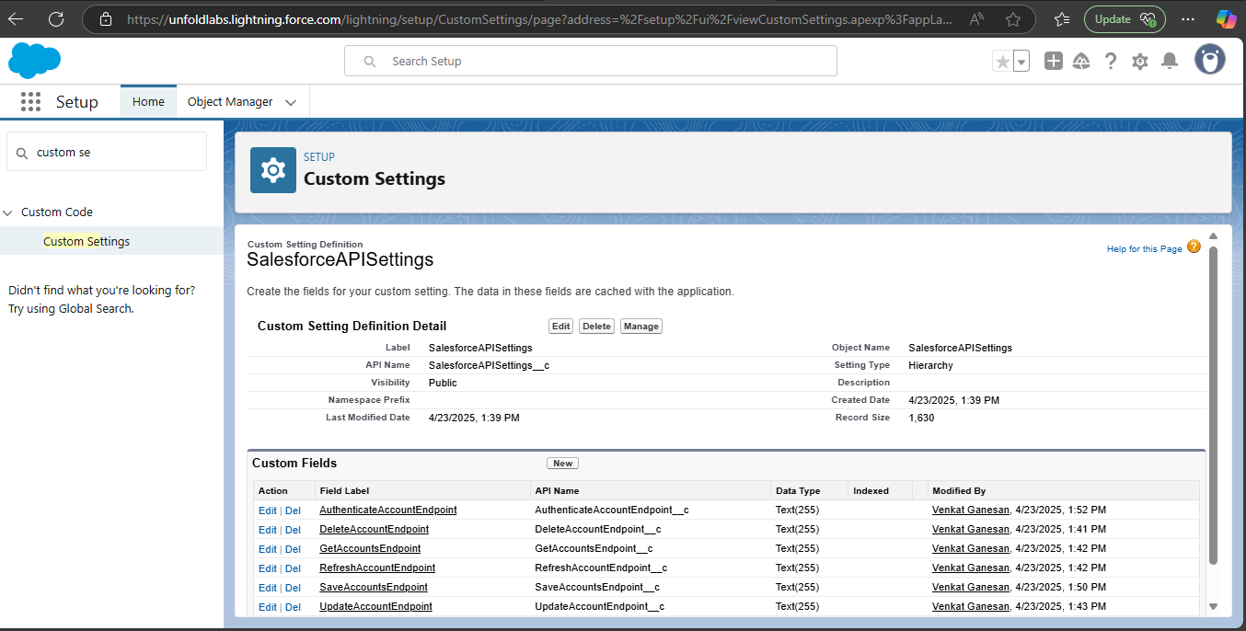
Object Modal: Integration Configuration
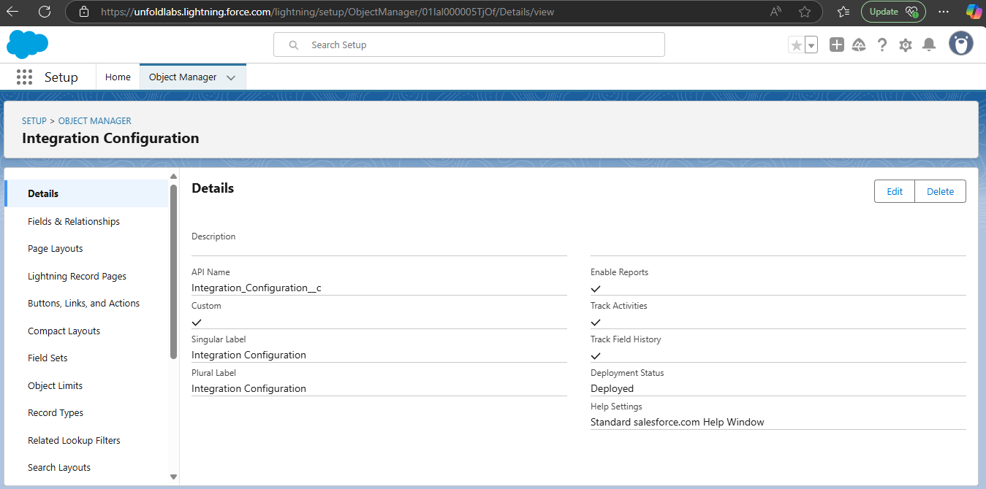
List View:
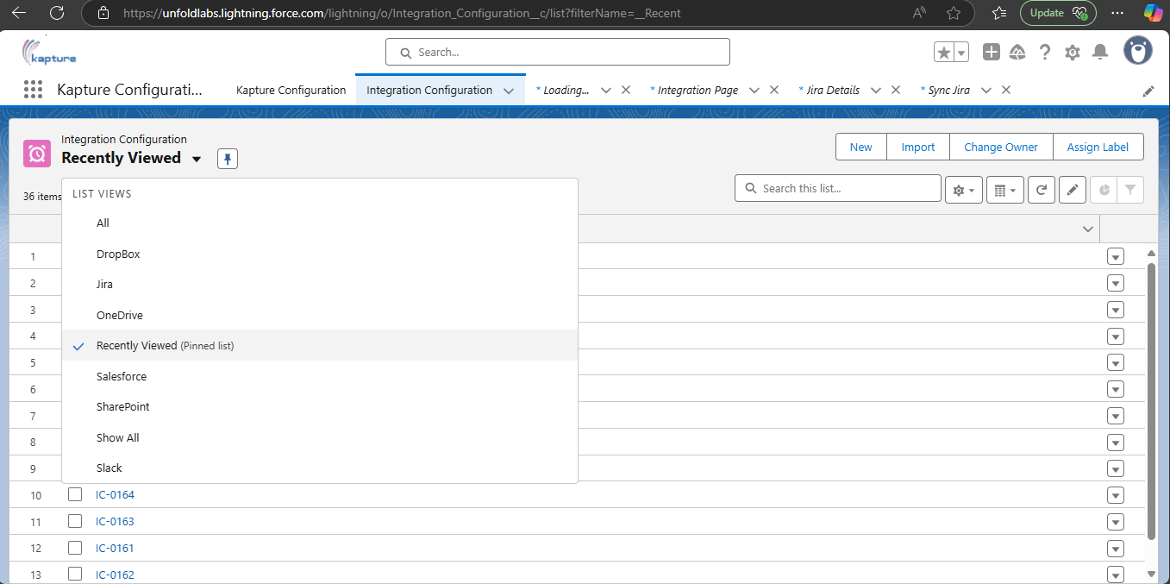
List of salesforce account in salesforce list view:
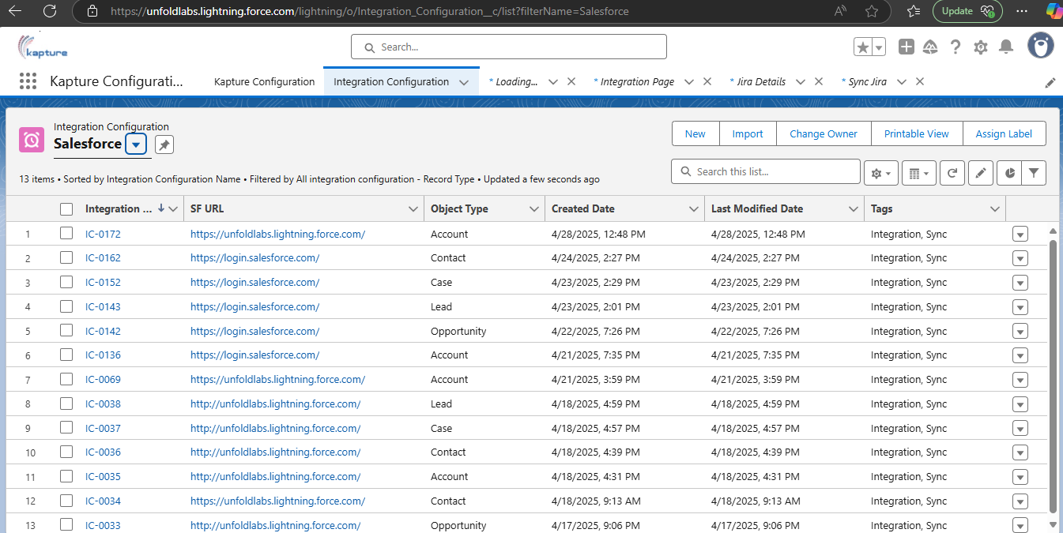
Custom profile: API User
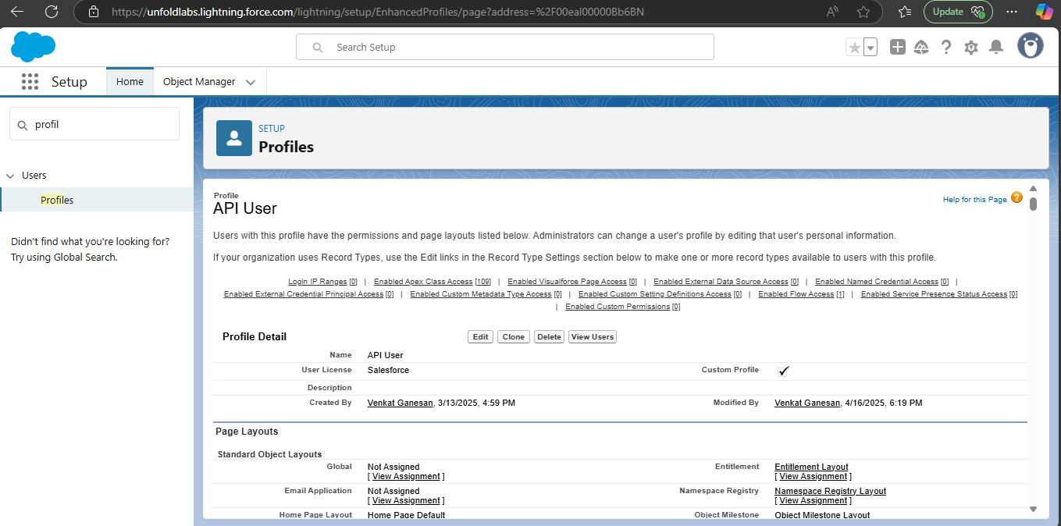
Permission sets: Kapture Access
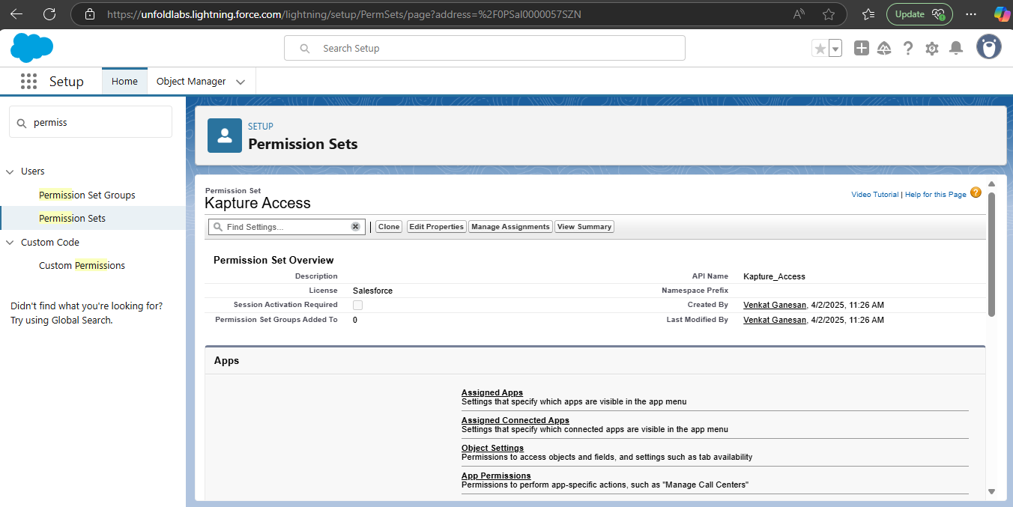
Lightning Experience App: Kapture Configuration
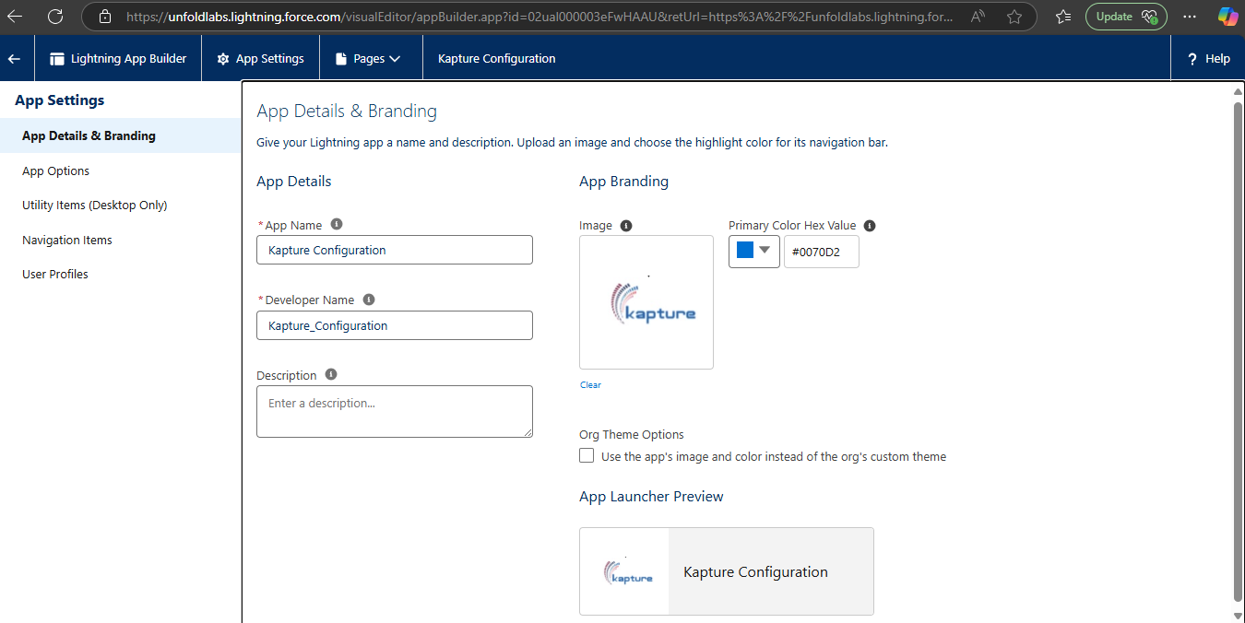
Kapture Search
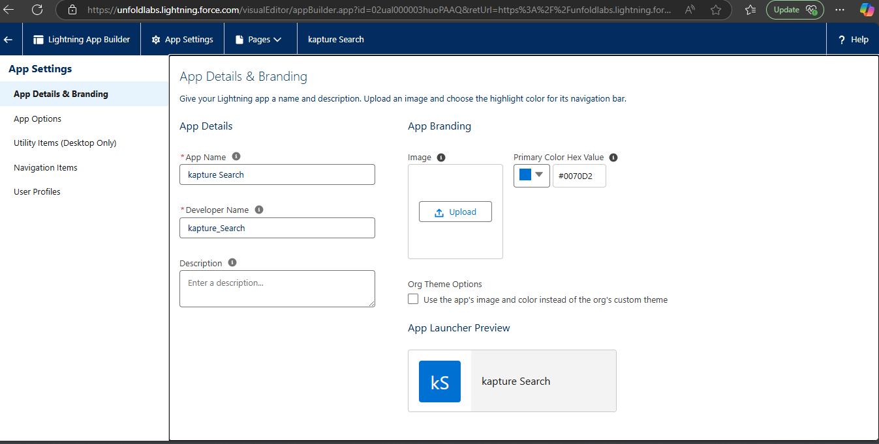
Managed Package

