

Kapture - Search - User Manual

Document Revision History
Date | Version No. | Author | Reviewer | Change Summary
30-04-2025 | 1.0 | Preetham C

Table of Contents
1 Introduction 4
2 Logging into ksearch 4
3 Dashboard Overview 5
3.1 Left Navigation Panel 5
3.2 Universal Search Bar 5
3.2.1 Features: 6
3.3 Top Navigation Bar 7
4 Home 7
4.1 How to Use the Home Screen 7
4.1.1 Generative AI Chatbot 8
4.2 Searching for a Document in kSearch 9
4.2.1 Viewing Document Details After Selecting Document ID in kSearch 10
4.2.2 Feedback Mechanism in Document Detail View (kSearch) 12
4.2.3 AI Assistance (Optional) 13
5 Content Browse 14
5.1 Accessing Content Browse 14
5.2 Document View Interface 15
6 Widgets 17
6.1 Accessing the Widgets 17
6.2 Widgets and Their Functions 17
6.2.1 Recently Published Documents 17
6.2.2 Top Rated Documents 18
6.2.3 Events Calendar 18
6.2.4 Bookmarked Articles 18
6.2.5 Top Searched Terms 18
6.2.6 User Rated Comments 18
6.2.7 Announcements 18

Introduction
kSearch is a unified AI-powered search and content discovery platform tailored for enterprise knowledge management. It enhances productivity by enabling users to search, interact, and derive insights from internal documents, manuals, and articles - all in one interface.

Logging into ksearch
To access the kSearch platform, follow the steps below:
- Open the web browser and enter the kAuthor login URL. You will see the ksearch login screen as shown below.
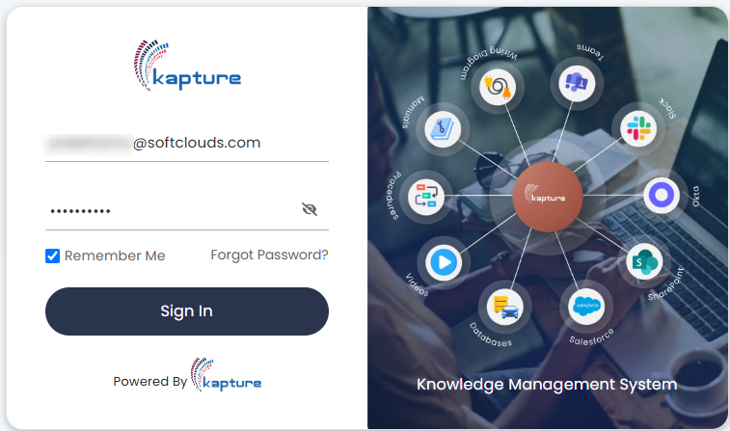
- Enter registered email ID in the first field.
- Enter secure password in the second field.
- Select the checkbox if you want the system to remember your login credentials for future logins.
- Click Forgot Password, if you need to reset your password. You will be redirected to a password recovery page to initiate the reset process.
- Click the Sign In button to log in to the ksearch account.

Dashboard Overview
The Kapture Search serves as the central workspace for all users, providing a streamlined interface to search, access, and navigate across knowledge assets, internal documentation, and GenAI-powered assistance tools.
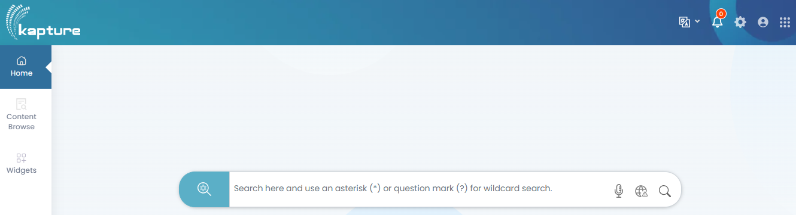
Following are the main components of Dashboard:

Left Navigation Panel
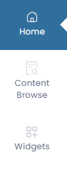
Menu Item | Description
Home | Default landing page with a universal search bar.
Content Browse | Navigate and filter content based on departments, categories, or metadata.
Widgets | View real-time highlights like top-rated, bookmarked, and most viewed docs.

Universal Search Bar
Positioned prominently at the centre of the dashboard, this is the gateway to finding relevant internal documentation.

Features:
Wildcard Search:
- Use * (asterisk) to match multiple characters.
- Use ? (question mark) to match a single character.
Voice Search:
- Click the microphone icon to search via voice command.
Store Offline:
- Allows users to download and store search results or articles locally on their device for offline access.
Search Assistant (Magnifying Glass Icon):
- Execute your query with one click.
Unified Search Interface
- Accessible from the Home tab.
- Allows users to perform document searches using keywords, voice input, or language-specific queries.
Search Intelligence with GenAI
- Offers three tone options for answers:
  - Standard, Classic, and Professional
- Supports direct question answering on selected documents using the GenAI assistant.
Extensive Search Options
- Filter content based on:
  - Integrations (e.g., Siebel, Kapture-GPT, Oracle Fusion GPT-4O)
  - Crawl Type and Document Type (doctype)
  - Use "Exact phrase" match with quotation marks
  - Exclude terms using minus (-) before a keyword (e.g., -draft)
- Wildcard search support with asterisk (*) and question mark (?)
Boosting Score Indicator
- Color-coded scoring:
  - Green/Yellow = strong match
  - Red = partial or weak match
Document Metadata & Insights
- Each result displays:
  - Document ID, timestamp, department, number of views
  - Likes, highlights, comments, and feedback options
AI-Powered Actions
- Voice search, language toggle, and AI reading assistant
- Features like playback at different speeds and selectable voices
User Actions on Documents
- Bookmark, download as PDF, highlight phrases, submit feedback
- Admin notifications (orange floater bars) for critical updates

Top Navigation Bar

Icon | Description
Language | Enables users to switch the interface language
Notifications | View recent alerts, updates, or announcements.
Settings | Customize user preferences and profile.
User Profile | Access user account options.

Home
The Home section of the kSearch dashboard is the primary landing page where users initiate intelligent document search. It serves as the command centre for content discovery, powered by both manual and AI-assisted options.
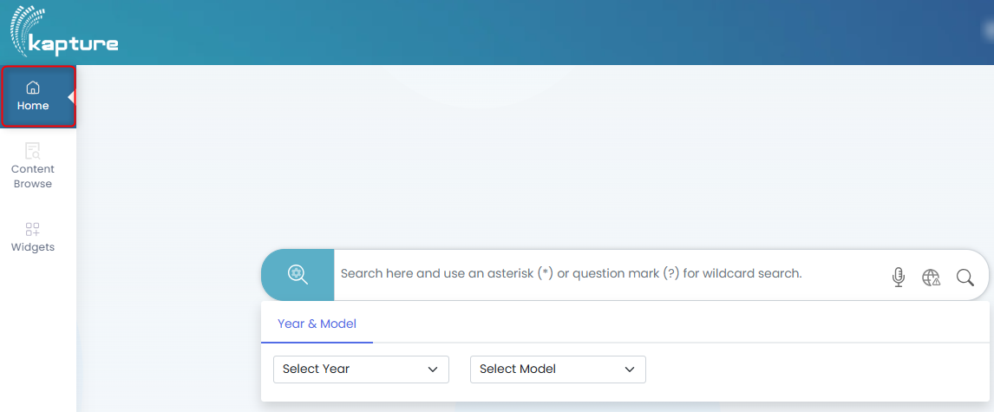

How to Use the Home Screen
- Enter the query in the search bar.
- Use special characters to improve results:
- (asterisk) for wildcard matches.
- ? (question mark) for single-character substitutions.
- Click the microphone icon to use voice input.
- Click the globe icon to download and store search results or articles locally on the device for offline access.

Generative AI Chatbot
Generative AI Chatbot enhances the search experience by enabling users to ask complex, natural language queries and receive contextually appropriate responses in real time.
How to Access the GenAI Chatbot:
- Locate the GenAI icon at the bottom-right corner of the dashboard.
- Click the chat bubble icon to launch the chatbot interface.
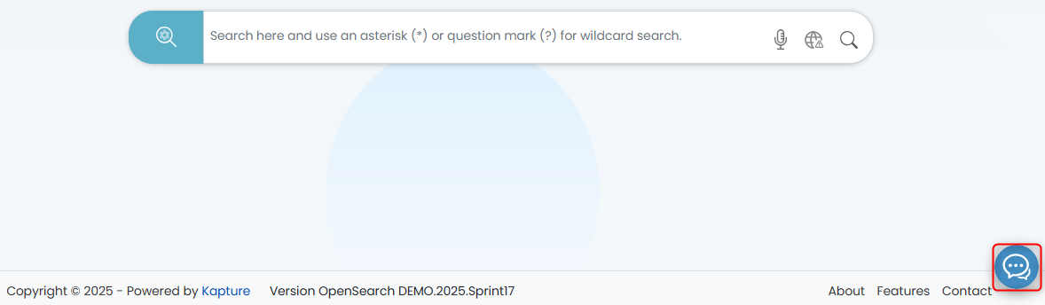
Key Functionalities:
- Conversational Querying: Instead of using strict keyword-based searches, users can enter full questions or commands like:
- “What’s the warranty policy for Kubota models launched in 2022?”
- “Show me oil change steps for X model.”
- Multiple Answer Styles: Choose the preferred tone or format of response:
- Classic - Simplified and direct.
- Standard - Balanced, informative tone.
- Professional - Formal and detailed, suitable for documentation or reports.
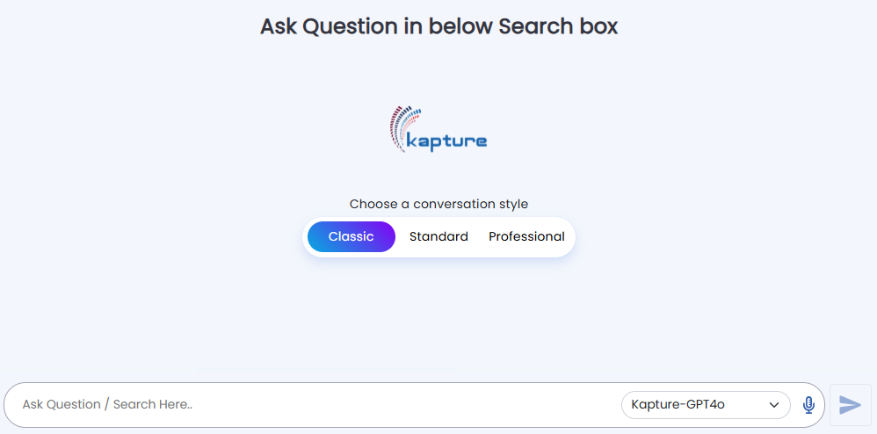
- Model Selection: Choose the desired AI backend (e.g., Kapture-GPT4o) to generate answers.
- Year & Model Filters: Use the dropdowns under the chatbot interface to select:
- Year
- Specific Model
Benefits:
- Reduces the time spent manually searching through large volumes of documentation.
- Returns concise answers pulled from the most relevant internal articles.
- Learns context from previous inputs to improve follow-up queries.

Additional Functionalities
Pre-Filters
- Users can pre-filter search results by selecting:
  - Crawl Type (how the document was indexed),
  - Document Type (manuals, support guides, etc.),
  - Tags or Categories.
- This improves relevance before the main search is triggered.
Saved Search Results
- Save frequently used queries.
- Access saved results with one click via the Search History icon or dashboard widget.
- Saves time for repetitive tasks or ongoing support issues.
Internationalization
- Language switcher (Globe icon) allows users to toggle between multiple supported languages.
- Ensures accessibility and usability for global users across regional teams.

Searching for a Document in kSearch
The kSearch feature in Kapture is a powerful internal search hub that helps users quickly locate and interact with relevant documents. Below are the step-by-step instructions on how to search for and navigate through documents using the kSearch feature.
- From the left navigation panel, click on the Home icon.
- You will see a central search bar displayed on the dashboard
- Click in the search bar and type your keyword (e.g., Automation).
- You may also:
- Use * for wildcard matches (e.g., Auto*).
- Use ? for single-character matches.
- Click the magnifying glass icon or press Enter to execute the search.
- Search results are displayed with details like:
- Title (e.g., Slack Automation)
- Document ID (e.g., AB6855)
- Source (e.g., AB_ONEDRIVE)
- Timestamp
- Boosting Score (indicates relevance: green/yellow for high match, red for partial match)
- Each result card includes:
- Content preview – first few lines of the document.
- View Count
- Boosting Indicator to help assess match quality.
- Related Documents (left panel)
- Similar Searches (left panel)
- Apply Filters
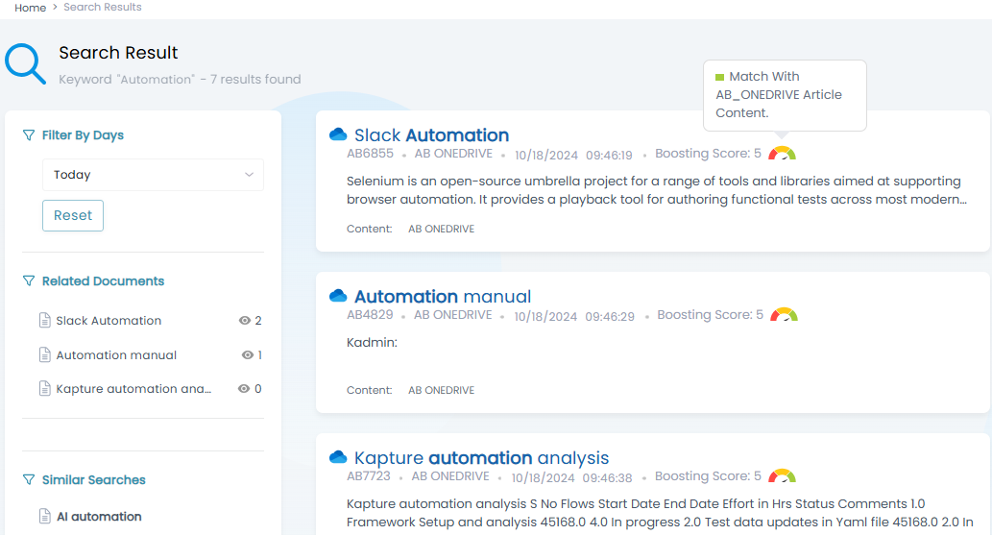
- You can refine results using the left sidebar filters:
- Filter by Days (e.g., Today, This Week)
- Related Documents
- Similar Searches
- Click on any search result (e.g., document AB6855) to:
- View full content
- Listen to the document at adjustable speed
- Highlight specific phrases
- Like, comment, or provide feedback
- Bookmark or export to PDF

Viewing Document Details After Selecting Document ID in kSearch
- Once you have selected a document by clicking its Document ID (e.g., AB6855) in kSearch, you are redirected to the document’s detailed view page.
- Following is how to navigate and use the available features:
- Title: Displayed prominently at the top (e.g., Slack Automation).
- Document ID: Shown under the title (e.g., AB6855).
- Published Date: When the document was made available (e.g., Oct 18, 2024).
- Time Metadata: View how many months ago the document was added and the number of views, replies, likes, and comments.
- Document Content Section provides a summary of the document's purpose and context.
- Title Section repeats the main title for clarity.
- All related files are listed under the Attachments section.
- You can:
  - Click the file name (e.g., Slack Automation) to open or download the file.
  - View the file type (PDF, Word, etc.) via the icon beside it.
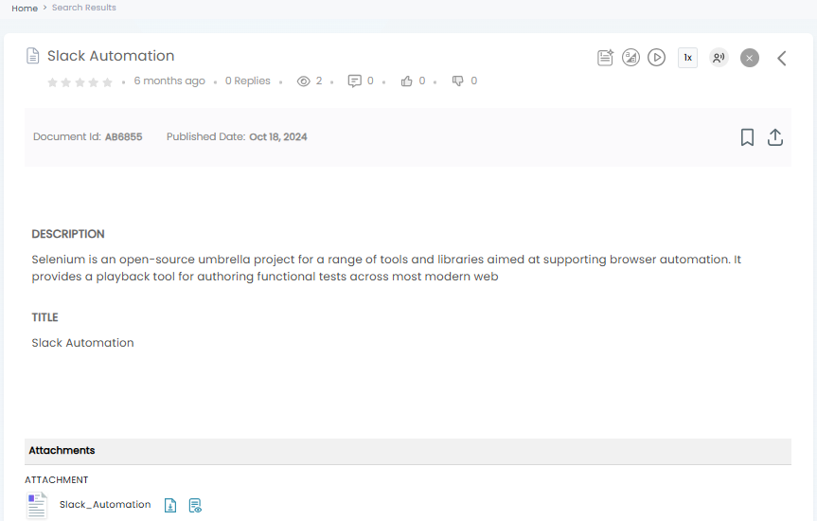

User Interaction Options
- Like the document to express feedback.
- Comment/Reply to leave suggestions or ask questions.
- Highlight a phrase for internal emphasis.
- Submit Feedback for improvements or flagging.

Feedback Mechanism in Document Detail View (kSearch)
Once a user selects a document (e.g., Document ID: AB6855), they land on the Document Details Page. This page not only displays the content and metadata but also includes interactive feedback options that help authors refine and enhance content quality.
How the Feedback Mechanism Works:
Rating and Reactions:
- Star Ratings: Users can rate the document using a 5-star system, visible at the top left beside the title.
- Reactions/Engagement Stats:
  - Views - How many times the article was accessed.
  - Replies - Number of user comments added.
  - Likes / Dislikes - Quick sentiment capture.
  - Comments - Users can post their feedback or clarification requests.
These metrics help gauge:
- The usefulness of the document.
- Whether the content requires revision, expansion, or clarification.
Comments and Replies:
Users can click the comment icon or scroll to the bottom of the document to leave a textual comment.
Comments can be used for:
- Requesting updates
- Reporting inaccuracies
- Suggesting improvements

Notification to the Author:
Once a comment or feedback is submitted:
- The document author is automatically notified via in-app alerts or email (depending on the system settings).
- This ensures that the author can:
- Respond promptly to user concerns.
- Make necessary content updates or clarifications.

AI Assistance (Optional)
The AI Assistant (GenAI) in the kSearch platform offers an interactive way to explore and understand documents more efficiently. It is especially helpful for users who prefer natural language interactions over traditional keyword search.
Key Features:
Ask Clarifying Questions:
- After opening a document, users can ask the GenAI assistant follow-up or contextual questions like:
  - “What is the procedure mentioned in this document?”
  - “Summarize this section.”
  - “What are the safety steps outlined here?”
- GenAI responds based on the actual content of the selected document.
Answer Tones / Styles:
Users can choose the tone of the AI's response depending on the target audience or purpose:
Tone | Description
Classic | Neutral and instructional. Suitable for general reference or internal use.
Standard | Friendly yet formal. Balanced tone ideal for business communications.
Professional | Polished and formal tone with precise language for executives or external use.

How to Access:
- Click the GenAI (chat icon) located at the bottom right of the dashboard.
- Choose a conversation style: Classic, Standard, or Professional.
- Type your question in the input field.
- (Optional) Select the appropriate model version (e.g., Kapture-GPT4o).
- Press Enter or click the Send icon to receive a response.

Content Browse
The Content Browse section in kSearch allows users to efficiently navigate and explore internal knowledge articles categorized by departments, document types, or business domains. It provides a structured, filterable interface for accessing wisdom content relevant to your team or process.

Accessing Content Browse
- On the left sidebar, click the Content Browse tab (second icon below Home).
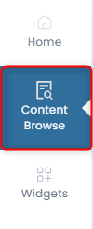
- This opens a categorized view of articles based on Article Type, such as:
- Kubota General Support
- Kubota Service Manuals
- Meiban Engg Tech
- NTTF ISO Standards
- OSVC CRM, etc.
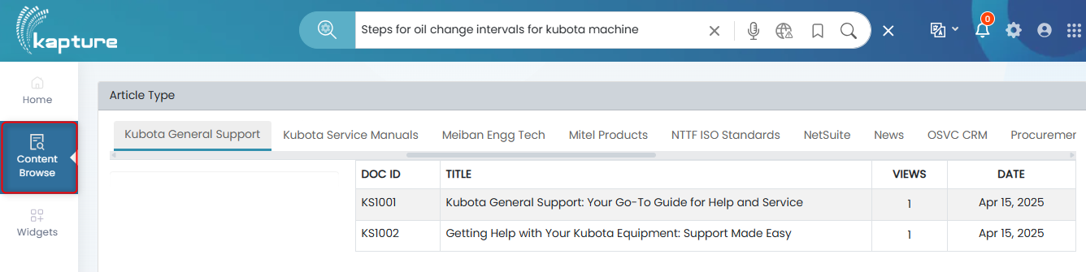
Navigating Articles
Each tab corresponds to a functional area or department. For each listed article, you'll see:
- DOC ID - A unique identifier for the article (e.g., KS1001).
- TITLE - A summary of the article’s content.
- VIEWS - Number of times the article has been viewed.
- DATE - The date the article was last published or updated.

- Click on a Doc ID (e.g., KS1001), you are directed to the full article view where you can access complete content, metadata, and approval details.

Document View Interface
Document Header
- Title: Displays the full article title.
- Doc ID: Unique identifier for internal tracking (e.g., KS1001).
- Published Date: Shows the article’s publishing timestamp.
- Engagement Stats:
- Views, Likes, Comments, and Replies.
- Icons for article interactions (bookmark, download, AI assist, etc.).
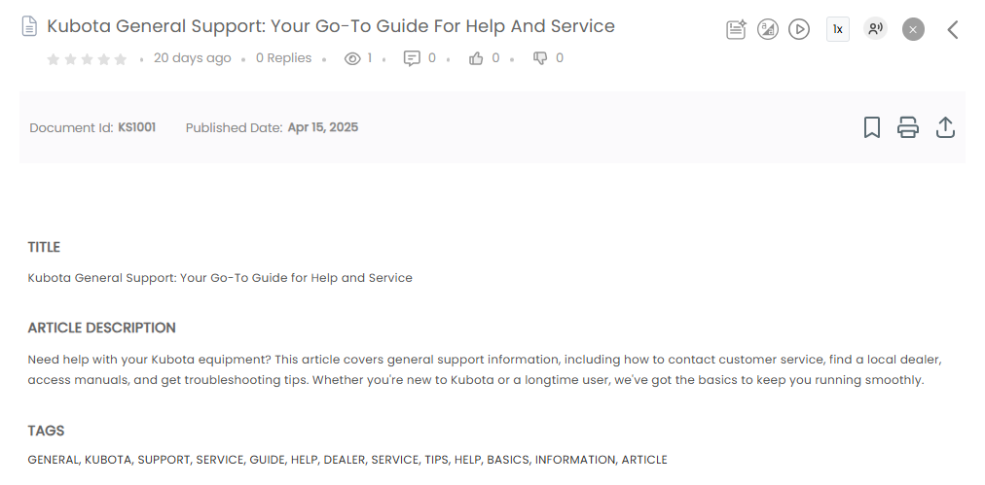
Content Area
- Article Description: A detailed write-up to guide users (e.g., how to contact support, access manuals).
- Tags: Displays tags like SUPPORT, GUIDE, KUBOTA, etc., which help improve searchability.

Approval Section
Approval section captures the lifecycle of the document:
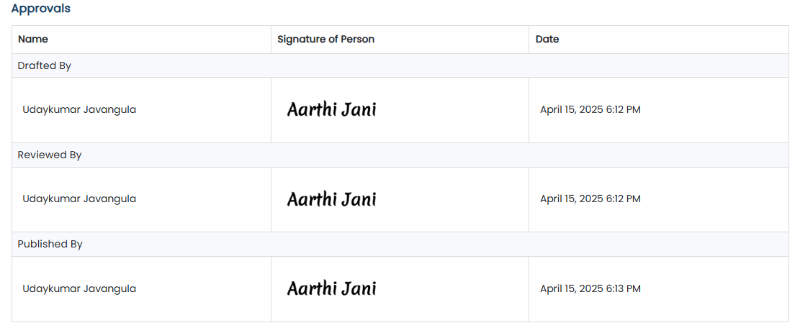

Top Right Utilities
Icons available for user actions:
- Bookmark: Save the document for quick access.
- Share: Export/download or share internally.
- Listen: Use AI voice assistant to hear the document content.
- Highlight: Emphasize keywords or parts of interest.
- AI Assistant: Interact with AI for quick summary or contextual answers.
- Comment: Leave insights or feedback.
- Speed & Voice Control: Adjust audio playback speed or switch to preferred voice.

Widgets
The Widgets section in kSearch provides a quick, organized overview of categorized content insights. These widgets help users stay informed and easily access relevant documents, events, comments, and searches without performing a manual lookup.

Accessing the Widgets
- On the left panel, click Widgets.
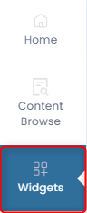
- You will be redirected to the Widgets Dashboard, where different content categories are displayed in separate panels.

Widgets and Their Functions

Recently Published Documents
- Displays the most recently uploaded or approved articles.
- Helps users stay updated on the latest content available in the system.
- Currently shows “No Data Found” if no documents are published recently.
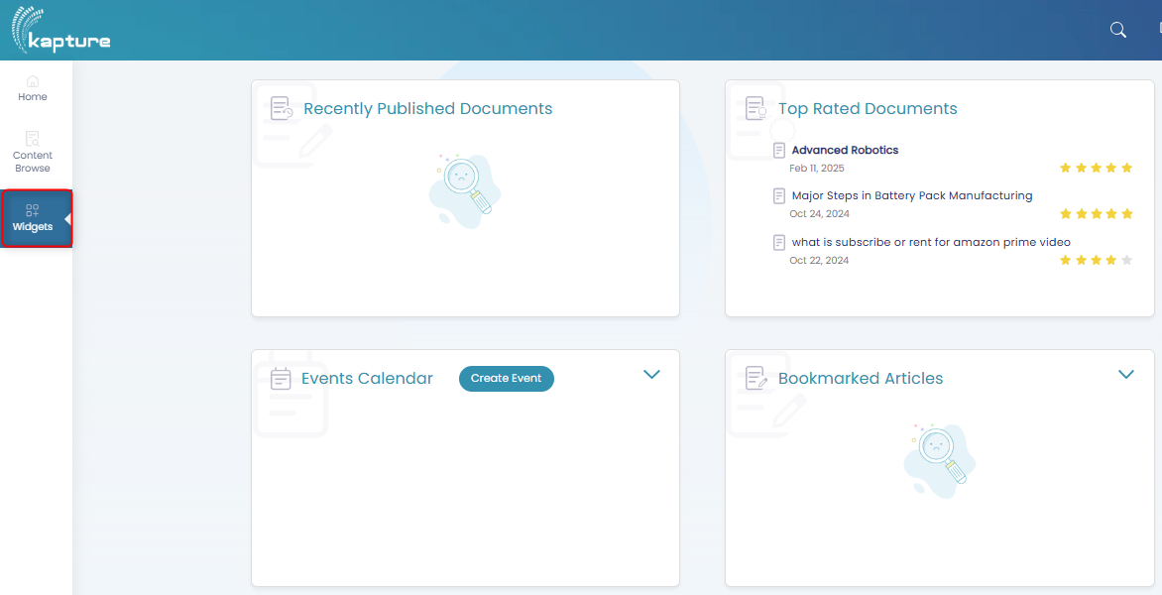

Top Rated Documents
- Lists documents that received the highest user ratings.
- You can see the document title, date, and star rating.
- Example: Advanced Robotics and Battery Pack Manufacturing articles are top-rated.

Events Calendar
- View or create calendar events.
- Click on Create Event to log training sessions, article discussions, or team meetings.

Bookmarked Articles
- Displays all documents that the user has bookmarked for future reference.
- If empty, it will show a message indicating no bookmarks are saved.

Top Searched Terms
- Shows a word cloud or list of the most frequently searched keywords or phrases.
- Clicking a term directly opens the search result for that keyword.
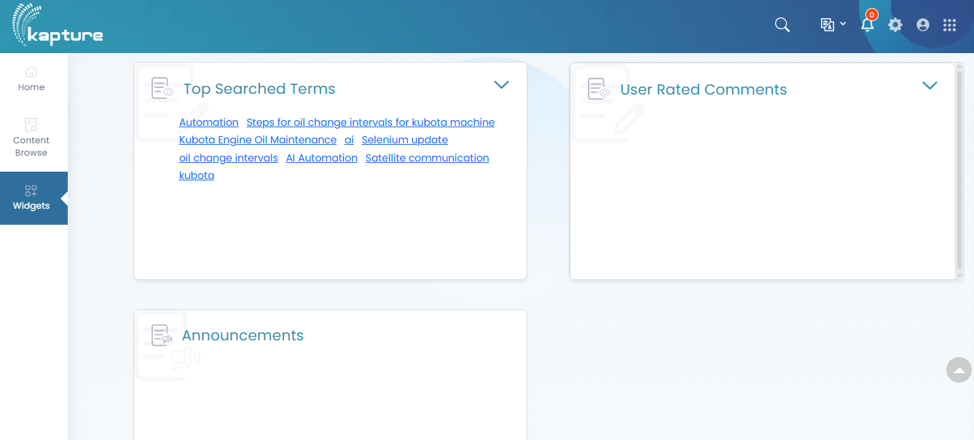

User Rated Comments
- Displays articles with the highest-rated user comments.
- Great for identifying documents that received community validation or feedback.

Announcements
- Admin-driven announcements or updates are listed here.
- This can include system notifications, upcoming releases, or training info.

