Kapture-User Story-34- Send article translation (or any task) requests to other users or work team as well as workflows



Contents

Introduction 4
Overview 4
Requirements 4

Introduction
This document defines the feature of sending notification and listing out the tasks assigned for logged in user with status.

Overview
When a workflow is assigned to, store the following details for that user w.r.t article.
- Current Workflow Step
- Channel of the article
- Created & Updated Date of assignment
- Task Assignment Type (Translation, Workflow)
Allow user to filter the tasks based on status – Assigned & Unassigned.

Requirements
When a task or workflow is assigned to User, when the logged-in to kAuthoring he/she should view the list of workflow tasks that are assigned along with the details. User should be able to filter the records by provided filters
- Assigned user
- Assignment Type
- Views
- Channels
- And Locale
Tasks View in kAuthoring:
Add new section named “Inbox” to view the list of tasks assigned for the users. Allow user to filter the records with pagination.
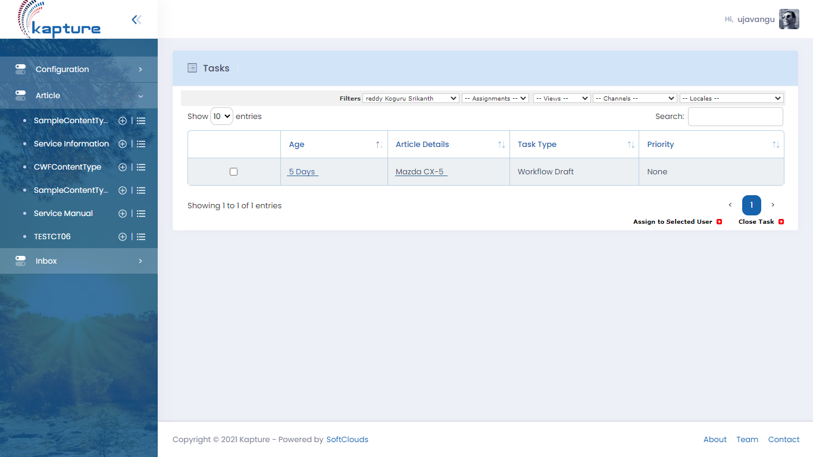
In case to view the history of the task, user can click on the “Age” link that re-directs to history of task.
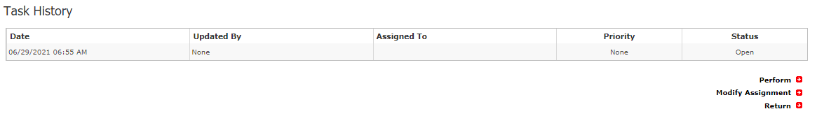
On selection of Article details link, navigate to the details of the Article along with Task details as mentioned below.

