Conditional Section


Contents
Introduction 3
Overview 3
Requirements 3

Introduction
This document details Conditional Sections in Kapture CMS.

Overview
There are two ways we can define conditional section to an article. Conditional section to the entire document or to the attributes level. This will ensure the data is secured and only those assigned to the user group will be able to access the content in the conditional sections in ksearch.

Requirements
Below are the modules within authoring.
- User Group
  - Create/Add User Groups in kadmin
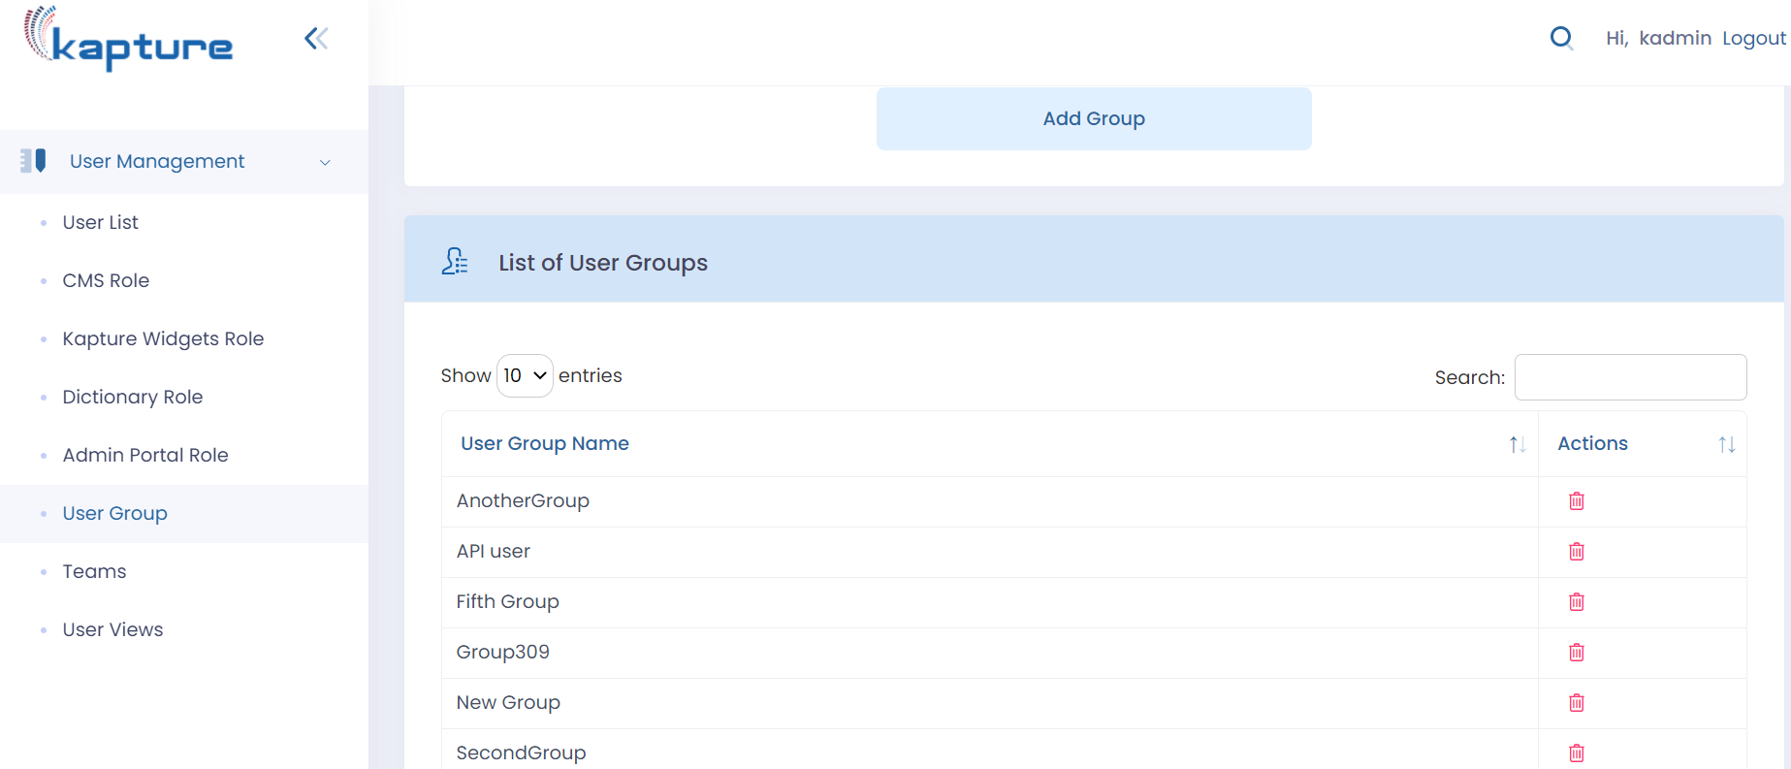
  - Add User Group to the content type. This will ensure that the entire content would be available to the end users based on the user group assigned to their user profile.
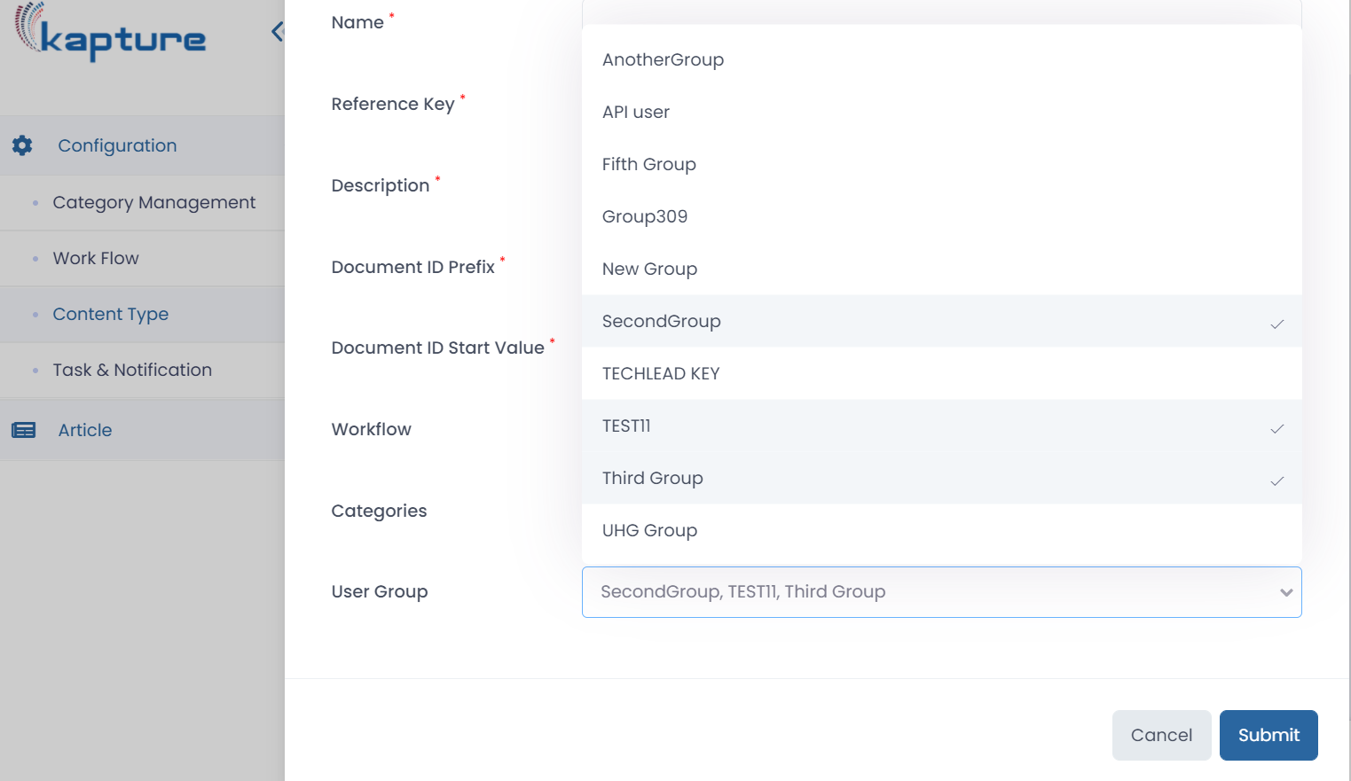

  - Insert a checkbox or multi select dropdown field to select usergroups that can see the content type.

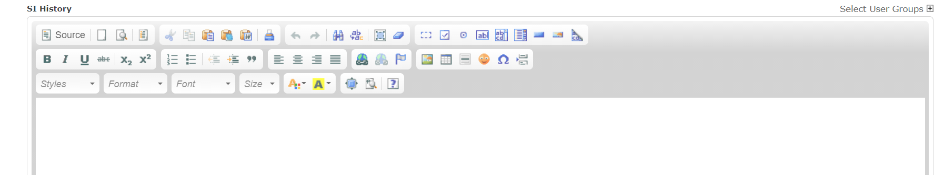
  - When we click on “Select Usergroup” it will display the list of usergroups assigned to the content type.

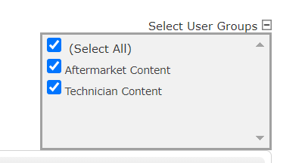

  - We can select multiple usergroups within the specific attribute. The user with specific usergroup would be able to access the specific information within the attribute. If Aftermarket content is selected then the information in the attribute would be accessed by the Aftermarket content user and if the Technician content is selected then the information in the attribute would be accessed by the user with Technician content Usergroup. This feature would ensure that the data is secured and is available to the limited audience.

