Kapture-User Subscription


Contents

Introduction 3
Overview 3
Requirements 3
Subscription Expirations 5
Subscription Batch Jobs 6

Introduction
User Subscriptions allow you to configure automatic content following options on a channel based on group membership. See the article on Subscriptions for more detail.

Overview
Admin can create and manage content subscriptions to enable end-users to subscribe to content by:
• Channel
• One or more categories within a subscribed channel
• Specific documents (by Document ID)
Subscriptions are objects within the Content Type, with properties, such as a name, allowing administrators to create, manage, and provide subscriptions to the uses.
Subscriptions also expire automatically, and users can renew or cancel subscriptions. By default, the expiration period is 90 days. Details given in “Subscription Expirations” section.

Requirements
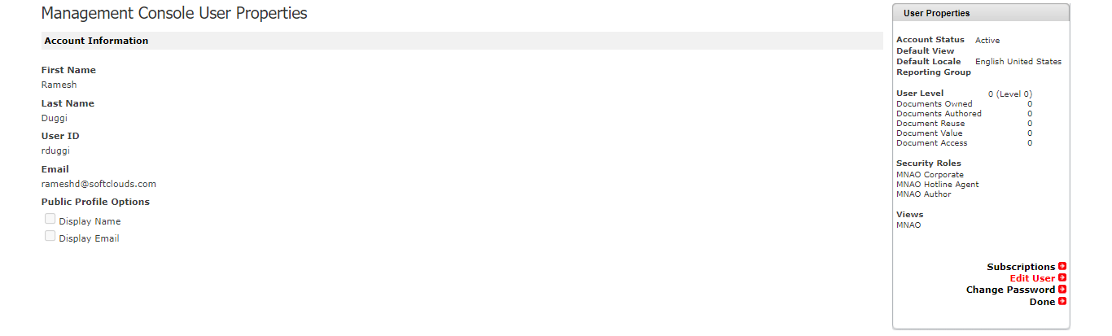

Subscriptions

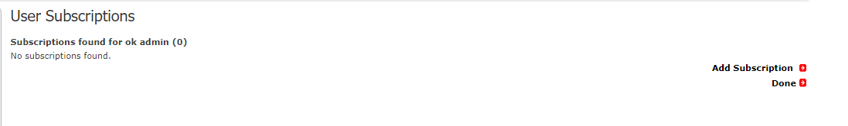

Add subscriptions
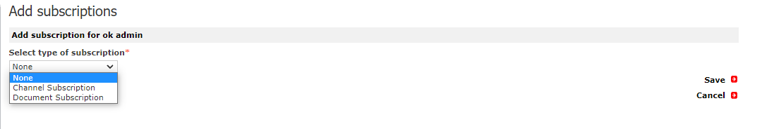

For Add Subscriptions, if Channel Subscription is being selected, populate below fields to make entries.

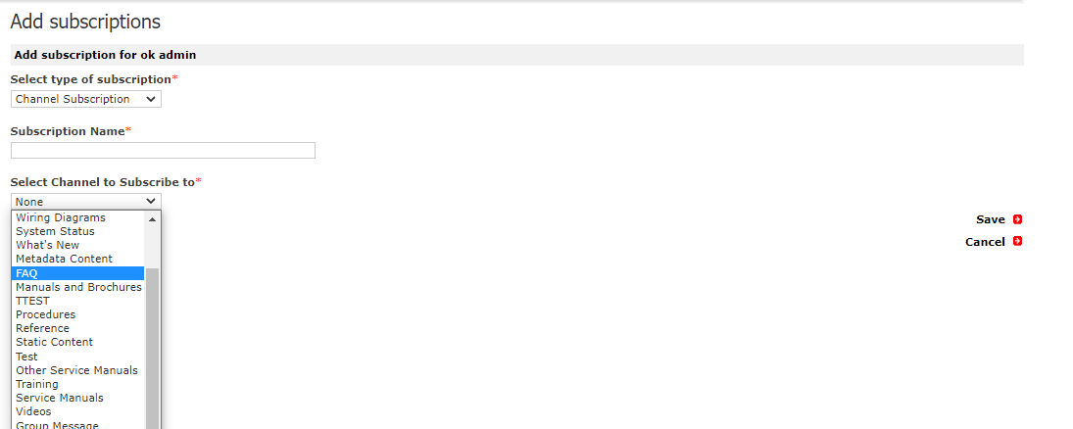

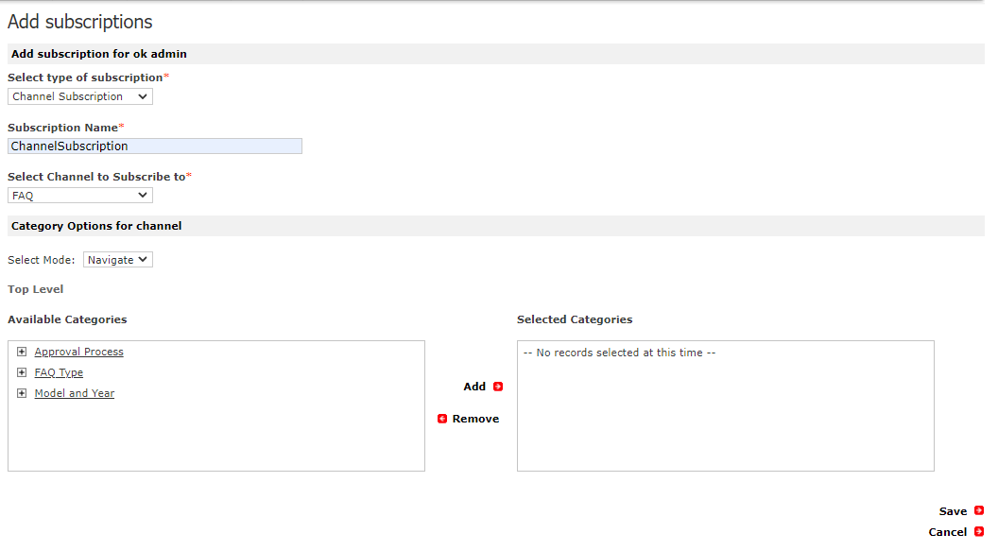

For Document Subscription,

Provide name of the subscription and chose the Content Type, based on the selection document id can be given manually or use “Search for Documents” option to find the required document.

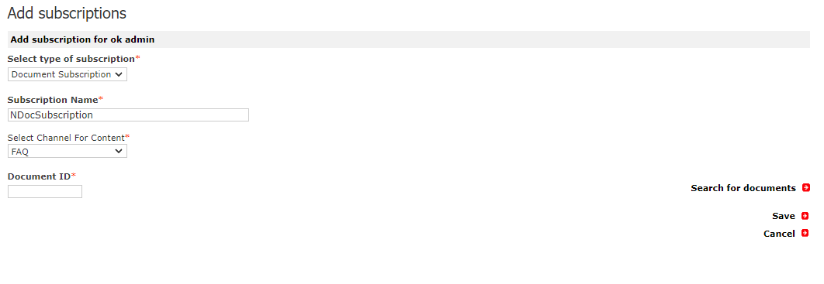

List of Subscriptions should be displayed after adding a subscription.
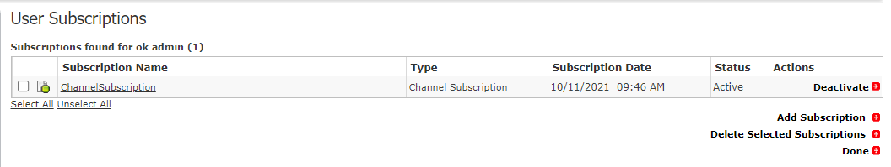

Subscription can be activated & deactivated, selected subscription can be deleted.

Subscription Expirations
Subscriptions expire after 90 days, by default. It can be reset the subscription expiration period by navigating to Inbox > Subscription Expirations
SUBSCRIPTION_END_DAYS parameter to reset the Parameter Value to another time period:
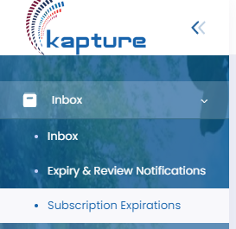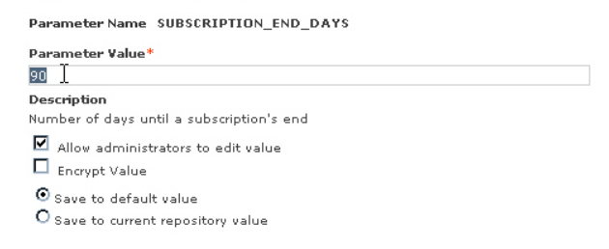

Subscription Batch Jobs
We require to setup three batch jobs related to subscriptions:
Send Subscription Emails
Use this job to send content-update notification emails to subscribers. The frequency setting can be overridden for individual users.
Expiring Subscriptions Notification
Use this job to search for subscriptions that will expire within a certain number of days and send notification emails to subscribers. By default, the expiration period is 90 days.
Delete Expired
Use this job to search for expired subscriptions and delete them.

