Kapture-User Story-17- Create an article under particular content type for logged-in user’s primary language


Contents

Introduction 3
Overview 3
Requirements 3

Introduction
This document defines the feature of article creation under specific Content Type in kAuthoring module.

Overview
Kapture allows user to manage the relationship of an article across different locales and languages, providing authors will have ability to develop locale-specific content and fine-tuning of the customer experience.
- Create an article under particular content type for logged-in user’s primary language.
- If user had multiple locales enabled – chose one of the assigned languages

Requirements
Under kAuthoring module, when an article is created for a Content Type, by default the article should be created for user profile specific locale. If the user had multiple locales, choose the primary locale.
As an author, user can create and publish articles, periodically update them, translate them into supported locales, and unpublish them when they are no longer needed.
Article List & Search Screen:
- By Default, display User Profile specific locale Articles
- If user changes the locale for performing the search, display results accordingly.
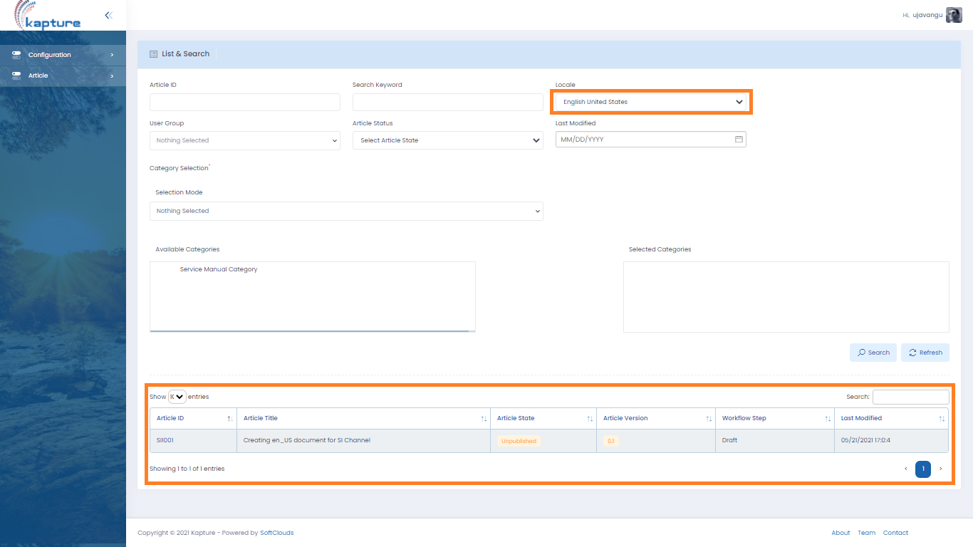

Creating a new Article for another locale:
- When a new article is being created, please create under user’s primary locale.
- Article ID should be created with format “ArticleNo” _ “Locale” (ex: KA001_en_US)
- If a new article created with another locale, article should be created with same article ID with the user selected locale
- Article status should be set to Draft by default.
  - If the content type does not contain any workflow, create the article, publish it.
  - If the content type had any workflow, content should undergo with respective workflow.
Request for Translation Steps
  - Allows user to create translated versions of articles in this Content Type for the locales specified in the user profile.
  - The Translate option of the Content Preview page displays only to authorized users
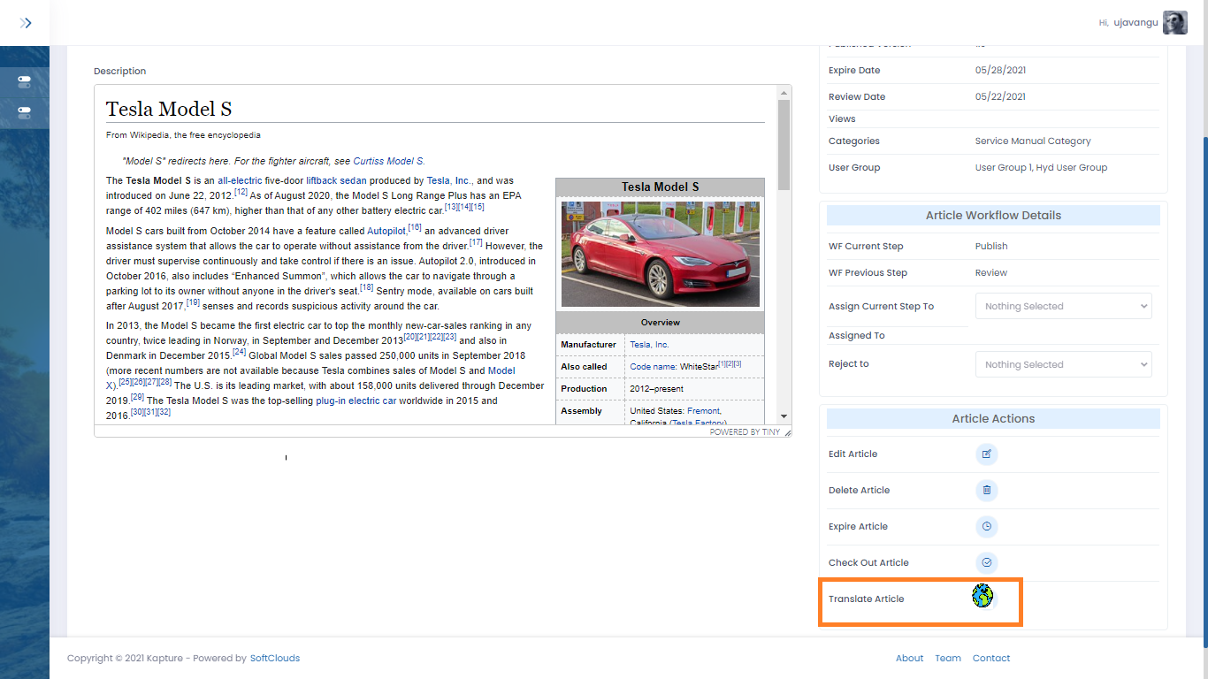
When the translation article option clicked, it’ll expand to display available languages, allowing user to request for on preferred language translation.
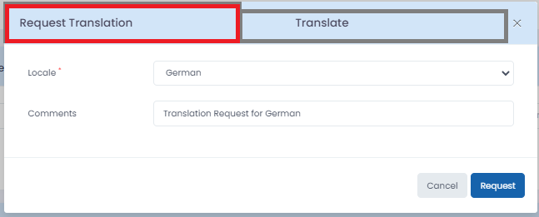
Under Request Translation tab, User can select multi-selection on locales that the translations required and that can be requested.
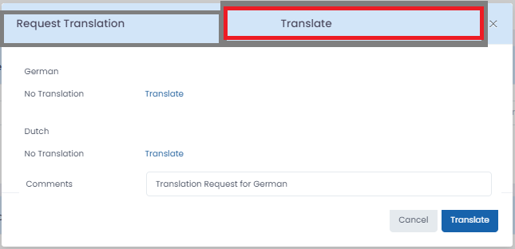
Under Translate tab, User can see the list of Translation requests and user case select the “Translate” option for the required locales.
Once user requests for “Translate”, we should display the current content for the user profile locale, and corresponding fields for the selected locale for translation.
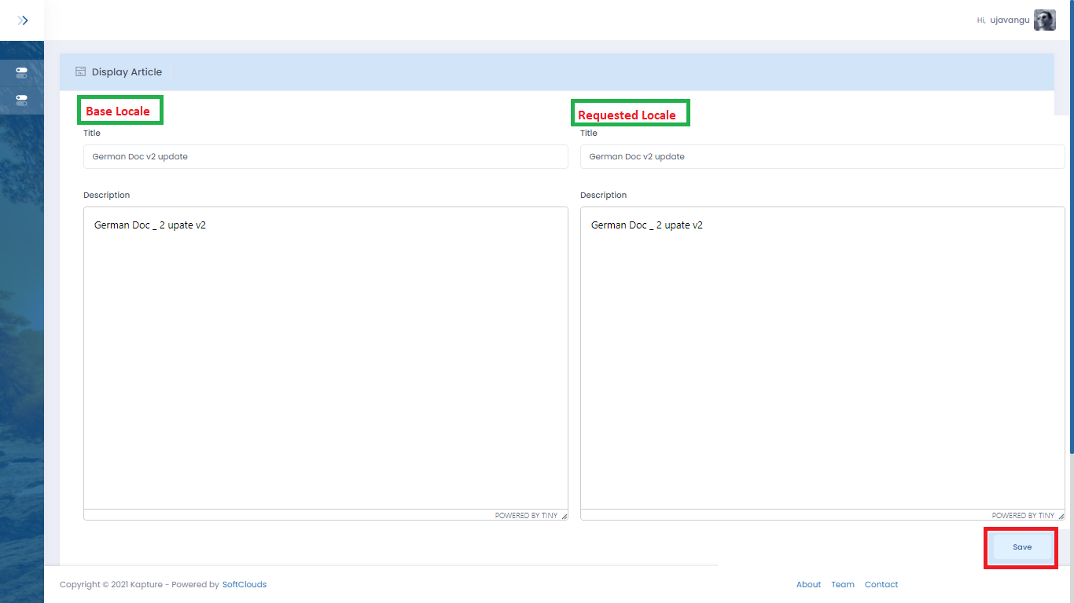
One selection of “Save” option, the document should be saved and published and should undergo with respective Workflow.

