Overview:
In addition to existing connectors, Dropbox is being introduced as a new type of integration in Kapture.
Should be available under Integrations > Add Dropbox section.
Integration & Crawling process remains same as existing. And follow below instructions to setup Dropbox account.
Dropbox – Setup steps:
- Sign in into Dropbox Business Account:
  - Access Dropbox Business website (https://www.dropbox.com/business) and sign in with your business account credentials.
- Open the App Console:
  - Go to the App Console in Dropbox account.
- Create a New App:
  - Click on the "Create App" button.
- Choose an API:
  - Select the "Scoped access" option which allows access to specific files and folders.
- Choose the Type of Access:
  - Select "Full dropbox" if you need access to the entire Dropbox or "App folder" if you only need access to a specific folder.
- Name Your App:
  - Enter a name for your app. Ex: given KaptureKM.
  - And click on “Create App” button
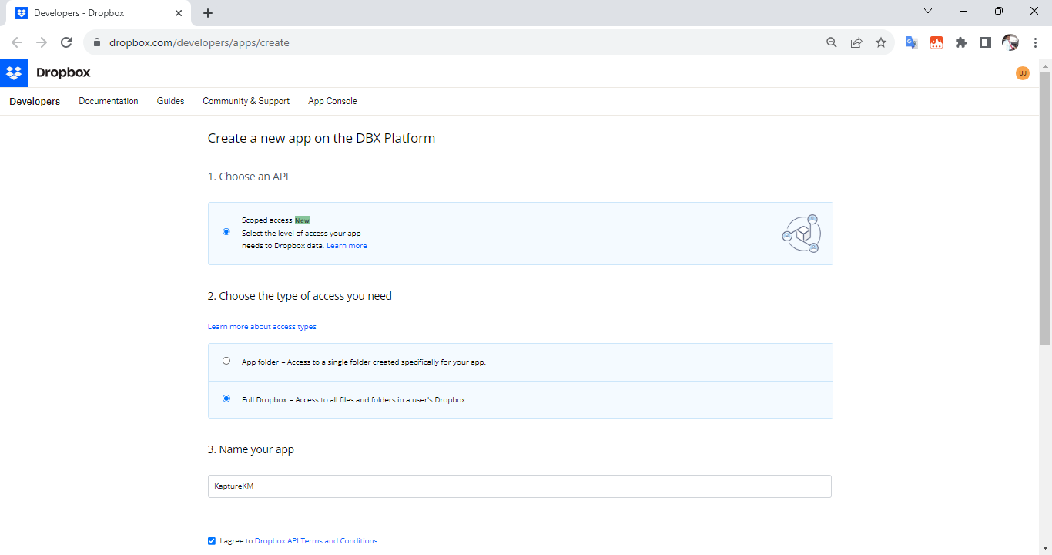
- Generate the Access Token:
  - Once the app is set up, go to the "Settings" tab within the App Console.
  - Scroll down to the "OAuth 2" section and find the "OAuth 2 access token" section.
  - Click on the "Generate" button to create a new access token.

- Set Permissions:
  - Configure the permissions for the created app. Choose the level of access it will have.
  - You can also specify what type of data your app will access - files and metadata, or just metadata.
Ex: Account Info:
Enable all .read permission ex: account_info.read, files.content.read
- Copy and Save the Access Token:
  - The generated access token will be displayed. Copy this token and make sure to save it securely, as it won't be shown again.
- Once everything is done, the created App will be listed.
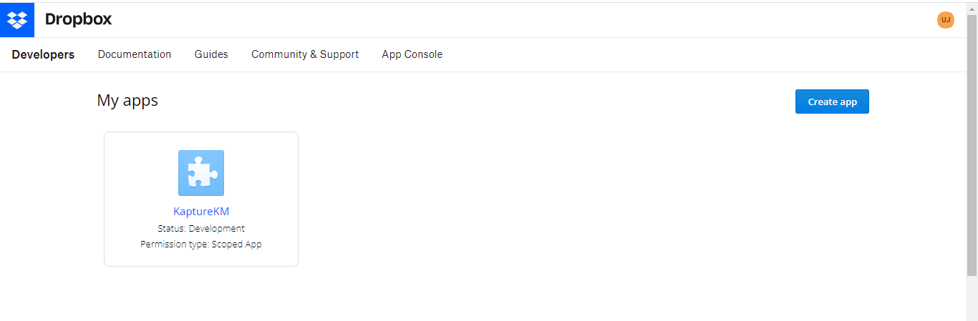
Refer documentation: https://www.dropbox.com/developers/documentation/java

To retrieve user account information
API : https://api.dropboxapi.com/2/users/get_current_account
Reference: https://github.com/dropbox/dropbox-sdk-java#dropbox-for-java-tutorial

Maven dependencies for pom.xml
<dependency>
<groupId>com.google.code.gson</groupId>
<artifactId>gson</artifactId>
<version>2.8.8</version>
</dependency>
<dependency>
<groupId>com.dropbox.core</groupId>
<artifactId>dropbox-core-sdk</artifactId>
<version>3.1.4</version>
</dependency>

