Service-Connect – Improvements



Contents
Introduction 3
Overview 3
Requirements 3

Introduction
This document describes the improvements needed for the Service connect application to fulfill agent-customer issue resolution flow.

Overview
The new enhancements cover to indicate the life cycle of case, tracking user log, and resolution of case closure also generating the knowledge based on case resolution.

Requirements
Use Story: Service Connect Enhancements.
The following enhancements should be fulfilled:
- Life Cycle | Timeline of Case
  - When the case has been opened, display the life cycle of the Case in below format.
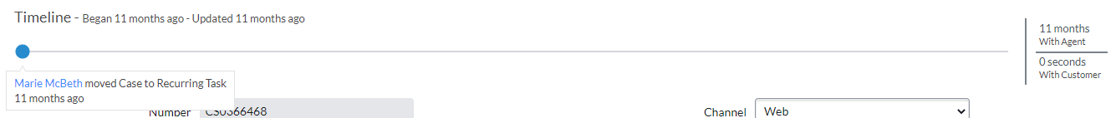

- Case Logs | Time Worked
  - To resolve a case, it must be worked by different people in the system, the work logs can be added by each user using the Case Log.
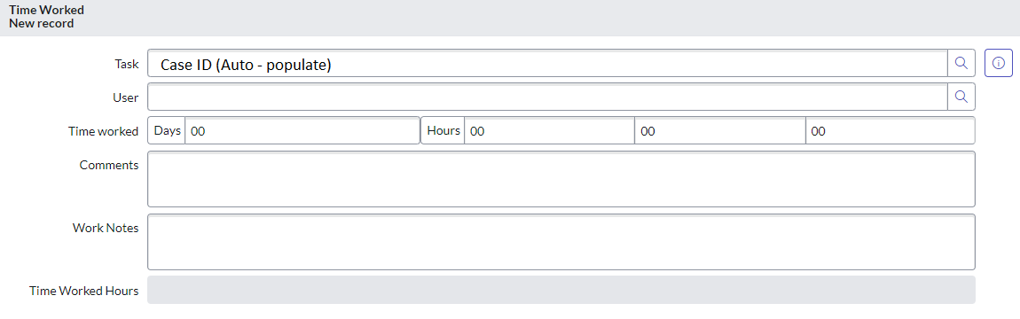
- Case Resolution Section
- When a case has been closed, based on this event change. A resolution note should be taken for closure.
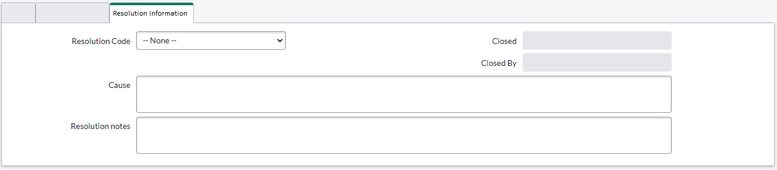
- Resolution Codes – pre-populate with common codes:
  - User Training
  - Data Issue
  - Duplicate Case
  - Design Issue
  - Code Fix
  - Requirement
  - Out of Scope
  - Implementation Issue
- Knowledge article from a Case:
  - Since a case can be resolved by agent by suggesting steps or guidelines to customer, based on the resolution steps of the case, using that information a new knowledge article can be created from it, re-used for later.
  - Required role - Support User / Agent, Admin.
  - In Authoring, setup a common channel / index with “service_connect_kapture_knowledge”.
  - Article Properties:
    - Article ID: Generate Unique number to identify the knowledge article (SC+Number example: SC0001)
    - Short Description: Case Subject
    - User Group - Public User Group
    - Categories – Set default categories.
    - Version
    - Resolution notes – Capture resolution notes from Case.
- Create should have visibility of Case along with assigned user.
  - Currently when a case has been created, based on assignment rules, only the assigned user was able to see the case but not the creator.
  - To see the case updates, creator of case should have access to the case at any moment.

