Solar cell :
For convection cells on the Sun's surface, see Solar granule.
Solar cell
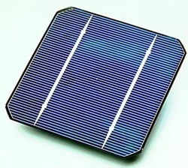
A conventional crystalline silicon solar cell (as of 2005). Electrical contacts made from busbars (the larger silver-colored strips) and fingers (the smaller ones) are printed on the silicon wafer.
Component type | Active
Working principle | Photovoltaic effect
Inventor | Edmond Becquerel
Invention year | 1839
First produced | 1950s
Electronic symbol
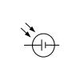
A solar cell, also known as a photovoltaic cell (PV cell), is an electronic device that converts the energy of light directly into electricity by means of the photovoltaic effect.^{[1]} It is a type of photoelectric cell, a device whose electrical characteristics (such as current, voltage, or resistance) vary when it is exposed to light. Individual solar cell devices are often the electrical building blocks of photovoltaic modules, known colloquially as "solar panels". Almost all commercial PV cells consist of crystalline silicon, with a market share of 95%. Cadmium telluride thin-film solar cells account for the remainder.^{[2]} The common single-junction silicon solar cell can produce a maximum open-circuit voltage of approximately 0.5 to 0.6 volts.^{[3]}
Photovoltaic cells may operate under sunlight or artificial light. In addition to producing solar power, they can be used as a photodetector (for example infrared detectors), to detect light or other electromagnetic radiation near the visible light range, as well as to measure light intensity.
The operation of a PV cell requires three basic attributes:
- The absorption of light, generating excitons (bound electron-hole pairs), unbound electron-hole pairs (via excitons), or plasmons.
- The separation of charge carriers of opposite types.
- The separate extraction of those carriers to an external circuit.
There are multiple input factors that affect the output power of solar cells, such as temperature, material properties, weather conditions, solar irradiance and more.^{[4]}
A similar type of "photoelectrolytic cell" (photoelectrochemical cell), can refer to devices
- using light to excite electrons that can further be transported by a semiconductor which delivers the energy (like that explored by Edmond Becquerel and implemented in modern dye-sensitized solar cells)
- using light to split water directly into hydrogen and oxygen which can further be used in power generation
In contrast to outputting power directly, a solar thermal collector absorbs sunlight, to produce either
- direct heat as a "solar thermal module" or "solar hot water panel"
indirect heat to be used to spin turbines in electrical power generation.
Arrays of solar cells are used to make solar modules that generate a usable amount of direct current (DC) from sunlight. Strings of solar modules create a solar array to generate solar power using solar energy, many times using an inverter to convert the solar power to alternating current (AC).
Applications
[edit]
Vehicular applications
[edit]
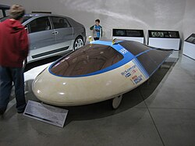The Sunraycer vehicle developed by GM (General Motors)
Electric vehicles that operate off of solar energy and/or sunlight are commonly referred to as solar cars.^{[citation needed]} These vehicles use solar panels to convert absorbed light into electrical energy to be used by electric motors, with any excess energy stored in batteries.^{[5]} Batteries in solar-powered vehicles differ from starting batteries in standard ICE cars because they are fashioned to impart power towards electrical components of the vehicle for a long durations.^{[6]}
The first instance of photovoltaic cells within vehicular applications was around midway through the second half of the 1900s. In an effort to increase publicity and awareness in solar powered transportation Hans Tholstrup decided to set up the first edition of the World Solar Challenge in 1987.^{[7]} It was a 3000 km race across the Australian outback where competitors from industry research groups and top universities around the globe were invited to compete. General Motors ended up winning the event by a significant margin with their Sunraycer vehicle that achieved speeds of over 40 mph. Contrary to popular belief however solar powered cars are one of the oldest alternative energy vehicles.^{[8]}
Cells, modules, panels and systems
[edit]
Main articles: Solar panel and Photovoltaic system
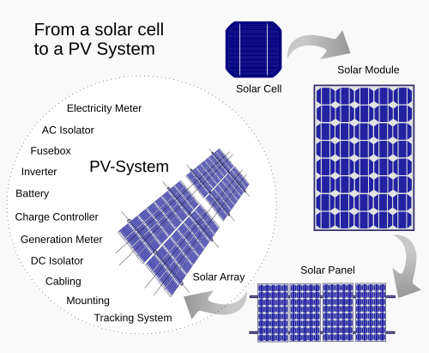From a solar cell to a PV system. Diagram of the possible components of a photovoltaic system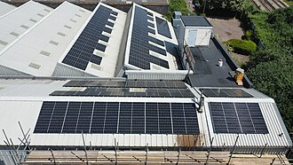Greencap Energy rooftop solar panels in Worthing, United Kingdom
Multiple solar cells in an integrated group, all oriented in one plane, constitute a solar photovoltaic panel or module. Photovoltaic modules often have a sheet of glass on the sun-facing side, allowing light to pass while protecting the semiconductor wafers. Solar cells connected in series creates an additive higher voltage, while connecting in parallel yields an additive higher current.
Parallel cells without bypass or shunt diodes that experience shade can shut down the weaker (less illuminated) parallel string (each string a number of series connected cells) causing substantial power loss and possible damage because of the reverse bias applied to the shaded cells by their illuminated partners.^{[9]}
Solar modules can be interconnected to create an array with a desired peak DC voltage and loading current capacity. This functionality can also be accomplished with various other solar devices that do more than just create the desired voltages and currents, such as with MPPTs (maximum power point trackers) or module level power electronic (MLPE) units: microinverters or DC-DC optimizers.
Multiple solar cells assembled together in a single plane form a solar photovoltaic (PV) panel or module. These modules typically feature a glass sheet on the sun-facing side, which allows sunlight to pass through while safeguarding the semiconductor wafers from environmental factors. Connecting solar cells in series increases the voltage output, whereas parallel connections enhance the current output.^{[10]}
To mitigate these issues, solar modules are often equipped with bypass diodes that isolate shaded cells, preventing them from affecting the performance of the entire string. These diodes allow the current to bypass the shaded or underperforming cells, thereby minimizing power loss and reducing the risk of damage.^{[11]}
Typical PV system prices in 2013 in selected countries (US$/W)
 | Australia | China | France | Germany | Italy | Japan | United Kingdom | United States
Residential | 1.8 | 1.5 | 4.1 | 2.4 | 2.8 | 4.2 | 2.8 | 4.9
Commercial | 1.7 | 1.4 | 2.7 | 1.8 | 1.9 | 3.6 | 2.4 | 4.5
Utility-scale | 2.0 | 1.4 | 2.2 | 1.4 | 1.5 | 2.9 | 1.9 | 3.3
Source: IEA – Technology Roadmap: Solar Photovoltaic Energy report, 2014 edition^{[12]: 15}
Note: DOE – Photovoltaic System Pricing Trends reports lower prices for the U.S.^{[13]}
By 2020, the United States cost per watt for a utility scale system had declined to $0.94.^{[14]}
Space
[edit]
See also: Space-based solar power and Solar panels on spacecraft
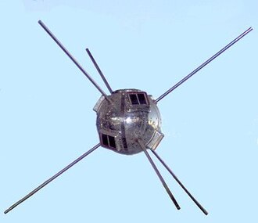NASA used solar cells on its spacecraft from the beginning, their second successful satellite Vanguard 1 (1958) featured the first solar cells in space.
Solar cells were first used in a prominent application when they were proposed and flown on the Vanguard satellite in 1958, as an alternative power source to the primary battery power source. By adding cells to the outside of the body, the mission time could be extended with no major changes to the spacecraft or its power systems. In 1959 the United States launched Explorer 6, featuring large wing-shaped solar arrays, which became a common feature in satellites. These arrays consisted of 9600 Hoffman solar cells.
By the 1960s, solar cells were (and still are) the main power source for most Earth orbiting satellites and a number of probes into the Solar System, since they offered the best power-to-weight ratio. The success of the space solar power market drove the development of higher efficiencies in solar cells, due to limited other power options and the desire for the best possible cells, up until the National Science Foundation "Research Applied to National Needs" program began to push development of solar cells for terrestrial applications.
In the early 1990s the technology used for space solar cells diverged from the silicon technology used by terrestrial panels, with the spacecraft application shifting to gallium arsenide-based III-V semiconductor materials, which then evolved into the modern III-V multijunction photovoltaic cell used on spacecraft that are lightweight, compact, flexible, and highly efficient. State of the art technology implemented on satellites uses multi-junction photovoltaic cells, which are composed of different p–n junctions with varying bandgaps in order to utilize a wider spectrum of the Sun's energy. Space solar cells additionally diverged from the protective layer used by terrestrial panels, with space applications using flexible laminate layers.
Additionally, large satellites require the use of large solar arrays to produce electricity. These solar arrays need to be broken down to fit in the geometric constraints of the launch vehicle the satellite travels on before being injected into orbit. Historically, solar cells on satellites consisted of several small terrestrial panels folded together. These small panels would be unfolded into a large panel after the satellite is deployed in its orbit. Newer satellites aim to use flexible rollable solar arrays that are very lightweight and can be packed into a very small volume. The smaller size and weight of these flexible arrays drastically decreases the overall cost of launching a satellite due to the direct relationship between payload weight and launch cost of a launch vehicle.^{[15]}
In 2020, the US Naval Research Laboratory conducted its first test of solar power generation in a satellite, the Photovoltaic Radio-frequency Antenna Module (PRAM) experiment aboard the Boeing X-37.^{[16][17]}
History
[edit]
For a chronological guide, see Timeline of solar cells.
See also: § Research in solar cells
The photovoltaic effect was experimentally demonstrated first by French physicist Edmond Becquerel. In 1839, at age 19, he built the world's first photovoltaic cell in his father's laboratory. Willoughby Smith first described the "Effect of Light on Selenium during the passage of an Electric Current" in a 20 February 1873 issue of Nature. In 1883 Charles Fritts built the first solid state photovoltaic cell by coating the semiconductor selenium with a thin layer of gold to form the junctions; the device was only around 1% efficient.^{[18]} Other milestones include:
- 1888 – Russian physicist Aleksandr Stoletov built the first cell based on the outer photoelectric effect discovered by Heinrich Hertz in 1887.^{[19]}
- 1904 – Julius Elster, together with Hans Friedrich Geitel, devised the first practical photoelectric cell.^{[20]}
- 1905 – Albert Einstein proposed a new quantum theory of light and explained the photoelectric effect in a landmark paper, for which he received the Nobel Prize in Physics in 1921.^{[21]}
- 1941 – Vadim Lashkaryov discovered p–n junctions in Cu₂O and Ag₂S protocells.^{[22]}
- 1946 – Russell Ohl patented the modern junction semiconductor solar cell,^{[23]} while working on the series of advances that would lead to the transistor.
- 1948 - Introduction to the World of Semiconductors states Kurt Lehovec may have been the first to explain the photo-voltaic effect in the peer-reviewed journal Physical Review.^{[24][25]}
- 1954 – The first practical photovoltaic cell was publicly demonstrated at Bell Laboratories.^{[26]} The inventors were Calvin Souther Fuller, Daryl Chapin and Gerald Pearson.^{[27]}
- 1958 – Solar cells gained prominence with their incorporation onto the Vanguard I satellite.^{[2}

