Addins-Integration:
New TestAddins-Integration:
Updated the Test…
- Select File > Get Add-ins.
Alternatively, you can also view your add-ins directly from the Home tab by selecting Add-ins.
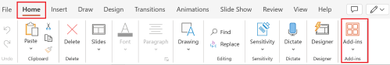
- You can directly install add-ins from this page or select More Add-ins to explore.
- In the Office Add-ins dialog, select My Add-ins tab.
- Select an add-in you want to view the details for and right-click to select Add-in details option.

