Below image describes important points in brief. If you are a quick reader, this might help you.
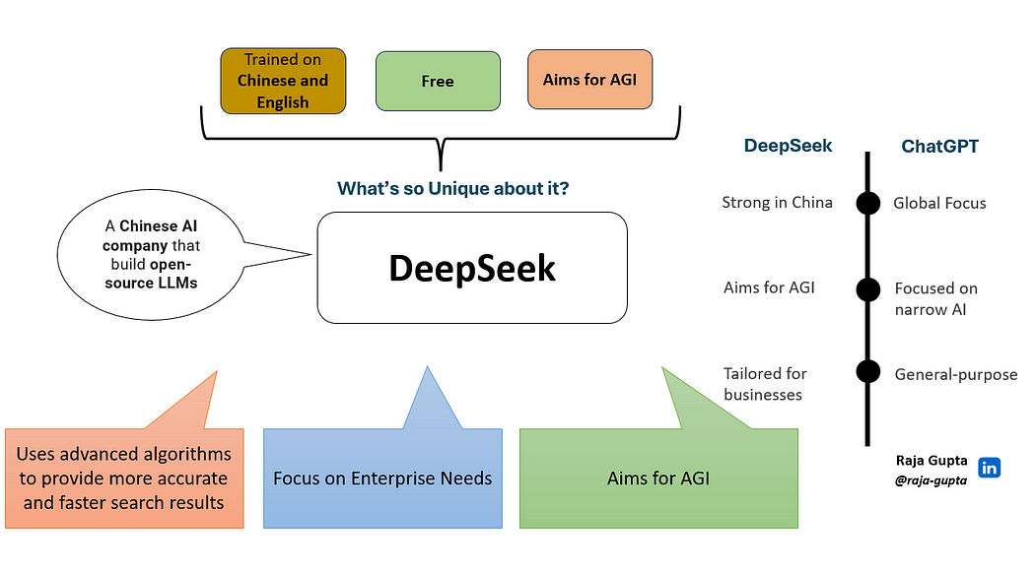
Let’s have a detail discussion now.
What’s DeepSeek?
DeepSeek is a Chinese AI company that build open-source large language models (LLMs).
Note: If you are new to LLM, it is a language model which is:
· a type of machine learning model
· that is trained on a large dataset of text
· to generate or predict human-like text.
For more about LLM, you may refer to What is Large Language Model?
DeepSeek-R1 is one of the LLM Model developed by DeepSeek. It is capable of providing responses comparable to other large language models, such as GPT.

