SQL Query Performance Tuning

Author: Narendar V
Creation Date: Oct 24, 2023
Last Updated: Oct 24, 2023
Document Ref: -
Version: 1.0

SQL Tuning
SQL Tuning is the combination of some techniques that will improve performance of the query.
How oracle executes the query.
- Oracle runs the query based on some execution plans (ways or methods).
- Either using index or reading multiple blocks at same time.

Steps
- Proper Joins.
- Maximum try to use ID columns to join multiple tables.
- Avoid character columns to join. (Note: In case there is no other option than use of it.)
- Avoid using views in SQL Queries.
- The main disadvantage of using views rather than real tables is performance degradation. Because views only create the appearance of a table not a real table. Joining two views also make more complex in scripts.
- Maximum try to avoid views usage.
- Avoid using unwanted tables and joins.
- If you are not showing any data column from the table, then avoid using those tables. (Note: In some cases, join between two table is not directly possible then you need third table to join indirectly, you can use it).
- INDEX
Types of Index.
- Unique index
- Non unique index
Unique index
- The Oracle Server automatically creates this index when.
- we define a column in a table to have a PRIMARY KEY
or a UNIQUE key constraint.
- The name of the index is the name given to the constraint.
Non-Unique index
- Which a user can create. For example, can create a FOREIGN KEY column index for a join in a query to improve retrieval speed.
- In SQL Developer, you can find explain the sql query. (Shortcut key F10).
- Using Explain Plan, you can find the cost of the query you return.
(Here cost means performance, whenever the cost is high the performance will be degraded.)
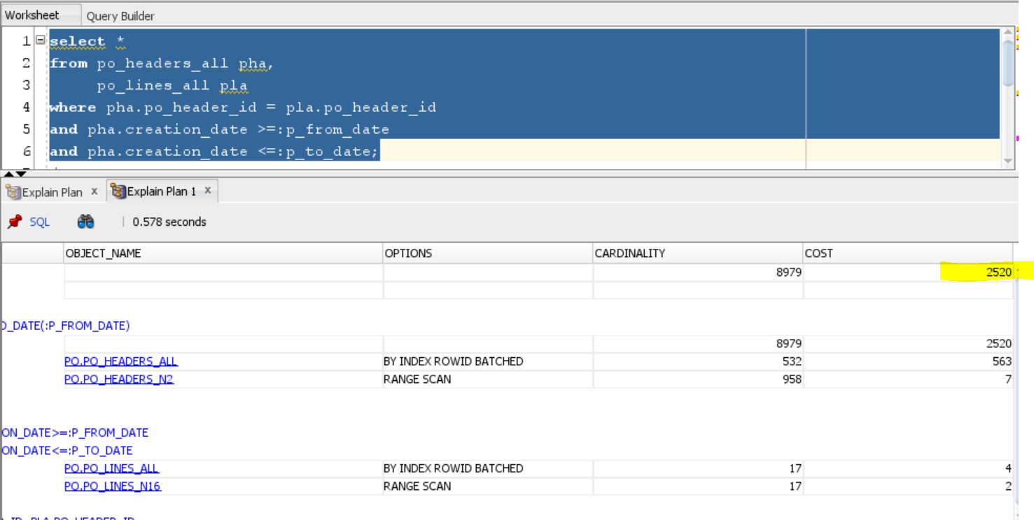

- To reduce the cost, we need to force the index.
(Note: For Number datatype Column, Use “+ 0 “
For varchar2 datatype Column, Use “||'' ‘’)
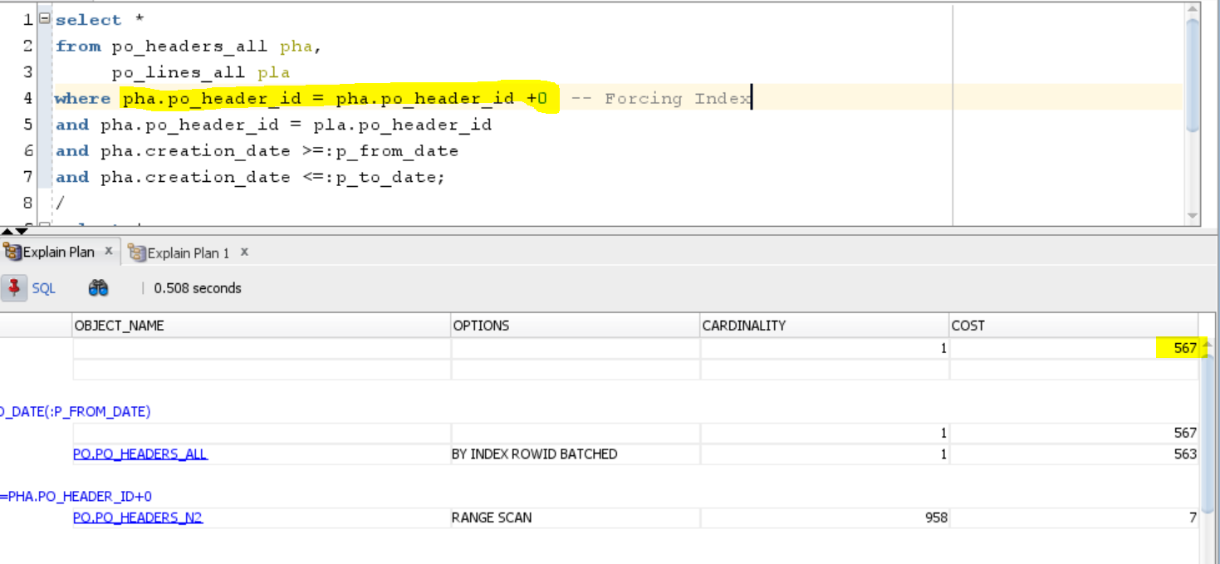

- Also, you can use unique index / non-unique index in select as below.
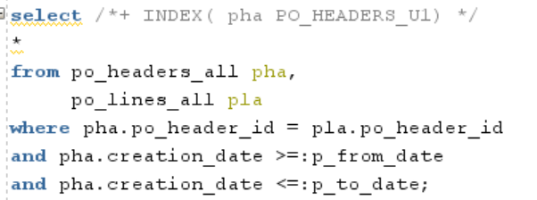
Example:
Select Employee_No, Employee_Name, Salary from xx_employee where Salary <50000;

We can create an index on salary.
Create Index xx4i_emp_salary_idx on Employee (Salary);
This will create the index named xx4i_emp_salary_idx.
We need to use that index forcefully.
Select Employee_No, Employee_Name,
/*+ INDEX (Employee xx4i_emp_salary_idx) */ Salary
from Employee where Salary < 50000;
Reference Link for Hints:
https://www.complexsql.com/types-of-oracle-hints-oracle-hints-examples/
- Create a Materialized View.
- In Oracle 12.1, you can create a materialized view as below.
Create or Replace Materialized View view_name_mv
As select column from table;

- But In 12.2, you want to create as in below document.
- Create an Index for the column which is used in group by and order by clause.
- Distinct Column Indexing.
- Usually, we don’t use distinct in select statement. For some cases there is exceptional we use distinct at the time we can create a composite index for those columns in select statement.
Syntax:
create index <index_name> on <table_name> (column1, column2, column3, column4) nologging;

- Create a Composite Index.
- If the query of cost is high on a specific table and it has two or three columns used in joins. We need to create a one composite index for those three columns.
Syntax:
create index <index_name> on <table_name> (column1, column2, column3, column4) nologging;
(NOTE: EXPLAIN PLAN predicts how Oracle will process your query, and EXECUTION PLAN describes the steps it took.

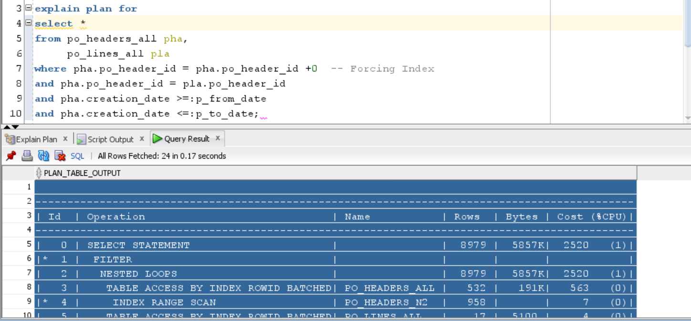

explain plan for
select *
from po_headers_all pha,
po_lines_all pla
where pha.po_header_id = pha.po_header_id +0 -- Forcing Index
and pha.po_header_id = pla.po_header_id
and pha.creation_date >=:p_from_date
and pha.creation_date <=:p_to_date;
To view the Explained Plan
select * from table(dbms_xplan.display);

