EBS Integration APIs
POST API Name: Upload Documents
https://aiplatform.kapturekm.com/Kapture-Author/api/ecm/upload-documents
Method: POST
Input request:
curl --location 'https://aiplatform.kapturekm.com/Kapture-Author/api/ecm/upload-documents' \
--form 'uploadDate="2024-09-24T15:30:00"' \
--form 'documentCategory="Invoice"' \
--form 'documentDescription="Monthly Invoice"' \
--form 'transactionType="Order"' \
--form 'uploaderUserId="4iguest"' \
--form 'transactionId="TN67890"' \
--form 'uploadedFiles=@"/C:/Users/SivaVenkataRaoM/Downloads/Case for ECM and ERP Integration Offering.docx"' \
--form 'uploadedFiles=@"/C:/Users/SivaVenkataRaoM/Downloads/image.png"'
Screen shot for your reference
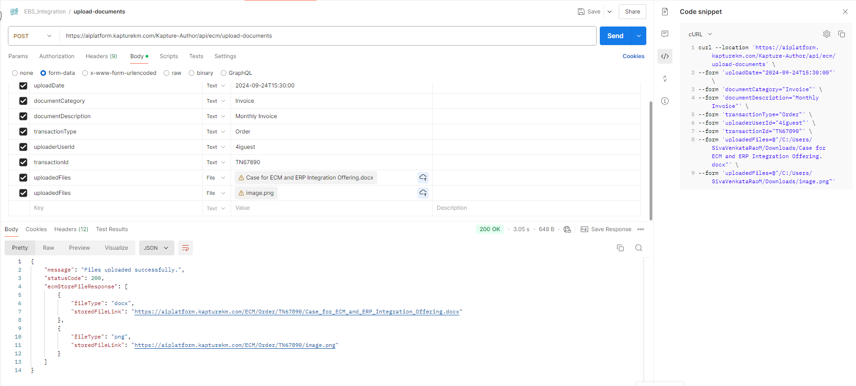
Response:
{
"message": "Files uploaded successfully.",
"statusCode": 200,
"ecmStoreFileResponse": [
{
"fileType": "docx",
"storedFileLink": "https://aiplatform.kapturekm.com/ECM/Order/TN67890/Case_for_ECM_and_ERP_Integration_Offering.docx"
},
{
"fileType": "png",
"storedFileLink": "https://aiplatform.kapturekm.com/ECM/Order/TN67890/image.png"
}
]
}
GET API Name: Get documents
/get-documents/{userId}/{transactionId}
https://aiplatform.kapturekm.com/Kapture-Author/api/ecm/get-documents/4iguest/TN67890
Method: GET
Input Request:
curl --location 'https://aiplatform.kapturekm.com/Kapture-Author/api/ecm/get-documents/4iguest/TN67890'

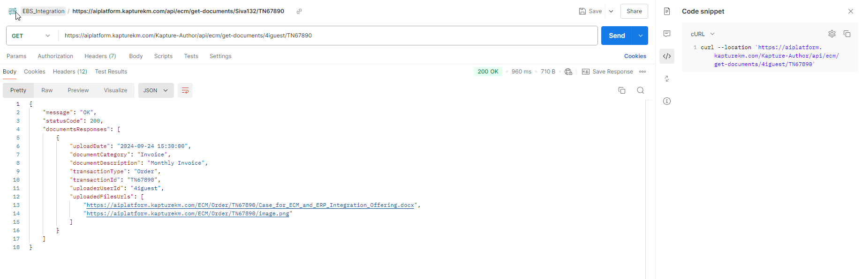
Response:
{
"message": "OK",
"statusCode": 200,
"documentsResponses": [
{
"uploadDate": "2024-09-24 15:30:00",
"documentCategory": "Invoice",
"documentDescription": "Monthly Invoice",
"transactionType": "Order",
"transactionId": "TN67890",
"uploaderUserId": "4iguest",
"uploadedFilesUrls": [
"https://aiplatform.kapturekm.com/ECM/Order/TN67890/Case_for_ECM_and_ERP_Integration_Offering.docx",
"https://aiplatform.kapturekm.com/ECM/Order/TN67890/image.png"
]
}
]
}
