
Business CASE for KAPTURE & Oracle E-Business ERP Integration
Draft Version

Case for ECM and ERP Integration Offering
- Background
ECM (with its variant names) has emerged as a new and efficient way of storing all digital content including documents and other digital files. ECMs Enterprise content management (ECM) is a set of capabilities for capturing, storing, activating, analyzing and automating business content, in order to provide new value from data that was previously unstructured and unavailable. So, ECM provides a great option to store enterprise-wide digital data, both structured and unstructured.

On the other hand, ERP / CRM based enterprise applications have become hugely successful and have automated the transaction-driven business processes across the enterprise. All organizations, big or medium or small have deployed ERP / CRM applications and benefitted from such applications.

However, transactions also need digital content, to complete the business processes. For example, supplier invoices processing depends on POs, Supplier Invoices, Material Receipt Documents and Quality Reports (if relevant) to complete a supplier invoicing approval and payment process. It is here, digital document storage greatly complements the business process automation and facilitate the transaction life cycle management.

Also, business process automation is also facilitated through documents and can also generate data from documents and digital contents that can be consumed by the transaction processing applications. In short, there is inter-dependance between the ECM and ERP applications. This can only accelerate further, given the rapid advancements in digital content processing.

It is in this context; this document explores the ECM based on Kapture and Oracle E-Business based ERP as a specific business case.

Enterprise Digital Repository
Enterprise Applications ERP/ CRM
Other Vertical Industry Applications
Other Structured & Unstructured Digital Files
Enterprise-wide Digital Content Repository

- Oracle E-Business Suite and Facility for digital file storage
Oracle has two flavors of ERP. The traditional ERP solution, popularly known as oracle E-Business suite is still popular and Oracle has plans to support the product till the 2034. The latest release 12.2.13 was done in November 2023.
Oracle has provisions to support documents management through a function called Attachment to store document contents. The attachments feature enables users to link unstructured data, such as images, word processing documents, spreadsheets, or text to their application data. For example, users can link images to items or video to operations as operation instructions.
Attachment information can flow through entire application. For example, if you enable attachments for a part number, where users would attach images of the part, you can then enable attachments for all your other forms that refer to your part number. Users would then be able to see the image of the part wherever that part number occurs.
You can provide security to limit which attachments users can see from particular forms by assigning document categories to your form functions. Users then assign individual attachments to particular categories.
You can add the attachments feature to your application forms and functions without modifying form code, so long as your forms are built using Oracle E-Business Suite standards (starting with the Oracle E-Business Suite TEMPLATE form). The following image shows how attachment feature is enabled in Oracle E-Business Suite:
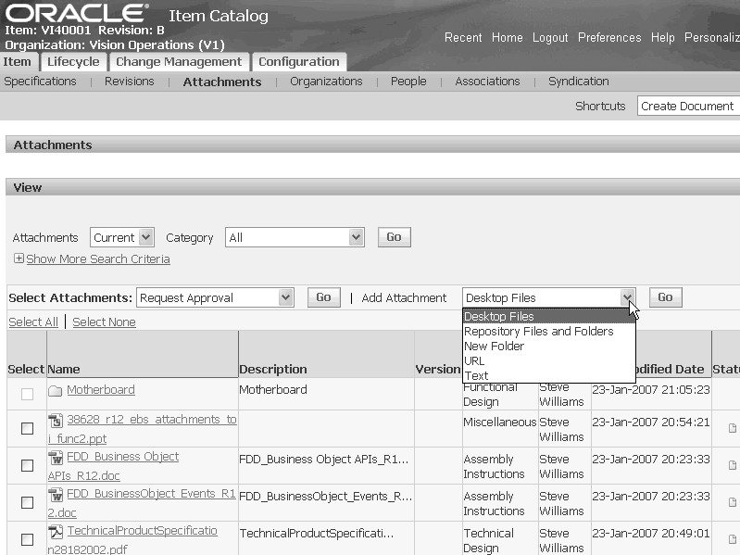

Further details of this feature can be found in this link:
https://docs.oracle.com/cd/E18727-01/doc.121/e13109/T381249T455567.htm
It may be noted that Oracle E-Business Suite provides “Attachment” in both Forms (traditional input) as well as OAF Pages (JAVA based). The above image shows the OAF, while traditional Form will have the following buttons in the Forms screen:
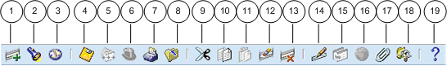
Item Number 17 refers to Attachment. Further details on the Form can be found in this link:
https://docs.oracle.com/cd/E26401_01/doc.122/e22956/T27641T391494.htm#ug_atta

- E-Business Kapture Integration
There exists a strong case to use ECM as a data store and use a link to facilitate the attachments link within Oracle E-Business Suite. Why such a separate data store is recommended is for the following reasons:
- Efficient storage of documents
- All documents and other digital contents can be managed in one server (either cloud or on-prem) instead of in different locations.
- Can be used to generate analytics.
- ECMs provide greater facility for search and can be used for generating contents combining the text and data.
It is suggested to use the attachment framework to link the documents with the specific transactions in the ERP. While it may be possible to generate even data and transfer the data to ERP (e.g.: Invoices data), attachment mechanism can be an easier way of integration and as the first step.
B
Oracle E-Business Suite
KAPTURE ECM
Transaction Data Base
Integration thru
Attachment
Documents and Other Digital Data
Enterprise Digital Repository

- Business Logic for Integration
The following will be considered for the derivation of the integration:
- ECM (KAPTURE) will be the module to scan, classify, index and store all the digital contents.
- No document content shall be stored in Oracle E-Business suite.
- Oracle E-Business shall only have the link with documents or other digital files stored in the ECM server.
- There will be integrity run for the documents or other files linked with Oracle E-Business Suite
- Any versioning or amendments of the documents shall only happen within ECM.
- Oracle E-Business will be customized (custom extension) to facilitate attachment link for both OAF and Forms environment.
- The security and user authorization may have to be common between E-Business suite and Kapture ECM Server.
- When a transaction is processed in Oracle E-Business suite, the user shall invoke the button, to identify the suitable documents / files for attachment. A new screen in the form of a search window will be enabled.
- The screen may invoke an API to scan the Kapture and such a selection will be based on the following:
  - Date
  - Category of the document
  - Description
  - Key Values
  - Key description
  - Type of files
- Based on the selection one or files will be displayed (output) in E-Business Suite and the user will select the files. Based on the user selection, the links(s) will be created by the custom-extension, and entry or entries shall be posted in the attachment window. The attachment links shall be stored as part of the standard E-Business practice.
- Optionally, it should be possible to generate the contents and publish. This can be part of the extension. Alternatively, publishing can be handled within ECM and E-Business can provide the key values of the document as part of the interface.
- ECM server will also store a transaction id (generated in E-Business suite) as reference.
In short, the documents and other digital files will get created and maintained within ECM server, and only a link shall be maintained with Oracle E-Business suite.
5.0 Conclusion
At the outset, the concept of digital documents and files repository will be a great enabler for even medium organizations and Kapture can play a rightful role to create and maintain contents and the same can be used by the ERP software. Oracle E-Business Suite can just be a beginning and can extend to Oracle Fusion software as well.

6.0 E-Business Custom Extension (Forms and OAF)
The following extensions are provided for additional reading to perform customizations:
- FormsExtension:https://docs.oracle.com/cd/E18727_01/doc.121/e12897/T302934T458264.htm
- Attachments: https://docs.oracle.com/cd/E26401_01/doc.122/e22961/T302934T458262.htm
- OAF:https://www.oracle.com/technetwork/apps-tech/personalizecustomizeextendebsui-1496732.pdf

